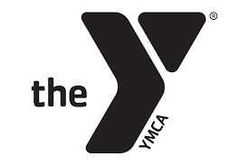
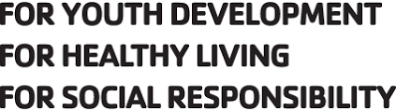
Reporting Information

At UMLY we strive to ensure that every individual who walks through our doors has a positive, healthy experience and wants to keep coming back. If you have experienced service that is not exceeding expectations towards our athletes and would like more information on how to deal with a Safe Sport matter please use the information provided below.

To deal with a Safe Sport concern, contact USA Swimming at (719) 866-4578
Contact the U.S. Center for Safe Sport to make a report. Call (720) 524-5640 or use the
online reporting form or find more information at http://www.uscenterforsafesport.org/

