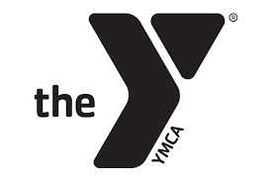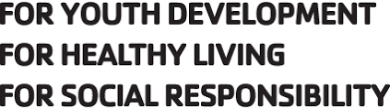

Coach Responsibilities
The coaches’ job is to supervise the competitive swim program. The UMLY coaching staff is dedicated to providing a program for our youth that will enable them to learn the value of striving to improve oneself to be the best they can be. Therefore, the coaches must be in control of matters affecting training and competition.
- The coaches are responsible for placing swimmers in practice groups. This is based on the age and ability of each individual. When it is in the best interest of a swimmer, he/she will be placed in a more challenging training group by the coach. Otherwise, they will swim with their designated practice group.
- Sole responsibility for stroke instruction and the training regimen rests with the Upper Main Line YMCA Swim Team coaching staff. Each group’s practices are geared to the goals of that group.
- At meets, the coaching staff will conduct and supervise warm-up procedures for the team. It is the swimmer’s responsibility to check-in with a coach before and after each race. The coaches will offer constructive criticism regarding the swimmer’s performance.
- The building of a relay team is the sole responsibility of the coaching staff.

Coach’s Code of Conduct
- I will provide an environment for my swimmers that is safe from physical and emotional harm.
- I will treat each swimmer as an individual, keeping in mind the wide range of physical and emotional development within the same age group.
- I will respect the swimmers by not speaking negatively about any swimmer either on the pool deck or in a social situation.
- I will place the emotional and physical well being of my swimmers ahead of any personal or parental desires to win.
- I will lead by example, demonstrating fair play and sportsmanship in my on- and off- deck activities.
- I will abide by the YMCA’s code of conduct:
A. I will not subject any child to neglect or to mental, verbal, physical, or sexual abuse
B.I will not leave any child unsupervised
C.I will not be alone with any child where we cannot be observed by others
D.I will not transport any children in my vehicle
E.I will treat all children equally without respect to gender, race, religion, culture, or ability
F. I will be a positive role model by maintaining an attitude of respect, loyalty, patience, courtesy, tact, and maturity
G. I will utilize positive guidance techniques
H. I will refrain from profanity and inappropriate jokes.
- I will not hold extra or special practices without permission of the Head Coach.
- I will use coaching techniques that are appropriate for all the ages and skill levels present.
- I will seek and encourage parental participation at meets and any other team activities.
- I will respectfully control the behavior of swimmers and parents by asking them to leave the deck should they become unruly or create an atmosphere that is not appropriate for the development of good sportsmanship.

