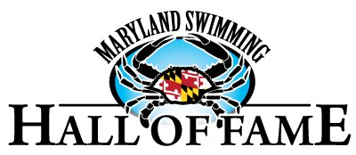

Nomination Form for Maryland Service Medal
In 2017, the Maryland Swimming Board approved the creation of the Joseph F. Curreri Maryland Swimming Service Medal to honor Maryland Swimming Athletes who served in the armed services of the United States.
Medals are awarded during Maryland Swimming Hall of Fame Induction Ceremonies and are accompanied by a donation to one of three charities: The USO, Home for Our Troops, or Fallen Patriots.
Eligible recipients must have swum for a team within the Maryland LSC for four years or more and have served or are serving in the United States Army, Navy, Marine Corps, Air Force or Coast Guard.

Your Name: _______________________________________________Date: ______________________
Email: _________________________________________Phone: ________________________________

I nominate ___________________________________________ for the Joseph F. Curreri Maryland

Swimming Service Medal. The nominee swam for (Team) ______________________________ from

______________until ______________. The nominee served in the U. S. (Branch) __________________

__________________________from _____________ until ______________.

Nominee’s Address ___________________________________________________________________
Email: ________________________________ Phone: _______________________________________
Please send form to John Cadigan 37 Tenbury Road Lutherville, MD 21093 or email : jac@mbrook.com

