How to: Sign-up Genius

Without volunteers, we are not able to host, nor attend any swim meets. Did you know that it takes a mininum of 22 volunteers to host a meet? Did you know it takes 10 volunteers for away meets?
Please follow the link provided in a recent email to sign up using the www.signupgenius.com.
If you didn't receive an email, or lost it, etc, please email the hagy gators board at hagy-gators-board@googlegroups.com

Once you create an account on signupgenius.com, you are able to find the sign-ups for the Gators by going to the "FIND A SIGN UP" tab. Then, enter "hagy.gators@gmail.com" in the "Enter the email of the Sign Up List's creator:" box and click "Search"

You should now be seeing all of the available sign-ups available for the gators. Please click on all active signup links.

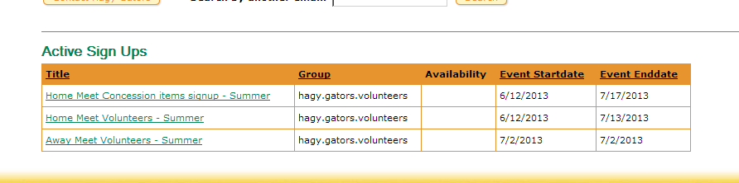

Thank you for your support.

