Name: Matthew Praley
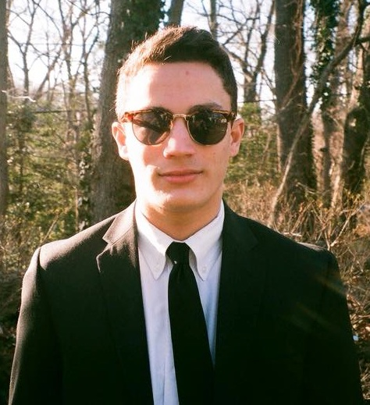

High School: Severna Park High School

Years on SPY: 10

College attending in the fall: Bard College

Hobbies when I’m not swimming: I’m probably either hanging out with my friends either from SPY or school. Working on my photographs is also a great joy of mine even though I may be alone on my computer for hours trying to edit photos and creating anything that looks interesting. I enjoy sleeping so much more now that SPY has forced me to wake up so early. I also enjoy listening to the most bizarre music that I share with my friends and singing Lemonade with Katie and Lauren.

Most Memorable Swim: Junior year at districts was one of my best meets and the 100 back was the last ever event of the meet so everyone was ready to finish this meet. I was seated 5th at finals and ended getting 4th along side Sam and Doug who got 2nd and 1st. I dropped a good amount of time and it just felt so great for all spy swimmers to place so high. Everyone was very happy for us.

Most Memorable/Funny Moment: The afternoon practices where we go insane because of lack of sleep. For some reason when we get 4 hours of sleep we get a burst of energy and will laugh at anything that happens at practice. Common things that happen on a Thursday afternoon practice are getting into fights with each other about getting water on each other and we end up throwing everyone’s goggles in the pool. Cones are also fun to throw in the pool. Of course the coaches hate it but we don’t care we got 4 hours of sleep. Sometimes when I get really bored I end up in lane 4 and fooling around with Lauren and Katie. Even though swimming doesn’t let you talk at all we manage to talk a whole bunch about stupid stuff.

Best Events: 100 back, 200 back, and 50 free.

Favorite Set(s): Any sprint set where we go in heats are my favorite, so basically any sprint set that consist of a lot of rest. Relay sets and game sets are fun because I swim with people that I don’t usually see during practice. They also create team bonding and get everyone to cheer for each other.
Least Favorite Sets: Anything long distance that has us constantly swimming, I am too impatient to swim long distance sets not even a couple 200 freestyles.

Pre-Swim Rituals: Music is what helps me focus and get me pumped. I try to get a certain song stuck in my head to keep myself pumped up. I am usually quiet and don’t talk to anyone before my race so that I am not distracted.

Favorite meal before a big meet: Any type of Pasta with bread. The morning of the meet I eat a plain bagel with nothing on it.

Advice for next year’s graduating class: Make SPY enjoyable not just for yourself, but for everyone else. Make great friends because you will be spending every single day with each other. Don’t be afraid to speak up.

