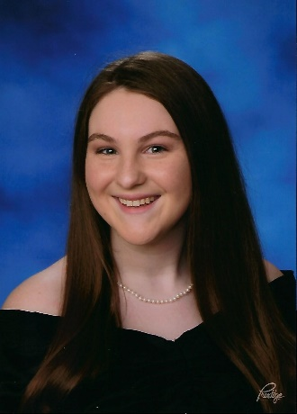
SPY SENIORS PAGE:

Name: Catherine Russell

High School: South River High School

Years on SPY: 5

College attending in Fall 2020: Rice University

Hobbies when not swimming: Orchestra, Travel, Concerts, Taking naps, Petting dogs

Most memorable swim: The 500 free at Districts 2018. I remember thinking during the race that I was winning, but I didn’t hear a bell on my last 50. I had never gotten the bell before, so I was disappointed that someone must have caught up during the last lap. Turns out, the official just forgot to ring the bell. I climbed out of the pool and Coach Ally told me that was the best she had ever seen me swim! While my dad, who was timing for me, was a bit mad that the official had forgotten, I was satisfied with my final race of that short course season.

Most memorable/funny moment: When I surprised Crystee with a cake on her birthday and we had a party instead of dryland

Best Event: 200 Back

Favorite Set: Swimming the gauntlet on Thanksgiving

Least Favorite Set: 400 IM test set

Pre-swim rituals: Shake it out, jump up and down, squat on the block

Favorite meal before a meet: Belvita bar and hot tea from Wawa

Advice for next year’s graduating class: Work hard. Write your essays early. Choose your battles. Live every day to its fullest. Don’t let anything get in the way of your goals. These are all great, but my philosophy is to enjoy yourself. Savor your final year! It’s time you won’t have again, so take risks and try new things. Smile - having a positive attitude is an easy way to light up your day and bring joy into someone else’s. And most importantly, have fun.

