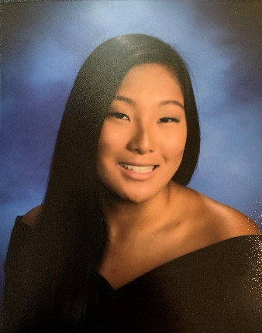

SPY SENIORS PAGE:

Name: Kim Horn

High School: Broadneck High School

Years on SPY: 5

College attending in Fall 2020: University of Delaware

Hobbies when not swimming: Baking, and sleeping.

Most memorable swim: 200 Medley Relay at Cap Classic 2019-2020. It was Friday night at finals and Cameryn, Reagan, Maddy and I had been told to suit up for the 200 relay, we didnt really want to put on kneeskins, but did it anyway. Joking around we looked up the nats cut and decided it was going to happen. We get in and we’re .7 off the cut. 3 hours later and we are back in the pool ready to try again at time trials. It’s 8 o’clock, we’ve been sitting for 3 hours straight, but we want all want this cut so bad. Reagan drops the second that we needed and now the spy girls are off to nats.

Most memorable/funny moment: So many good memories were made this year, but my favorite was at the girls sleep over when none of us got any sleep. While Reagan slept soundly upstairs the majority of the girls were in her basement freaking out over a toy that kept making noise. There was a lot of screaming and not a lot of sleeping. Every 15 minutes the toy would say “play with me” or “do you want to be my friend,” I’m pretty sure we all thought we were gonna die. However, looking back it was really fun night and I’m super grateful for how close the girls were this year.

Best Event: 100 Back and 200 Free

Favorite Set: Distance Free Wednesday with Richard

Least Favorite Set: IM sets on Monday with Richard and Freestyle Race Pace

Pre-swim rituals: 32 oz Dunkin’ iced latte before swimming, and a lot of stretching behind the blocks

Favorite meal before a meet: Tortellini with cheese bread

Advice for next years graduating class: Senioritis is real, get your college apps done early, and go to practice. You get out what you put in, finish your last year off strong and enjoy your senior year. My last year on Spy was the best year I think I had, so make the most out of it. Good luck and I’ll miss you guys!

