General Meet Information

USA Swimming, the national governing body for the sport of swimming, divides the country into 59 regional governing bodies called Local Swimming Committees (LSCs). Michigan Swimming is the LSC that governs swimming in the state of Michigan.

There are several types of meets that Gator swimmers may attend throughout the season, ranging from ABC meets, where all levels of Gator swimmers are eligible to attend, to time standard meets, where swimmers need to have achieved the minimum qualifying time to enter the meet.

There are also different meet formats, such as timed finals, where all swimmers who are signed up for a particular event will swim it only once and prelim/finals, where all swimmers who signed up for a particular event will swim that event in prelims and the top times from the prelim session will advance to the finals session in the evening, as specified in the meet packet.

Championship Meets

Each LSC holds a championship meet series twice a year in late February/early March for short course season (swum in a 25-yard pool) and then again in July for long course season (swum in a 50 meter or Olympic size pool).

In 2021, Michigan Swimming has revised its championship to better align its programming with the USA Swimming Age Group & Senior model. This model enables Michigan Swimming to better meet the unique needs of each athlete group through new and improved tailored competition and development opportunities.

The Regional Championship Meet is the first level of the Michigan Swimming Championship Meets. Swimmers must have achieved the Regional time standards to compete in events in this meet. You may only compete in events that you have achieved a Regional qualifying time. If swimmers have a State Championship Meet qualifying time in any event, they are not allowed to swim that event at the Regional meet. Swimmers can qualify for the State Championship meet at the Regional meet.

The State Championship Meet is the second Michigan Swimming Championship meet. Swimmers must have a state qualifying time or faster to compete at the State Meet. There is not a slower than time cutoff. Swimmers can qualify for higher level meets at the State Championship Meet. The State Championship Meet is broken up into two meets, the Michigan Age Group Championships (MAGS) for 14 & Unders and the Michigan Ultra Championships (ULTR) for Open ages.

Gator swimmers at the Michigan Swimming Championship meets may qualify for even faster meets, including Zones Championships, NCSA/ISCA Age Group Championships, Sectionals and NCSA/ISCA Senior Championships.

USA Swimming also divides the 59 LSCs into four zones: Eastern, Central, Southern and Western. Like each LSC, each zone holds one or more championship meets at the end of the winter and summer seasons for select age group and senior swimmers for LSCs within that zone. “Zones” are the zonal championship meets for 14 and under age group swimmers, and “Sectionals” are the zonal championship meets for senior swimmers. At Zones, each LSC compiles a team of its fastest age group swimmers to compete against other LSCs in the same zone, and these swimmers compete under the name of their LSC (not their clubs). At Sectionals, however, swimmers generally compete under their own club’s name.

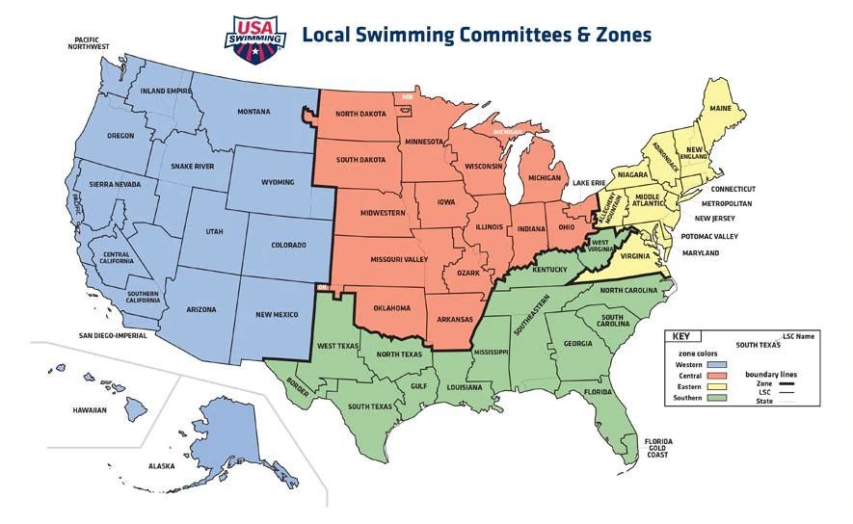
Michigan Swimming is assigned to the Central Zone. The Central Zone hosts the Central Zone Championship Meet for 14 and under age group swimmers at the conclusion of summer season. It is a regional championship meet that swimmers compete in as a part of Team Michigan.

The 14 & Under (NCSA or ISCA) Age Group Championship Meet is a great meet for 14 and Under swimmers to gain experience at even bigger travel Prelim/Final meets. This meet has qualifying times for each age within an age group. For example, in the 11-12 age group there are separate time standards for 11 and 12-year-old swimmers. Teams from anywhere in the US are eligible to swim in this meet.

Championship meets after these meets are open to all ages and are “one qualifying time” meets. That means that swimmers of any age can compete at these meets if they meet the qualifying time standard(s) for an event(s). The first level of the one qualifying time for all ages meets is the Central Zone Sectional Championship Meet. It is a regional meet that is a level above the 14 & Under Zone Championship Meet.

The following meets are all national meets and are listed in order of time standards from slowest to fastest. The Junior National Championship Meets (NCSA or ISCA) in March and August, The Speedo Junior National Championship Meet, Speedo Senior National Championship Meet (both in December), and Olympic Trials (on Summer Olympic years) are the main national meets. There are other national meets that swimmers may qualify for or may be chosen to compete in.

You can find qualifying times at https://www.teamunify.com/SubTabGeneric.jsp?team=milsc&_stabid_=162570 or in the specific meet information on our website.

