LIQUID LIGHTNING COLLEGE AND UNIVERSITY SWIMMERS

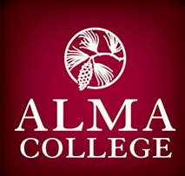
Michaela Collins Brooklyn DenOuden Eliana Ritt
Emily Diener

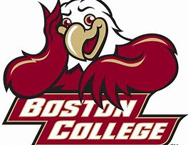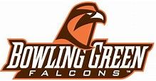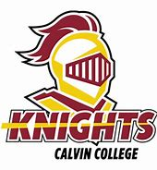
Lauren Sielicki Sarah Hennings Brian Goins

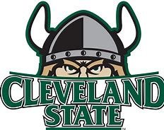 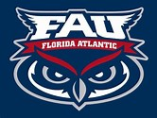Caroline Hughes Aiden Schurig Lauren LeBrun

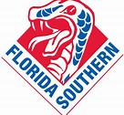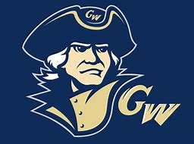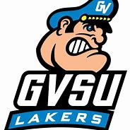
Krystal Karas Hannah Kopydlowski Danny Abbott
Brien Moffit
Bianca Tiberio
Ben Walling

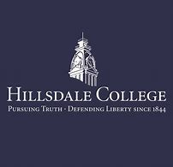 Emily Shallman Evan Gorgas Jamie Kaleel
Monica Gorgas

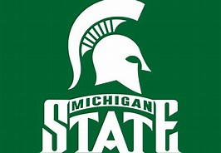 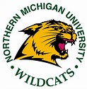 Haley Kornburger Kristen Finney Courtney Konopitski

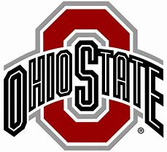
Kirstyn Abbasse Annie Jongekrijg Kathryn Roesch
Bethany Abramczyk
Sarah Heines
Brett Larson
Kyle Larson

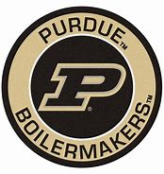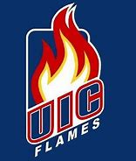
Claire Abbasse Olivia Cassise Ashley Weltyk
Lydia Mattar

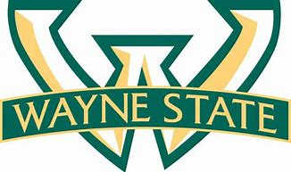 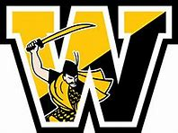 Betsey Walkowiak Ashley Corriveau Elizabeth Roesch Emily Roesch Danielle Kudla
Nicole Kudla
Theresa Riviera
Tanner Roberston

