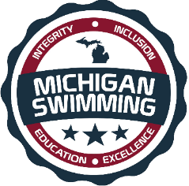
JENISON WILDCAT AQUATICS (JAWS) &
MICHIGAN SWIMMING

- WHAT:
  - JENISON WILDCAT AQUATICS (JAWS), ALONG WITH MICHIGAN SWIMMING, IS HOSTING A “NEW” OFFICIALS CLINIC!

- WHERE:
  - JENISON HIGH SCHOOL
  - 2140 BAUER ROAD JENISON, MICHIGAN 49428

- WHEN:
  - December 14, 2018
6:30 PM – 8:30 PM

- WHO:
  - THIS CLINIC IS FOR ANYONE INTERESTED IN BECOMING A MICHIGAN SWIMMING CERTIFIED OFFICIAL.

- RSVP:
  - PLEASE GO TO THE OFFICIALS WEBSITE, TO REGISTER AND RESERVE YOUR SPOT FOR THE CLINIC OR CLICK ON THE LINK BELOW.
  - (Reservation is preferred for planning purposes, but not required, all are welcome to attend)

- NOTE: ALL CLINIC ATTENDEES ON DECEMBER 14TH, WHO WISH TO BEGIN THEIR APPRENTICSHIPS WILL BE INVITED ON DECK AT BOTH THE MLA COURTNEY BARTHOLOMEW MEET (HELD AT Holland Community and Recreation Center) AND WMS WINTER CLASSIC (HELD ZEELAND NATORIUM))

JAWS NEW OFFICIALS CLINIC REGISTRATION

