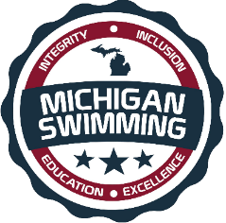
LIVONIA COMMUNITY SWIM CLUB &
MICHIGAN SWIMMING

- WHAT:
  - LIVONIA COMMUNITY SWIM CLUB, ALONG WITH MICHIGAN SWIMMING, IS HOSTING A “NEW” OFFICIALS CLINIC!

- WHERE:
  - JACK E. KIRKSEY, COMMUNITY RECREATION CENTER
  - 15100 HUBBARD LANE, LIVONIA, MICHIGAN 48154

- WHEN:
  - December 6, 2018
6:00 PM – 8:00 PM

- WHO:
  - THIS CLINIC IS FOR ANYONE INTERESTED IN BECOMING A MICHIGAN SWIMMING CERTIFIED OFFICIAL.

- RSVP:
  - PLEASE GO TO THE OFFICIALS WEBSITE, TO REGISTER AND RESERVE YOUR SPOT FOR THE CLINIC OR CLICK ON THE LINK BELOW.
  - (Reservation is preferred, for planning purposes, but not required; however, all are welcome to attend)

- NOTE: ALL CLINIC ATTENDEES ON DECEMBER 6TH, WHO WISH TO BEGIN THEIR APPRENTICSHIP WILL BE INVITED ON DECK AT BOTH THE LCSC SNOWBALL SPLASH MEET (HELD AT LCSC) AND THE GLT TSUNAMI MEET (HELD AT WATERFORD MOTT HIGH SCHOOL)

LCSC NEW OFFICIALS CLINIC REGISTRATION

