Hello from Michigan Swimming Community:

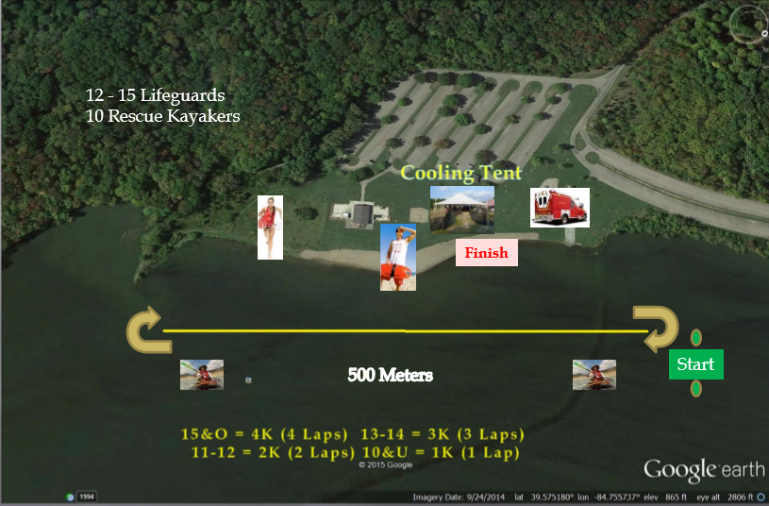

Are you looking to race in a different medium? Are you looking to see how amazing swimming is under the sun in an open lake? Well wait and wonder no longer. We have your next challenge!
We would like to extend an invitation to all Michigan Swimming swimmers that qualify for the first ever Open Water Championship. This year the Open Water Championship will be hosted near Oxford, Ohio. This unique and exciting event pulls the best Open Water Swimmers from 5 different LSC’s (Lake Erie Swimming, Allegheny Swimming, Kentucky Swimming, and Michigan Swimming). Some of the current best open water swimmers started at this event.
For more information check this out: https://www.teamunify.com/SubTabGeneric.jsp?team=milsc&_stabid_=96733

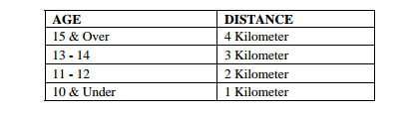
Swimmers will compete as individuals. However, swimmers may also compete on relays. A relay consists of three (3) swimmers, in the same age group/same sex, from the same club. The cumulative finishing times of the three fastest swimmers in each age group/sex/club will make up the A relay. The second fastest cumulative times will make up the B relay, etc. The fastest cumulative time will be used to determine the winners and the place. Only the Top 2 Relays are eligible for Points & Awards.
See the list as to who has qualified here.
---------------------------------------------------------------------------------------------------------------------------------------

