Integrity, Inclusion, Education, Excellence
Penguin Plunge Open Water Meet
Hosted By: Huron Valley Penguins
June 24th, 2017

SANCTION - This meet is sanctioned by Michigan Swimming, Inc. (MS), as an Open Water 1k, 3k, or 5k meet on behalf of USA Swimming (USA-S), Sanction Number MI1617131. In granting this sanction it is understood and agreed that USA Swimming shall be free from any liabilities or claims for damages arising by reason of injuries to anyone during the conduct of the event. MS rules, safety, and warm up procedures will govern the meet as is fully set forth in these meet rules.
LOCATION - Island Lake State Recreational Area, 6301 Kensington Road, Brighton, Mi 48116 NOTE** Kent Lake is the body of water
*A State of Michigan Recreational Passport is required for vehicles to enter the park. State of Michigan residents’ vehicle passport is $11.00.
COURSE: This lake course is a 1 Kilometer Course. One lap = 1 Kilometer.
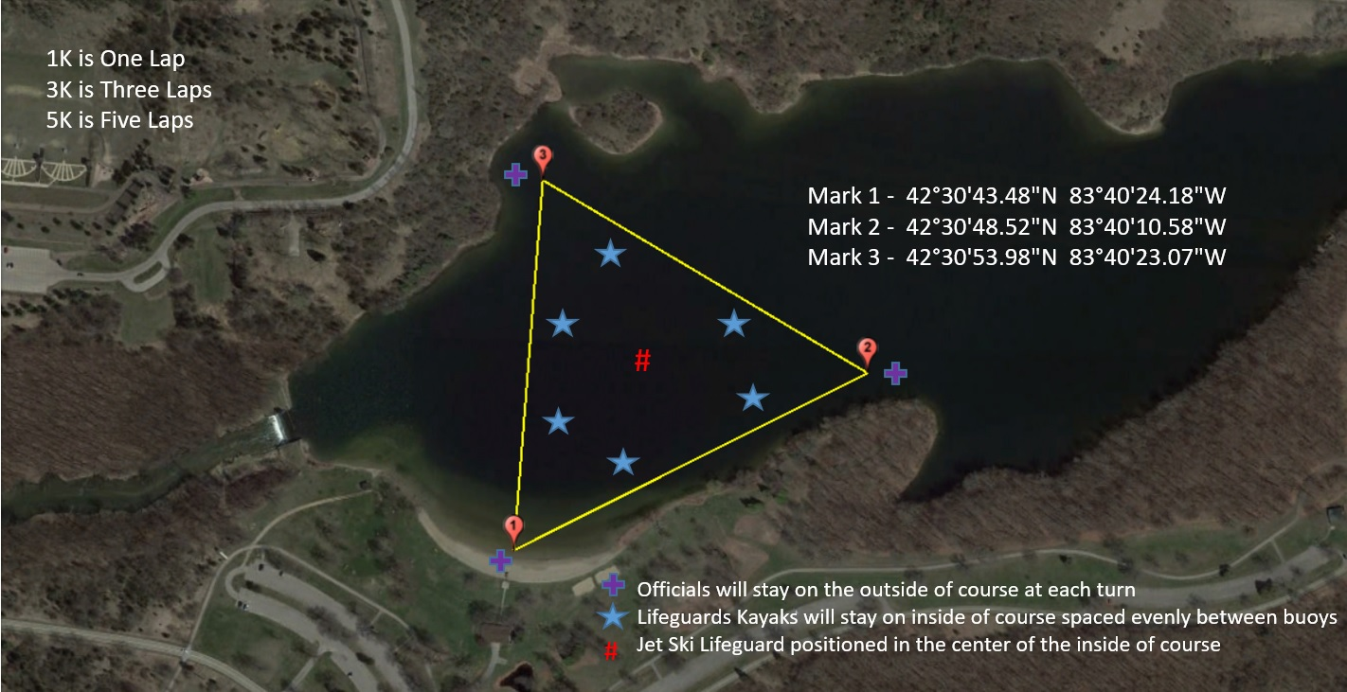
TIMES –
NOTE: All events are unescorted (Exception could be granted for vision impaired athletes, see the Swimmers with a Disability section).

6:00 – 7:00 AM: Officials Meeting
7:00 – 7:15 AM: Mandatory Coaches Meeting
7:00-7:30 am (Deck entries will not be accepted after this time)
7:30-8:00 AM: Check-In
7:30 AM: Course Open for Warm-Up
8:00 – 8:15 AM: Swimmer Pre-Race Meeting - MANDATORY
8:30 AM: 5K Begins
9:30 AM: 3K Begins
10:30 AM: 1K Begins
LODGING – Use your favorite Hotel booking website.
FACILITIES –Kent Lake has a beach front and restroom building. Picnic tables and outdoor grills are located in the area. A registration tent and first aid tent will be available. Water, Gatorade, fruit and energy bars will be available for all participates. Coolers are acceptable to bring into State Recreation Parks- Please note-No alcoholic beverages are permitted on site.
*A State of Michigan Recreational Passport is required for vehicles to enter the park. State of Michigan residents’ vehicle passport is $11.00.
ELIGIBILITY – Penguin Plunge Open Water is for those swimmers age 11 and older. All swimmers must be currently registered with United States of America Swimming (USA-S). A swimmer's age on June 24th will determine his/her eligibility for a particular age group. Athlete must show proof of swimming distances greater than 500yrd/400M in a USA swimming sanctioned meet.
DECK USA SWIMMING REGISTRATION - Unregistered swimmers must register on deck at this meet by turning in the athlete registration form and payment to the Meet Referee. The cost of registering on deck is $10.00 for an open water single event registration.
MEET FORMAT – The following distances are available for swimmers to compete in.
Age 11-12 yrs. Option of 1K or 3K
Age 13 & Over yrs. Option of 1K, 3K or 5K
ENTRY LIMITS - Entries will be accepted on a first come first serve basis by date of email for electronic entries and date of receipt by the Administrative Referee for hard copy entries until meet cap of 250 entrants is made. This event will only be open to the first 250 swimmers. The first 150 entered swimmers will receive a Meet t-shirt with their entry. Swimmers are limited to 1 event for the meet.
SWIMMERS WITHOUT A COACH - All swimmers & Coaches or Swimmer’s legal guardian if under 18yrs of age, must attend mandatory Pre-Race Meeting.
INDIVIDUAL ENTRY LIMITS –Swimmers are limited to 1 event for the meet.
ELECTRONIC ENTRIES - $35.00 per event. Make checks payable to: Huron Valley Schools.
PAPER/EMAILED ENTRIES - MS rules regarding non-electronic entries apply. $36.00 per individual event. Michigan Swimming $1.00 general surcharge for each swimmer also applies to paper entries.
ENTRY PROCEDURES - Entries may be submitted to the Administrative Referee as of June 3rd. The Administrative Referee must receive all entries no later than June 10th. Entries must include correct swimmer name (as registered with USA/MS Swimming), age and USA number. You can import the order of events and event numbers from the Michigan Swimming website (http://www.miswim.org/). All individual entries should be submitted via electronic mail to the Administrative Referee at hvpmeetentries@gmail.com . All entries will be processed in order by email date code or mail date code. Any entries submitted will be considered provisional until such time as the Administrative Referee has received a hard copy of: (a) your club's entries (Team Manager Meet Entries Report), (b) a hard copy of your club's signed release/waiver agreement (c) your clubs signed certification of entered athletes and (d) your club's entry fees. This must be received in a timely fashion prior to the start of the meet or your swimmers will not be allowed to swim in the meet. The complete Penguin Plunge Open Water entry packet with entry forms is available on the Michigan Swimming Website at http://www.miswim.org/
REFUNDS - Once a team or individual entry has been received and processed by the Administrative Official there are no refunds in full or in part unless the “over qualification exception” applies (see MS Rules). Refunds due to poor or inclement weather will be at the discretion of Huron Valley Penguins and are not guaranteed.
ENTRIES- Your Club's Entry, Entry Summary Sheet, Release/Waiver, Certification of Entered Athletes and Check should be sent via U.S. mail or nationally recognized overnight courier to:
Steve Smetana
PO Box 1391,
Highland, MI 48356
hvpmeetentries@gmail.com
(248) 202.7057 – No calls after 9PM

CHECK IN - Check in is required and will be available from 7:15-8:00am. Failure to check in, will cause the swimmer to be scratched from the race. Events will be swum in order. Events may be started prior to the completion of the previous event(s) at the discretion of the Referee. Details of the competition schedule will be discussed during the Clinic. Swimmers must report to the check-in table appropriate for their event # and report to the Meet Volunteer that they are present and prepared to swim. At that time, the swimmers will be briefed regarding instructions for the competition deemed necessary.
MEET WARM-UP PROCEDURES: An area adjacent to the competition will be available for continuous warm-up and warm-down during competition. Swimmers found in the water outside of the designated area and not engaged in competition will be scratched from the meet.
SAFETY PROCEDURES- There will be a mandatory Pre-Race Briefing held before competition begins to discuss the course, rules and safety procedures. The Referee will remove any swimmer from competition who does not attend the clinic or is found to be inattentive during the clinic. Course will be patrolled by qualified safety personnel. Different colored swim caps will be issued to athletes in each distance group so that Meet Management can monitor swimmers’ progress through the course.

ATHLETE ATTITUDE- Athlete conduct will be governed by Part Seven of the USA Swimming Rules and Regulations Handbook. Intentional obstruction, interference or intentional contact with another swimmer may be deemed "Unsporting Impedance" and lead to disqualification. Swimmers shall maintain clearance from other swimmers except at the start, turn, and the finish or where the course or race conditions dictate otherwise. Parents and swimmers should be advised there are a significant number of entrants, open water swimming may be expected to involve inadvertent contact with other swimmers. It is important that swimmers keep a cool head while in the water.

DECK ENTRIES– *DECK ENTRIES WILL ONLY BE ACCEPTED FROM 7-7:30 AM* Deck entries will only be allowed if the race maximum of 250 swimmers is not met. Deck entries will be $45.00. Deck entry swimmers are subject to the Michigan Swimming $1.00 general surcharge. For deck entries, registration status must be proven by providing a current USA Swimming membership card or a current print out of an athlete roster from the Club Portal, the Club Portal is located on the USA Swimming website. The athlete may also enter by showing their membership from USA Swimming’s DECK PASS on a smart phone. Name, athlete ID and club affiliation should then be added to your database just as it appears on the card or list or the swimmer may compete unattached (UN) if they request to do so.
SCORING – Top 16 Girls & Boys 11-12, 13-14 & Open will be scored 1-16.
AWARDS – Top 3 Girls & Boys 11-12, 13-14, and Open in each race distance will receive a trophy.
RESULTS- Complete Official meet results will be posted on the Michigan Swimming Website at http://www.miswim.org/ . Unofficial results will also be available on flash drive (HY-TEK Team Manager result file) upon request. Teams must provide their own flash drive. Unofficial race results will also be posted on the Active Network. Active.com.
CONCESSIONS - Food and beverages will be available at the beach house by vending machine. A hospitality area will be available for coaches and officials. Coolers are permissible on State Park grounds. *No alcoholic beverages allowed.
LOST AND FOUND - Articles may be turned in/picked up at administrative table. Articles not picked up by the end of the meet will be retained by the Meet Director or a representative for at least 14 days (any longer period shall be in the sole discretion of the Meet Director).
SWIMMING SAFETY –
ACCOUNTING FOR SWIMMERS-
- All competitors are pre-assigned Competitor Numbers.
- Each swimmer’s competitor number will be marked on their cap, vertically down the arms, on both hands and horizontally across the back.
- All swimmers must check-in at Clerk of Course, receive their Race Ticket, and be marked with their competitor numbers. Any swimmer not checking in, is scratched.
- All scratches are sent to Admin 30 minutes before each race.
- After the mandatory pre-race Instructional Briefing (Pre-Race Meeting), all athletes enter the pre-race Assembly Area. Referee collects each Race Ticket re-confirming the Athlete Name & Competitor Number markings.
- Any swimmer that decides not to compete, after checking in, the Race Ticket is collected by a Referee, sent to Admin, as a post check-in scratch.

MONITORING SWIMMERS DURING RACE-
- One certified Lifeguard in a kayak for each 100 meters. Emergency Jet Ski for any need for quick removal or return to beach, in the center of the race course.
- All “first responders” shall have the capacity to react to a need for assistance within 10 seconds, and are able to reach the swimmer within an additional 20 seconds.
- Land spotters as well as Officials (in boats at all turn buoys) will also be able to communicate to first responders.

SWIMMERS WITH DISABILITIES - All swimmers are encouraged to participate. If any of your swimmers have special needs or requests please indicate them on the entry form and with the Clerk of Course and/or the Meet Referee during warm ups. We welcome registered athletes with cognitive or physical disabilities, and the Referee will make reasonable accommodations to facilitate participation. We request you notify the Meet Director or the Meet Referee in advance, to allow us to understand the nature of any accommodation being requested.
GENERAL INFORMATION - Any errors or omissions in the program will be documented and signed by the Meet Referee and available for review at the Clerk of Course for Coaches review. Information will also be covered at the Technical Meeting.
FIRST AID - Supplies will be kept in Medical First Aid Tent. EMT will be onsite in case of emergency.
FACILITY ITEMS-
(A) Pursuant to applicable Michigan law, no glass will be allowed on the beach or in the locker rooms.
(B) An Emergency Action Plan has been submitted by the Host Club to the Safety Chair and the Program Operations Chair of Michigan Swimming prior to sanction of this meet and is available for review and inspection at the administrative table.
(C) To comply with USA Swimming privacy and security policy, the use of audio or visual recording devices, including a cell phone, is not permitted in changing areas, rest rooms or locker rooms.
(D) Changing, in whole or in part, into or out of a swimsuit when wearing just one suit in an area other than a permanent or temporary locker room, bathroom, changing room or other space designated for changing purposes is prohibited.
(E) Operation of a drone, or any other flying apparatus, is prohibited over the venue (pools, athlete/coach areas, spectator areas and open ceiling locker rooms) any time athletes, coaches, officials and/or spectators are present.

MEET DIRECTOR –
Janette Heaton coach_janette@yahoo.com
Meghan Penny mmp0711@gmail.com
MEET REFEREE –
Chip Carrigan chip.carrigan@gmail.com
MEET ADMINISTRATIVE REFEREE -
Paul Jones PWJ6@outlook.com
SAFETY MARSHAL –
Melissa Millerick-May Melissa.May@miswim.org
START/FINISH- A “beach start” and a “beach finish” will be used for each individual event.
TIME LIMITS- Swimmers must finish within 30 minutes of the first swimmer in their event to be eligible for scoring and award.
OFFICIALS- We welcome all USA Swimming Certified Officials, and you may receive your certification as an Open Water Judge or Open Water Referee at this meet. Please refer to the USA Swimming website for complete certification requirements. The on-line tests for Open Water Judge and Open Water Referee can be found on the USA Swimming website in the Officials Section.
SEEDING/CONDUCT-
- All swimmers must report to the check in area prior to the mandatory safety briefing for their competitor number, body marking, and cap.
- Please make sure that fingernails and toenails are trimmed and all jewelry and watches are removed prior to the morning registration. Swimmers must be nail-checked before body marking.
- There will be no penalty for scratching; entry fees will not be refunded.
- Athletes must notify the Clerk of Course if they decide to scratch from their event after completing registration.
- No swimmer shall be allowed to use or wear any device that may be an aid
to his/her speed.

OPEN WATER EVENTS
EVENT # | AGE | DIST | TYPE
1 | 13 & O | 5 Kilometer | Individual
2 | 11 & O | 3 Kilometer | Individual
3 | 11 & O | 1 Kilometer | Individual

*ALL NON-USA SWIMMING APPLICANTS MUST SUBMIT THE BELOW FORM AT CHECK-IN LOCATED ON MICHIGANSWIMMING.COM>ATHLETES>OPEN WATER APPLICATION.
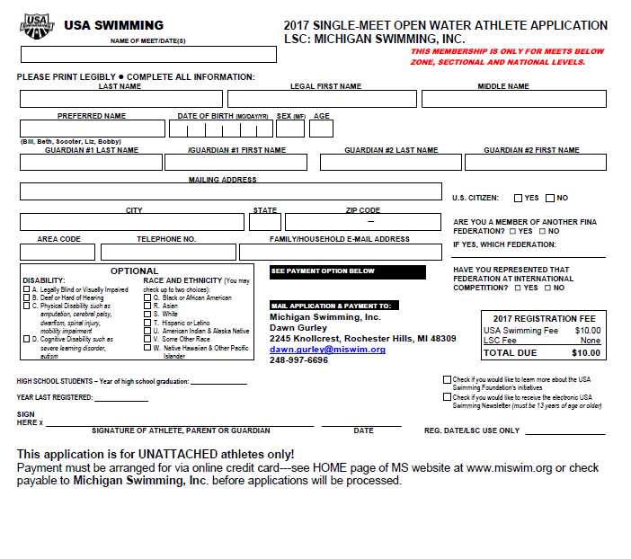

RELEASE AND WAIVER
Sanction Number: MI1617131
Enclosed is a total of $__________ covering fees for all the above entries. In consideration of acceptance of this entry I/We hereby, for ourselves, our heirs, administrators, and assigns, waive and release any and all claims against Huron Valley Penguins, State of Michigan, Island Lake State Recreation Area or Michigan Department of Natural Resources (DNR), Michigan Swimming, Inc., and United States Swimming, Inc. for injuries and expenses incurred by Me/Us at or traveling to this swim meet.
>>>>>>>>>>>>>>>>>>>>>>>>>>>>>>>>>>>>>>>>>>>>>>>>>>>>>>>>>
In granting the sanction it is understood and agreed that USA Swimming and Michigan Swimming, Inc. shall be free from any liabilities or claims for damages arising by reason of injuries to anyone during the conduct of this event.
Signature:
Position:
Street Address:
City, State, Zip:
E-mail:
Coach Name:
Coach Phone:
Coach E-Mail:
Club Name:
Club Code: ______________________________________________________________

Certification of Registration Status
Of All Entered Athletes
Penguin Plunge Open Water Meet
Sanction Number: MI1617131
Michigan Swimming Clubs must register and pay for the registration of all athletes that are contained in the electronic TM Entry File or any paper entries that are submitted to the Meet Host with the Office of Michigan Swimming prior to submitting the meet entry to the meet host. Clubs from other LSCs must register and pay for the registration of their athletes with their respective LSC Membership Coordinator.
A penalty fee of $100.00 per unregistered athlete will be levied against any Club found to have entered an athlete in a meet without first registering the athlete and paying for that registration with the Office of Michigan Swimming or their respective LSC Membership Coordinator.
Submitting a meet entry without the athlete being registered and that registration paid for beforehand may also subject the Club to appropriate Board of Review sanctions.
The authority for these actions is:
UNITED STATES SWIMMING RULES AND REGULATIONS 302.4 FALSE REGISTRATION – A host LSC may impose a fine of up to $100.00 per event against a member Coach or a member Club submitting a meet entry which indicates a swimmer is registered with USA Swimming when that swimmer or the listed Club is not properly registered. The host LSC will be entitled to any fines imposed.
>>>>>>>>>>>>>>>>>>>>>>>>>>>>>>>>>>>>>>>>>>>>>>>>>>>>>>>>>
I certify that all athletes submitted with this meet entry are currently registered members of USA Swimming and that I am authorized by my Club to make this representation in my listed capacity.
By: ________________________________________
(Signature)
__________________________________________
(Printed Name of person signing above)
Capacity: __________________________________
Club Name: _________________________________
Date: ______________________________________

This form must be signed and returned with the entry or the entry will not be accepted.

Meet Evaluation Form
Sanction Number: MI1617131
Name of Meet: Penguins Plunge Open Water Meet
Date of Meet: June 24, 2017
Host of Meet: Huron Valley Penguins
Place of Meet: Island Lakes State Recreation Area (Kent Lake)- Brighton MI
Who do you represent (circle)? Host Club Visiting Club Unattached
Describe yourself (circle) Athlete Coach Official Meet Worker Spectator
Please rate the overall quality of this meet:
(Please write any comments or suggestions below or on the reverse side)
Low High
1. Swimming pool (e.g., water quality, ventilation) 1 2 3 4 5
_______________________________________________________________________________
2. Equipment (e.g., timing system, PA system): 1 2 3 4 5
_______________________________________________________________________________
3. Swimmer facilities (e.g., locker rooms, rest areas): 1 2 3 4 5
_______________________________________________________________________________
4. Spectator facilities (e.g., seating, rest rooms): 1 2 3 4 5
_______________________________________________________________________________
5. Meet services (e.g., concessions, admissions, programs): 1 2 3 4 5
_______________________________________________________________________________
6. Officiating 1 2 3 4 5
_______________________________________________________________________________
7. Awards and award presentations: 1 2 3 4 5
_______________________________________________________________________________
8. Safety provisions: 1 2 3 4 5
_______________________________________________________________________________
9. Overall success of the meet: 1 2 3 4 5
______________________________________________________________________________
10. Other (please specify): 1 2 3 4 5
______________________________________________________________________________
Return this completed evaluation to a representative of the Meet Host. Thank you.
Meet Host: Copy all of these submitted Meet Evaluations to the current Program Operations Vice-Chair (Joe McBratnie) and the Michigan Swimming Office (Dawn Gurley and John Loria) within 30 days.

