USA SWIMMING
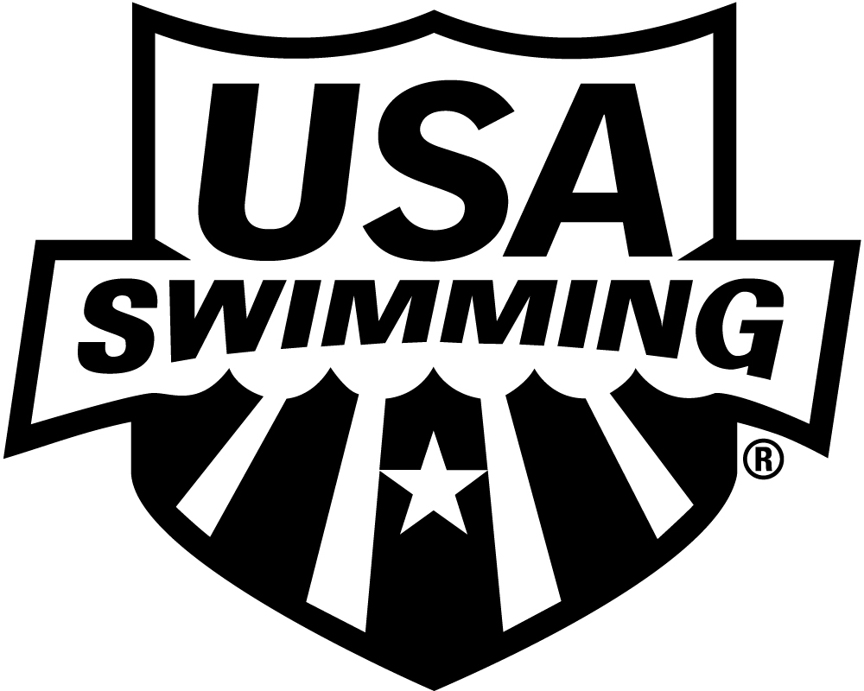

2017 APPRENTICE OFFICIAL APPLICATION INITIAL TRAINING

LSC: MICHIGAN SWIMMING, INC. SESSION DATE:
PLEASE PRINT LEGIBLY  COMPLETE ALL INFORMATION TO ENSURE THAT CONTACT INFORMATION IS CORRECT AND UP TO DATE:

LAST NAME LEGAL FIRST NAME MIDDLE NAME

Have you ever been a member of USA Swimming under a different last name? If yes, please provide that name:

Previously registered with USA Swimming? □ Yes □ No If registered in a different LSC, which LSC:

PREFERRED NAME DATE OF BIRTH (MO/DAY/YR) SEX (M/F) CLUB CODE CLUB NAME

(Bill, Beth, Scooter, Liz, Bobby) If not affiliated with a club, enter “Unattached”

MAILING ADDRESS

CITY STATE ZIP CODE

–

AREA CODE TELEPHONE NO. AREA CODE TELEPHONE NO. E-MAIL ADDRESS

HOME MOBILE

THIS APPRENTICE OFFICIAL STATUS EXPIRES 60 DAYS FROM THE DATE OF THE INITIAL TRAINING SESSION. CONTACT YOUR LSC OFFICIALS CHAIR FOR FURTHER INSTRUCTIONS.

MAIL OR EMAIL APPLICATION TO:
LSC OFFIICIALS CHAIR:

Dawn Gurley Steve Weeks
2245 Knollcrest steve.weeks@miswim.org
Rochester Hills, MI 48309
dawn.gurley@miswim.org

