Integrity, Inclusion, Education, Excellence
Cruisin’ into Summer
Hosted By: Plymouth Canton Cruisers
May 17-19, 2019

Sanction - This meet is sanctioned by Michigan Swimming, Inc. (MS), as a timed final meet on behalf of USA Swimming (USA-S), Sanction Number MI1819110. In granting this sanction it is understood and agreed that USA Swimming shall be free from any liabilities or claims for damages arising by reason of injuries to anyone during the conduct of the event. MS rules, safety, and warm up procedures will govern the meet as is fully set forth in these meet rules.
Location - Eastern Michigan University
Olds-Robb Student Recreation Building
100 Olds/Robb
Ypsilanti, Michigan 48197

Directions: http://www.emich.edu/recim/directions.htm

NOTE: The REC/IM Building will be undergoing signifiant construction during the meet. The entrance to the pool will be on the backside of building at the doors where the diving boards are/current emergency doors. (See parking information and a map at the end of the packet). PCC volunteers and signs will be posted to help direct swimmers and spectators.

Times –
Session | Warm-Up/Check-in Closes | First Event
Friday Evening | 5:00pm / 5:15pm | 6:00pm
Saturday Morning | 7:30am / 7:45am | 8:30am
Saturday Afternoon | 12:30pm / 12:45pm | 1:30pm
Saturday Evening | 5:00pm / 5:15pm | 5:45 pm
Sunday Morning  Sunday Afternoon | 7:30am / 7:45am  12:30pm / 12:45pm | 8:30am  1:30pm

Motels – Use your favorite Hotel booking website.
Facilities - Michael Jones pool in the Olds-Robb Student Recreation is a 10 lane, 50 meter pool. Depth at start is 12’0’’ and 4’0’’ at turn. Permanent starting blocks and non-turbulent lane markers will be used. Daktronics timing with a 10 lane display will be used. A separate warm-up pool is available at the facility. There is ample balcony seating for spectators. Lockers are available (provide your own lock). Public phones will be available. The competition course has not been certified in accordance with 104.2.2C (4).
Eligibility Cruisin’ Into Summer is for A/B/C swimmers.All swimmers must be currently registered with United States of - America Swimming (USA-S). A swimmer's age on May 17, 2019 will determine his/her eligibility for a particular age group.
Deck Registration - Unregistered swimmers must register on deck at this meet by turning in the athlete registration form and payment to the Meet Referee. The cost of registering on deck is double the normal fee ($156.00 per swimmer for 2018-19 registration).
Meet Format - Cruisin’ Into Summer is an A/B/C timed finals competition.
- Friday Evening Session is 400 IM and 400 Free for all ages
- Saturday/Sunday AM Sessions are 14 and under
- Saturday/Sunday Afternoon Sessions are 11 and over
- Saturday Evening Session is Open 800m Freestyle
Entry Limits - Entries will be accepted on a first come first serve basis by date of email for electronic entries and date of receipt by the Administrative Official for hard copy entries until the Michigan Swimming Four (4) hour per session maximum time limit is met. As set forth in entry procedures below, (A) a hard copy of your club’s entry summary sheet, (B) a hard copy of your club’s signed release/waiver agreement (C) your club’s certification of entered athletes and (D) your club’s entry and entry fees must be received by the Entry Chair in a timely fashion prior to the start of the meet, or your swimmers will not be allowed to swim in the meet. Entries received after the four (4) hour per session time limit has been met will be returned even if received before the entry deadline.
Swimmers Without A Coach - Any swimmer entered in the meet, unaccompanied by a USA-S member coach, must be certified by a USA-S member coach as being proficient in performing a racing start or must start each race from within the water. It is the responsibility of the swimmer or the swimmer’s legal guardian to ensure compliance with this requirement.
Individual Entry Limits - Swimmers may enter and swim a maximum of two (2) events on Friday, four (4) events on Saturday plus the 800m Freestyle and four (4) events on Sunday for a maximum of eleven (11) events for the entire meet.
Electronic Entries - $5.00 per individual event. Please include a $1.00 Michigan Swimming surcharge for each swimmer entered. Make checks payable to: Plymouth Canton Cruisers.
Paper Entries - MS rules regarding non-electronic entries apply. $6.00 per individual event. There is a $1.00 additional charge per individual event paid if the entry is not submitted in Hy-Tek format. The Michigan Swimming $1.00 general surcharge for each swimmer also applies to paper entries. Paper entries may be submitted to the Administrative Official on a spreadsheet of your choice however the paper entry must be logically formatted and must contain all pertinent information to allow the Administrative Official to easily enter the swimmer(s) in the correct events with correct seed times.
Entry Procedures - Entries may be submitted to the Administrative Official as of Monday, April 29 at 11:00 AM. The Administrative Official must receive all entries no later than Sunday, May 12 at 11:00 PM. Entries must include correct swimmer name (as registered with USA/MS Swimming), age and USA number. You can import the order of events and event numbers from the Michigan Swimming website (http://www.miswim.org/). All individual entries should be submitted via electronic mail to the Administrative Official at SwimEntriesLL@yahoo.com . All entries will be processed in order by email date code or mail date code. Any entries submitted will be considered provisional until such time as the Administrative Official has received a hard copy of: (a) your club's entries (Team Manager Meet Entries Report), (b) a hard copy of your club's signed release/waiver agreement (c) your clubs signed certification of entered athletes and (d) your club's entry fees. This must be received in a timely fashion prior to the start of the meet or your swimmers will not be allowed to swim in the meet. The complete Cruisin’ into Summer entry packet with entry forms is available on the Michigan Swimming Website at http://www.miswim.org/
Refunds - Once a team or individual entry has been received and processed by the Administrative Official there are no refunds in full or in part unless the “over qualification exception” applies (see MS Rules).
Entries - Your club's Entry, Entry Summary Sheet, Release/Waiver, Certification of Entered Athletes and Check should be sent via U.S. mail or nationally recognized overnight courier to:
Plymouth Canton Cruisers
PO Box 5306
Plymouth, MI 48170
Lisa Lambert SwimEntriesLL@yahoo.com
Check In - Check in will be required. Check in will be available at least 15 minutes If mandatory check in is used, it will be required by the time set forth in this meet announcement. Failure to check in, if required, it will cause the swimmer to be scratched from all events in that session. Check in will close 15 minutes after the start of warm up for each session. Check in sheets will be posted on deck adjacent to the locker rooms.
Scratch Rules - Prior to check in close a swimmer may scratch events at the Clerk of Course. After check in closes, you must see the Meet Referee to scratch an event.
Marshaling - This is a self-marshaled meet. Heat sheets will be posted in well-trafficked areas around the pool deck. Swimmers will be responsible for reporting to the marshaling area when their event is called. At least one heat sheet will be posed in the spectator area to comply with Michigan Swimming Rules and Procedures.
Seeding - Seeding will be done after positive check-in closes. Swimmers who fail to check in for an event will be scratched from that event.
All events are timed finals and will be seeded slowest to fastest except for Open 400m IM (#5-6) and Open 800m Freestyle (#29-30) which will be seeded fastest to slowest alternating gender, girls followed by boys.
The Meet Referee reserves the right to combine genders and/or same stroke/distance events in order to reduce the number of heats.

Deck Entries/Time Trials – Time Trials will not be offered. Deck entries may be accepted if time and space permit, and at the sole discretion of the Meet Referee and Meet Director. Deck entries are $7.00 per individual event. Deck entry swimmers are subject to the Michigan Swimming $1.00 general surcharge if they are not already entered in the meet. For deck entries, registration status must be proven by providing a current USA Swimming membership card or a current print out of an athlete roster from the Club Portal, the Club Portal is located on the USA Swimming website. The athlete may also enter by showing their membership from USA Swimming’s DECK PASS on a smart phone. Name, athlete ID and club affiliation should then be added to your database just as it appears on the card or list or the swimmer may compete unattached (UN) if they request to do so.
Meet Programs/Admissions - Admission costs $5.00 per person per day for individuals over the age of 12. There is no admission charge for children age 12 and under. Heat Sheets will be available for purchase ($3) shortly after the beginning of the events.
Scoring - No individual or team scoring that will be kept.
Awards – Ribbons will be only awarded for 10 and under and 11/12 for Friday night and Saturday/Sunday morning events only. The top 8 swimmers in the A, B, and C divisions will be awarded.
Results - Complete Official meet results will be posted on the Michigan Swimming Website at http://www.miswim.org/ . Unofficial results will also be available on flash drive (HY-TEK Team Manager result file) upon request. Teams must provide their own flash drive.
Concessions - Food and beverages will be available in EMU concession counter in the Rec/IM lobby. A hospitality area will be available for coaches and officials.
Lost and Found - Articles may be turned in/picked up next to Admin table on deck. Articles not picked up by the end of the meet will be retained by the Meet Director or a representative for at least 14 days (any longer period shall be in the sole discretion of the Meet Director).
Swimming Safety - Michigan Swimming warm up rules will be followed. To protect all swimmers during warm-ups, swimmers are required to enter the pool feet first at all times except when sprint lanes have been designated. No jumping or diving. The same rules will apply with respect to the warm-down pool and diving well. Penalties for violating these rules will be in the sole discretion of the Meet Referee which may include ejection from the meet.
Deck Personnel/Locker Rooms/Credentialing - Only registered and current coaches, athletes, officials and meet personnel are allowed on the deck or in locker rooms. Access to the pool deck may only be granted to any other individual in the event of emergency through approval by the Meet Director or the Meet Referee. The General Chair of MS, Program Operations Vice-Chair of MS, Officials Chairs of MS, and the Michigan Swimming Office staff are authorized deck personnel at all MS meets. Personal assistants/helpers of athletes with a disability shall be permitted when requested by an athlete with a disability or a coach of an athlete with a disability.
Lists of registered coaches, certified officials and meet personnel will be placed in the hallway outside the locker rooms/pool deck. Meet personnel will check the list of approved individuals and issue a credential to be displayed at all times during the meet. This credential will include the Plymouth Canton Cruiser logo as well as the function of the individual being granted access to the pool deck (Coach, Official, Timer, or Meet Personnel). In order to obtain a credential, Coaches and Officials must be current in all certifications through the final date of the meet. Meet personnel must return the credential at the conclusion of working each day and be reissued a credential daily.
All access points to the pool deck and locker rooms will either be secured or staffed by a meet worker checking credentials throughout the duration of the meet.
Swimmers with Disabilities - All swimmers are encouraged to participate. If any of your swimmers have special needs or requests please indicate them on the entry form and with the Clerk of Course and/or the Meet Referee during warm ups.
General Info - Any errors or omissions in the program will be documented and signed by the Meet Referee and available for review at the Clerk of Course for Coaches review. Information will also be covered at the Coaches’ Meeting.
First Aid - Supplies will be kept in on deck with the EMU Rec/IM personnel.
Facility Items –
(A) No smoking is allowed in the building or on the grounds of Eastern Michigan University.
(B) Pursuant to applicable Michigan law, no glass will be allowed on the deck of the pool or in the locker rooms.
(C) No bare feet allowed outside of the pool area. Swimmers need to have shoes to go into the hallway to awards or concessions.
(D) An Emergency Action Plan has been submitted by the Host Club to the Safety Chair and the Program Operations Chair of Michigan Swimming prior to sanction of this meet and is available for review and inspection at Eastern Michigan Jones Pool.
(E) To comply with USA Swimming privacy and security policy, the use of audio or visual recording devices, including a cell phone, is not permitted in changing areas, rest rooms or locker rooms.
(F) Deck changing, in whole or in part, into or out of a swimsuit when wearing just one
suit in an area other than a permanent or temporary locker room, bathroom,
changing room or other space designated for changing purposes is prohibited.
(G) Operation of a drone, or any other flying apparatus, is prohibited over the venue (pools, athlete/coach areas, spectator areas and open ceiling locker rooms) any time athletes, coaches, officials and/or spectators are present.

.
Meet Director - Dan Tabar / 248-451-4287
Meet Referee - Jeff Wilkins /313-574-3638 jeffrey.wilkins@comcast.net
Safety Marshal – Mike Breda
Administrative Official - Lisa Lambert
SwimEntriesLL@yahoo.com

Cruisin’ into Summer
Hosted By: Plymouth Canton Cruisers
May 17-19, 2019
Sanction Number: MI1819110

Friday, May 17th Evening Events
Warm-up: 5:00pm Events: 6:00pm
Girls | Event | Boys
1 | 13 & Over 400m Freestyle | 2
3 | 12 & Under 400m Freestyle | 4
5 | 11 & Over 400m IM | 6

Saturday, May 18th Morning Events
Warm-Up: 7:30am Events: 8:30am
Girls | Event | Boys
7 | 14 & Under 200m Freestyle | 8
9 | 14 & Under 50m Backstroke | 10
11 | 14 & Under 100m Breaststroke | 12
13 | 14 & Under 50m Butterfly | 14
15 | 11 -14 200m Butterfly | 16
17 | 14 & Under 100m Freestyle | 18

Saturday, May 18th Afternoon Events
Warm-Up: 12:30pm Events: 1:30pm
Girls | Event | Boys
19 | 11 & Over 100m Freestyle | 20
21 | 11 & Over 200m Butterfly | 22
23 | 11 & Over 100m Backstroke | 24
25 | 11 & Over 200m Breaststroke | 26
27 | 11 & Over 50m Freestyle | 28

Cruisin’ into Summer
Hosted By: Plymouth Canton Cruisers
May 17-19, 2019
Sanction Number: MI1819110

Saturday, May 18th Evening Events
Warm-Up: 5:00pm (club pool) Events: 5:45pm
Girls | Event | Boys
29 | Open 800m Freestyle | 30

Sunday, May 19th Morning Events
Warm-Up: 7:30am Events: 8:30am
Girls | Event | Boys
31 | 14 & Under 200m IM | 32
33 | 14 & Under 50m Breaststroke | 34
35 | 11 - 14 200m Breaststroke | 36
37 | 14 & Under 100m Butterfly | 38
39 | 14 & Under 50m Freestyle | 40
41 | 14 & Under 100m Backstroke | 42
43 | 11 - 14 200m Backstroke | 44

Sunday, May 19th Afternoon Events
Warm-Up: 12:30pm Events: 1:30pm
Girls | Event | Boys
45 | 11 & Over 200m IM | 46
47 | 11 & Over 100m Breaststroke | 48
49 | 11 & Over 200m Backstroke | 50
51 | 11 & Over 100m Butterfly | 52
53 | 11 & Over 200m Freestyle | 54

CERTIFICATION OF REGISTRATION STATUS OF ALL ENTERED ATHLETES
RELEASE AND WAIVER
Cruisin’ into Summer
Sanction Number: MI1819110
Enclosed is a total of $__________ covering fees for all the above entries. In consideration of acceptance of this entry I/We hereby, for ourselves, our heirs, administrators, and assigns, waive and release any and all claims against Plymouth Canton Cruisers, Eastern Michigan University, Michigan Swimming, Inc., and United States Swimming, Inc. for injuries and expenses incurred by Me/Us at or traveling to this swim meet.
>>>>>>>>>>>>>>>>>>>>>>>>>>>>>>>>>>>>>>>>>>>>>>>>>>>>>>>>>
In granting the sanction it is understood and agreed that USA Swimming and Michigan Swimming, Inc. shall be free from any liabilities or claims for damages arising by reason of injuries to anyone during the conduct of this event.
Michigan Swimming Clubs must register and pay for the registration of all athletes that are contained in the electronic TM Entry File or any paper entries that are submitted to the Meet Host with the Office of Michigan Swimming prior to submitting the meet entry to the meet host. Clubs from other LSCs must register and pay for the registration of their athletes with their respective LSC Membership Coordinator.
A penalty fee of $100.00 per unregistered athlete will be levied against any Club found to have entered an athlete in a meet without first registering the athlete and paying for that registration with the Office of Michigan Swimming or their respective LSC Membership Coordinator.
Submitting a meet entry without the athlete being registered and that registration paid for beforehand may also subject the Club to appropriate Board of Review sanctions.
The authority for these actions is: UNITED STATES SWIMMING RULES AND REGULATIONS 302.4 FALSE REGISTRATION – A host LSC may impose a fine of up to $100.00 per event against a member Coach or a member Club submitting a meet entry which indicates a swimmer is registered with USA Swimming when that swimmer or the listed Club is not properly registered. The host LSC will be entitled to any fines imposed.
>>>>>>>>>>>>>>>>>>>>>>>>>>>>>>>>>>>>>>>>>>>>>>>>>>>>>>>>>
I certify that all athletes submitted with this meet entry are currently registered members of USA Swimming and that I am authorized by my Club to make this representation in my listed capacity.
Signature: | Position:
Street Address: | City, State Zip:
Club Email: | Phone:
Coach Name: | Club Name:
Coach Email: | Club Code:

Meet Evaluation Form
Sanction Number: MI1819110
Name of Meet: Cruisin’ into Summer
Date of Meet: May 17-19, 2019 _______
Host of Meet: Plymouth Canton Cruisers
Place of Meet: Eastern Michigan University
Who do you represent (circle)? Host Club Visiting Club Unattached
Describe yourself (circle) Athlete Coach Official Meet Worker Spectator
Please rate the overall quality of this meet:
(Please write any comments or suggestions below or on the reverse side)
Low High
1. Swimming pool (e.g., water quality, ventilation) 1 2 3 4 5
_______________________________________________________________________________
2. Equipment (e.g., timing system, PA system): 1 2 3 4 5
_______________________________________________________________________________
3. Swimmer facilities (e.g., locker rooms, rest areas): 1 2 3 4 5
_______________________________________________________________________________
4. Spectator facilities (e.g., seating, rest rooms): 1 2 3 4 5
_______________________________________________________________________________
5. Meet services (e.g., concessions, admissions, programs): 1 2 3 4 5
_______________________________________________________________________________
6. Officiating 1 2 3 4 5
_______________________________________________________________________________
7. Awards and award presentations: 1 2 3 4 5
_______________________________________________________________________________
8. Safety provisions: 1 2 3 4 5
_______________________________________________________________________________
9. Overall success of the meet: 1 2 3 4 5
______________________________________________________________________________
10. Other (please specify): 1 2 3 4 5
______________________________________________________________________________
Return this completed evaluation to a representative of the Meet Host. Thank you.
Meet Host: Copy all of these submitted Meet Evaluations to the current Program Operations Vice-Chair (Shawn Kornoelje) and the Michigan Swimming Office (Dawn Gurley) within 30 days.

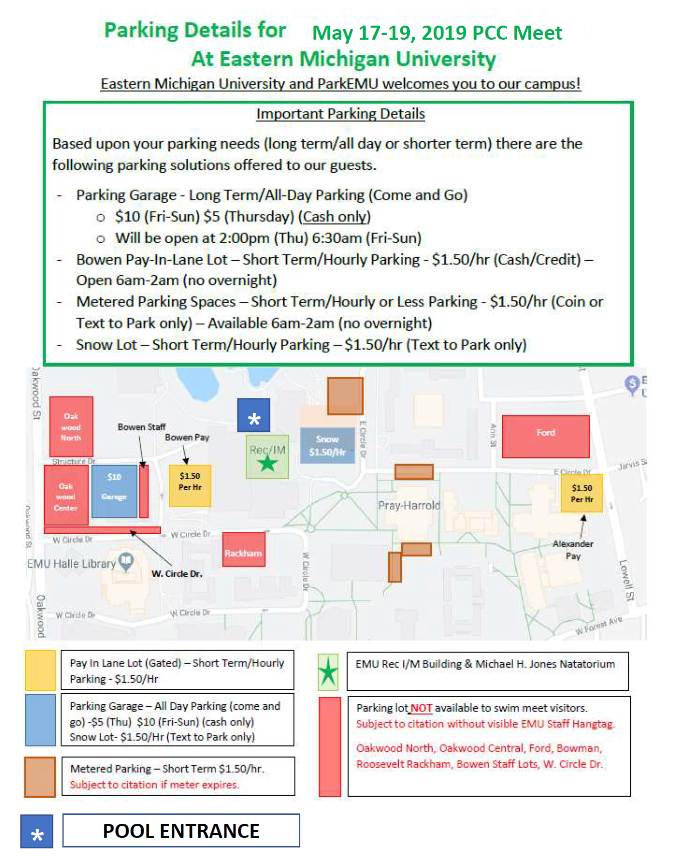

Depth at Start must meet State of Michigan requirements.

