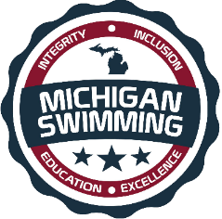
AQUA CLUB (AQUA) & Michigan Swimming
NEW OFFICIAL TRAINING CLINIC

- WHAT:
  - AQUA CLUB & MICHIGAN SWIMMING ARE HOSTING A “NEW” OFFICIALS TRAINING CLINIC.

- WHERE:
  - Online Conference Call
  - Comfort of your own home

- WHEN:
  - May 02, 2019
  - 6:30 PM (2 hours or less)

- WHO:
  - THIS CLINIC IS FOR ANYONE INTERESTED IN BECOMING A MICHIGAN SWIMMING CERTIFIED STROKE AND TURN OFFICIAL.
  - PARTICIPANTS ON THE CALL WILL BE INVITED TO BEGIN APPRENTICING AT THE AQUA MEET ON SATURDAY MAY 4TH. AT EASTERN MICHIGAN UNIVERSITY (EMU)

- RSVP:
  - THE CONFERENCE CALL INFORMATION WILL BE SENT TO ALL THOSE THAT REGISTER.
  - RESERVE YOUR SPOT NOW BY CLICKING ON THE LINK BELOW, OR BY GOING TO THE MISWIM.ORG/OFFICIALS WEBSITE AND OPEN CLINICS TAB FOR REGISTRATION

  - Registration for NEW Officials Training Clinic

