Northville Park Association
2800 Leelanau Drive NE, Grand Rapids, MI 49525
Website: https://www.northvillepark.org/
Contact if you get lost: Heather 616-822-3117
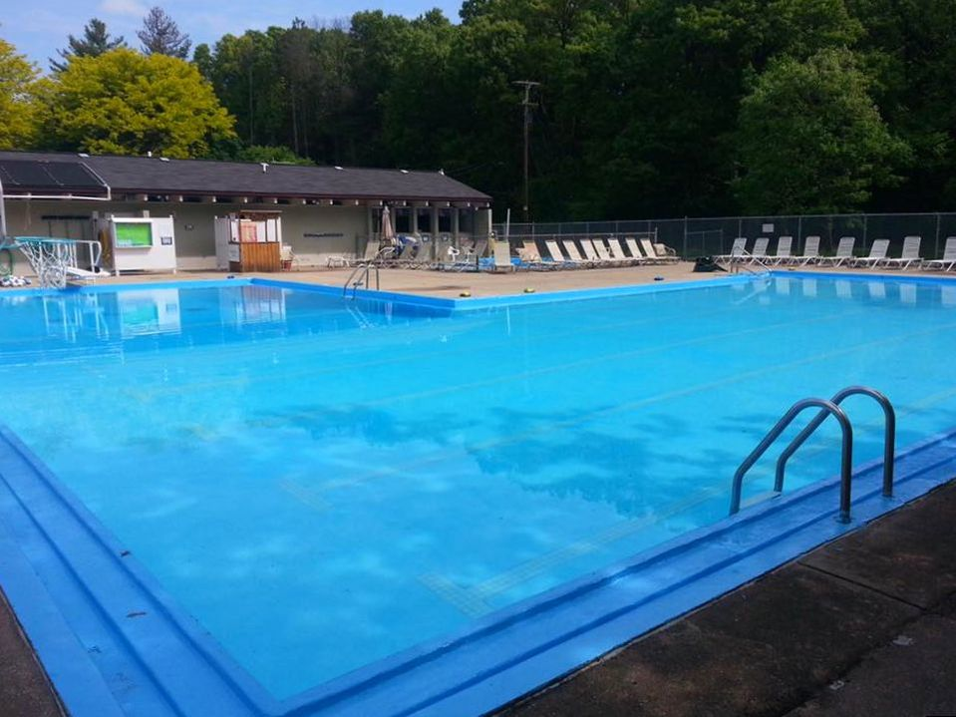

Directions – You can access Leelanau Drive from Northville Drive off of either 5 Mile Road or Plainfield Avenue (the map shows the Plainfield route). It is tucked in a suburban community and there is a small sign at the end of the driveway that says Northville Park Association. You will drive down the drive, drop of your athlete, and then look around to the left in the turnaround through the trees. The parking lot is small and narrow.

