Shoulder Health Action Plan
- Posture: In AND out of the pool
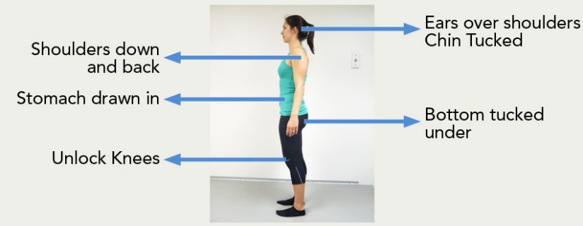
Optimal posture = longer reach (distance per stroke) and stronger pull
Well-aligned posture allows arms and legs to maximize their flexibility and puts muscles in a position where they can exert the most power.

- Thoracic (middle) Spine Flexibility: rotation, flexion, extension

  - Foam roller and bench
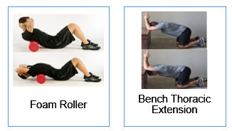
  - Diagonals “chop and lift” in tall or half kneel
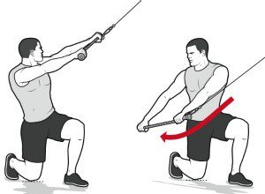
  - Quadruped (Hands and knees) Thoracic Rotation
  - Huge array of yoga positions: cat-cow, sun salutation, etc
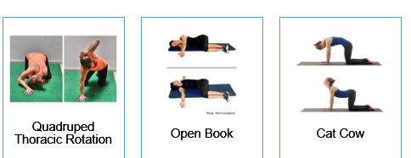

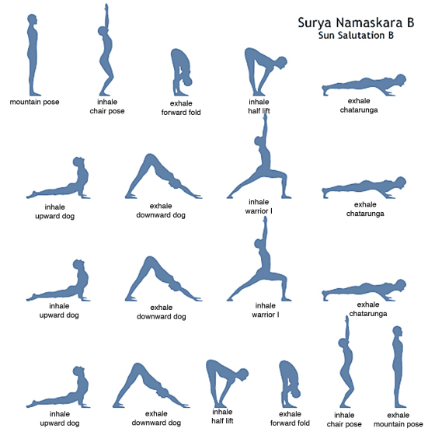

- Scapular (shoulder blade) Stability
Proximal stability before distal mobility – need a stable base (core) for the muscles in arms and legs to exert lots of force

How to strengthen?

    - Scapular Setting – squeeze your shoulder blades back together and down as though you’re putting them into opposite back pockets. This is a basic part of all good posture and should be how to begin and what you re-check many times throughout any exercise program.
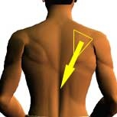

    - Prone squeeze and lift (the letter I):
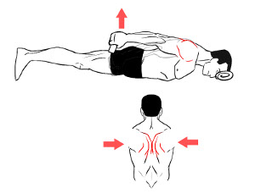
    - Prone bent squeeze and lift (the letter T): 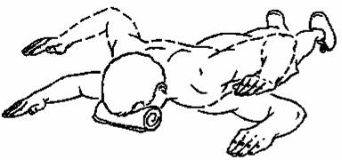

    - Non-streamline superman (the letter Y)

    - Prone or quadruped opposite arm/leg lift

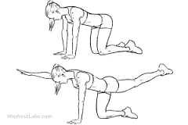
    - Rows – in any position, elbows out OR to sides, goal is to squeeze your shoulder blades together and down as you pull back
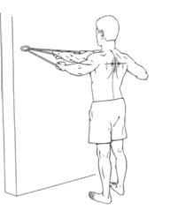
    - Push-up with a ‘plus’ – normal push-up with a stable trunk from feet, knees, or against wall. Hold plank position and press up another inch or so as you feel your shoulder blade slide out to the side.
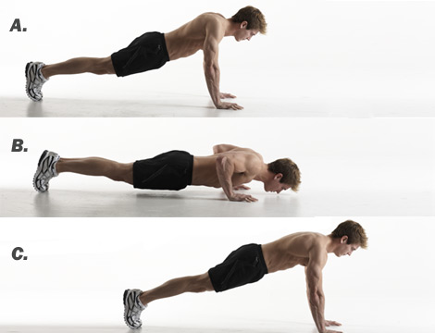

- Rotator Cuff Strengthening

  - Internal rotation and external rotation – hold elbow at side and rotate hand towards or away from body
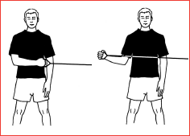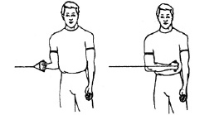
  - Forward flexion, abduction, and “scaption”:
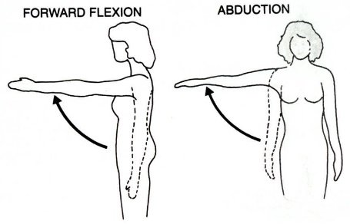
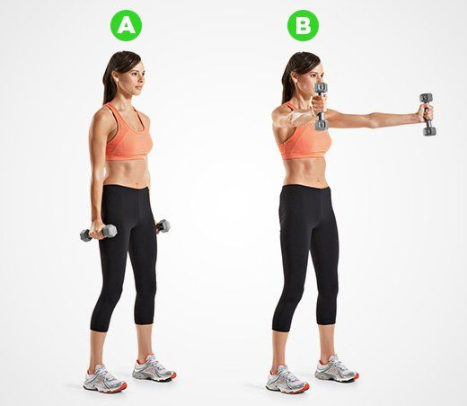

- Technique! Focus points:
  - Rotation:
    - stable trunk, shoulders and hips rotate together
    - Head is steady (rudder)
  - Entry:
    - In front of shoulder
    - Middle finger first (magic dot)
  - Catch:
    - Move from straight elbow to boomerang position, hand remains in line with shoulder
  - Pull:
    - Shoulder safe zone
    - Maintain boomerang throughout
    - “in-line” pull
    - Pull is powered by trunk rotation
  - Recovery:
    - High elbow to encourage rotation
    - Hand relaxed and swings wide
  - REMEMBER:
- Form before intensity
- Rapid increase in intensity increases rate of injury. Consider increasing dry-land preparation and off-season training to minimize injuries

