Shoulder Health Action Plan
How to set your shoulders up for success before entering the pool:

- Posture: Maintaining optimal posture in and out of the pool helps you to maximize your flexibility and puts your muscles in a position where they can exert the most power. Optimizing your posture will yield a longer reach (greater distance per stroke) and a more powerful pull while also improving your alignment on each stroke (decreasing any “wiggle”).
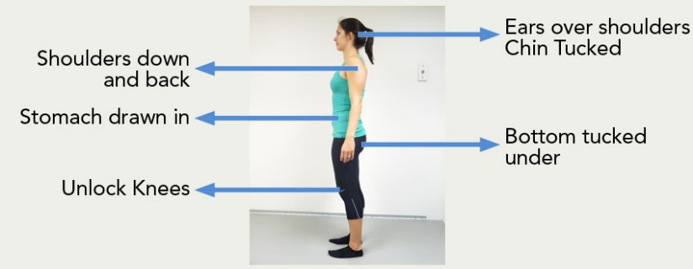

- Thoracic Spine Mobility:
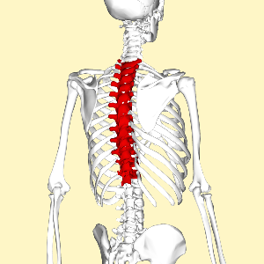
If your thoracic spine is “tight” or inflexible, your shoulders get overstretched with each stroke you take or streamline you attempt. Increasing the flexibility in your mid-spine improves your alignment in streamlines off the wall as well as in your “body line” positions, the extended phase of each stroke. Activities that flex, extend or rotate your thoracic spine while stabilizing your lumbar spine (low back) will improve your thoracic spine mobility.

- Scapular Stability:
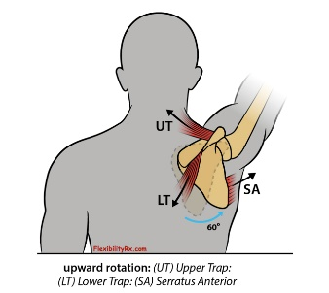
Your scapula, or shoulder blade, is stabilized on your back by a number of very strong muscles. As you reach overhead your scapula rotates out to allow for a greater range of motion. If the muscles that stabilize it are weak, it may move too far too fast and allow excessive motion around your shoulder joint, resulting in injury. If instead it’s well-stabilized on your back, you can actually start your arm pull with the strong muscles around your scapula. Activities in which you bear weight on your hands while maintaining a stable trunk will improve your scapular stability.

Technique Focus points: How to Protect Your Shoulders While Swimming
- Rotation:
  - Stable trunk -- shoulders and hips rotate together
  - Steady Head (rudder)
- Entry:
  - Shoulder-width
  - FR: Middle finger first (magic dot), BK: pinky first
- Catch:
  - Stabilize scapulae and enter a high-elbow boomerang position, hand remains in line with shoulder
- Pull:
  - Shoulder Safe Zone: maintain boomerang with hand in line with shoulder
  - Pull is powered by trunk rotation
- Recovery:
  - High elbow to encourage rotation and maintain high hip balance position
  - Hand relaxed and swings wide
***REMEMBER: Technique comes first. Without the proper technique you will always be at risk of injury and limited in how fast you can go. Once you nail your technique you can increase training intensity, efficiency, and speed.***

