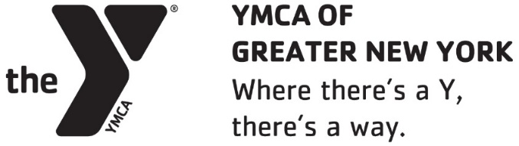

Full-time

Director, Lifeguard Training and Certification

The YMCA of Greater New York is here for all New Yorkers — to empower youth, improve health, and strengthen community. Founded in 1852, today the Y serves a diverse population of more than half a million New Yorkers who learn, grow, and thrive through programs and services at our 24 branches. Community is the cornerstone of the Y. Together, we connect active, engaged New Yorkers to build stronger communities.

We are seeking a Director of Lifeguard Training and Certification who will help develop and lead the Association’s first ever Lifeguard Training & Certification program, an offering of the Aquatics Center of Excellence in the newly formed Center for Access, Innovation and Advocacy. Responsibilities include recruiting, scheduling, evaluating, and training new and current lifeguard / lifeguard instructor candidates and creating a pipeline of potential candidates via strategic partnerships. The Director, Lifeguard Training and Certification will represent the Y brand both internally and externally.

Key Responsibilities:
- Know and understand all YMCA, state and local health and safety requirements, including Pool Safety Plan, Emergency Action Plan, Emergency Evacuation Routes and staff certifications.
- Ensure the safety of YMCA staff and members.
- Develop a comprehensive participant recruitment plan and annual certification schedule.
- Collaborate with Research, Evaluation and Strategy on developing program performance metrics, evaluating program performance and suggesting enhancements.
- Conduct lifeguard certification classes and all related administrative tasks.
- Track and report on metrics routinely, identifying opportunities to demonstrate the impact of the program and provide the Fund Development and Public Affairs department with information needed to request further support.
- Act as a brand ambassador by connecting candidates to employment opportunities or a development course.
- Engage graduates of the program to build a certification referral program.
- Support development opportunities for program staff.
- Maintain certification level of physical and mental readiness
- Responsible for recertification before expiration.
- Actively participate in professional development, designated meetings, and special events, as appropriate and requested.
- Other activities and duties as needed that address the ongoing health and well-being of our staff and members.
- Follow and maintain sanitary habits in accordance with CDC guidelines.

Desired Skills & Experience:
- Bachelor’s degree or equivalent desired.
- Minimum of three (3) to five (5) years of experience supervising lifeguards and swim instructors.
- Strong lifeguarding skills and experience in assessing and correcting skills gaps in others.
- Current YMCA Lifeguard certification or National equivalent (must attain YMCA LG certification within 90 days of hire)
- Current YMCA Swim Lesson Instructor certification or National equivalent (must attain YMCA Swim Lesson Instructor certification within 120 days of hire)
- Current Basic Life Support (CPRO), First Aid and Emergency Oxygen.
- Current YMCA Lifeguard Instructor Certification or National equivalent.
- Must be willing to work flexible hours, including weekends and holidays.

We offer an exciting and innovative work environment with an organizational culture committed to serving all members of our community. As a leading not-for-profit, community service organization, our Association relies heavily on fundraising to support the wide range of programs we proudly provide the communities we serve. Our expectation is that all staff promotes participation of their branch fundraising efforts in some capacity.

How to Apply:
If you would like to be a member of our dynamic team, please complete our online application and submit your résumé and a thoughtful cover letter that explains your interest in the role and our organization.

Apply Here: https://ymcanyc.csod.com/ux/ats/careersite/1/home/requisition/590?c=ymcanyc

** New Requirement**
All potential YMCA of Greater New York employees are required to show proof of COVID-19 vaccination. Please use the “Additional Attachment” section on the online application to upload your proof of COVID-19 vaccination.

EQUAL OPPORTUNITY EMPLOYER ♦ DRUGFREE WORKPLACE
Auxiliary aids and services are available upon request to individuals with disabilities
YMCA OF GREATER NEW YORK | Where there's a Y, there’s a way.

