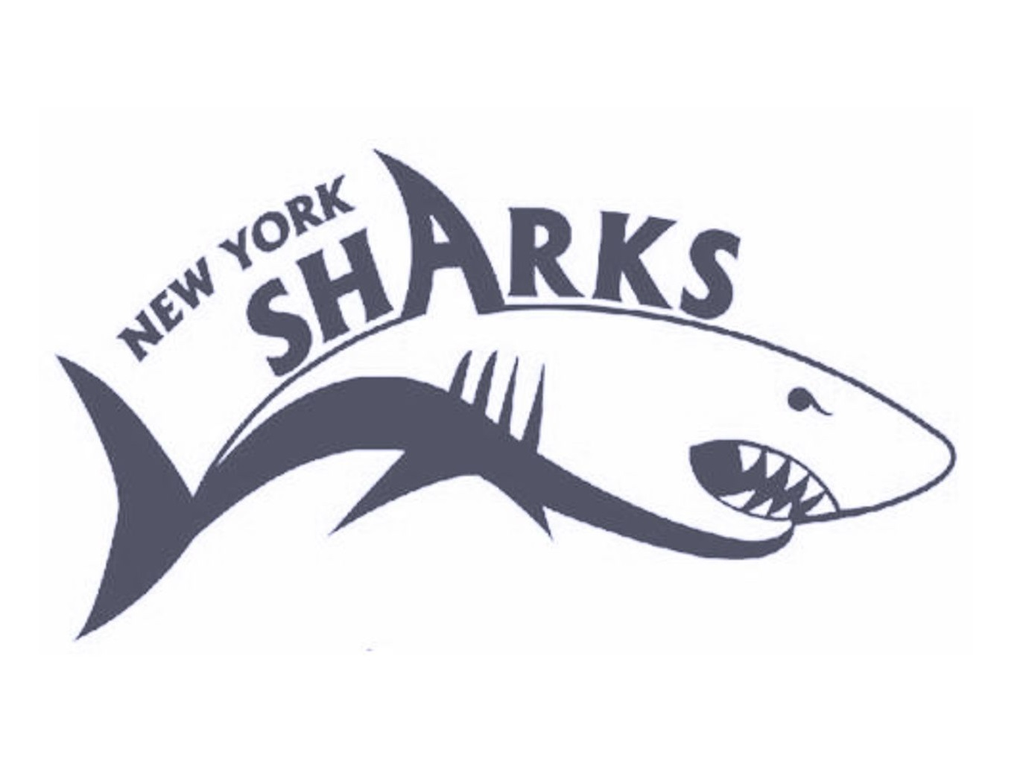

**NYSA 2019 FALL CLASSIC INVITATIONAL**

**At Felix Festa Middle School**

**November 1- 3, 2019**

## Metro Sanction # 191111

Invited Teams: AG, WSSC, MWSC, NBS,RFAC, HVD, TRS, BAD, YMID, BGNW, EAST, HAWKS, VAC, GAEL, LIE, DA, COND, AGUA, MVA, YBAR, NCAC, SPAR, SSC, SMC, SSL, WAC, APEX, FAST, IA, LGAC, MAKO, MPNY, WEST, PAC, GATORS-NJ, BBNJ,WAV-NJ, LSA, FREE, SWAG, CAT-NJ, HCY-NJ, YFD, LIAC, HS, DESC-NJ, PATS, SS, WSA, JCC, TS, HAA, QNS, SWIM70-CT, Ridgefield Aquatic Club CT, SCY, DVWM, FOBY, SCAR, EXCEL-NJ, IA-MR, Red Bank YMCA

**NYSA 2019 FALL CLASSIC INVITATIONAL**

**Friday, Saturday & Sunday November 1-3, 2019**

|  |  |
| --- | --- |
| **SANCTION:** | Held under the sanction of USA Swimming/Metropolitan Swimming, Inc., #191111. |
|  |  |
| **LOCATION:** | FELIX FESTA MIDDLE SCHOOL, 30 PARROTT ROAD, WEST NYACK, NY 10994 |
|  |  |
| **FACILITY:** | Felix Festa is an indoor 8 lane 50 meter pool with a bulkhead. The meet will be run in the deep end of the pool and the shallow end will be used for continuous warm up and warm downs. Colorado electronic timing system and an 8-line scoreboard.  The pool ***has not been*** certified in accordance with Article 104.2.2C (4) |
|  |  |
| **SESSIONS:** | Session 1: Friday PM: 5:30 PM Warm Up, 6:15 PM Start **(DUE TO VARISTY PRACTICE)**  Session 2: Saturday AM: 9:30 AM Warm Up, 10:30 AM Start **(DUE TO VARISTY PRACTICE)**  Session 3: Saturday PM: 3:30 PM Warm Up, 4:30 PM Start  Session 4: Sunday AM: 8:00 AM Warm Up, 9:00 AM Start  Session 5: Sunday PM: 2:00 PM Warm Up, 3:00 PM Start |
|  |  |
| **FORMAT:** | This is a timed final meet.  The meet will be deck seeded. |
|  |
|  |  |
| **ELIGIBILITY:** | Open to all Invited USA Swimming/Metropolitan Swimming Inc. registered swimmers.  All swimmers participating in this meet must be registered by the first day of the meet.  No “Deck Registrations” will be accepted  Age on **Friday November 1, 2019** will determine age for the entire meet.  **All applicable adults participating in or associated with this meet, acknowledge that they are subject to the provisions of the USA Swimming Minor Athlete Abuse Prevention Policy (“MAAPP”), and that they understand that compliance with the MAAPP policy is a condition of participation in the conduct of this competition.** |
|  |  |
| **DISABILITY SWIMMERS:** | Swimmers with disabilities are encouraged to attend.  Contact the meet director if you need special consideration. The athlete (or the athlete’s coach) is also responsible for notifying the meet referee of any disability prior to the competition. |
|  |  |
| **ENTRIES:** | Swimmers may compete in 2 individual events on Friday and 3 individual events per day for Saturday and Sunday. NT’s will not be accepted. The host club reserves the right to enter their swimmers with NT’s. All entries will be accepted on a first come, first serve basis. Teams will be considered accepted when the host club accepts the entries The host club must stay within the four hour per session rule.  **Please note if the meet is close to being closed by capacity, the clubs will be asked to update their files so that we can accurately estimate the number of swimmers and splashes. Once closed, each club is responsible for all entries.**  All received entries will be confirmed within 48 hours. Emailed Hy-Tek entry file is preferred. If sending by mail, entries should be sent on disk. A master sheet must accompany all entries.  **Please SEND PAYMENTS TO ADDRESS BELOW.**  U.S. Mail Entries/Payment to: **NYS Aquatics, Inc,**  **c/o Regina O’Brien**  **10 Julia Court**  **Tappan, NY 10983**  Email Entries/Confirm Entry Receipt: [NYSAentries@gmail.com](mailto:NYSAentries@gmail.com) |
|  | ***Sign Express Mail Waiver allowing delivery without signature.*** |
|  |  |
| **DEADLINE:** | 1: All invited teams will be given priority on a first come/first serve basis. All other teams please send email to BG26608@hotmail.com. All entries must be received by October 20, 2019.  2: The final entry deadline for this meet is October 15, 2019  An email confirming receipt of entries if you provide an email contact. Please contact Meet Director if you do not receive such a report within 2 days of your original email. |
|  |  |
|  |  |
| **ENTRY FEE:** | An entry fee of $8.00 per individual event and a $3.00 per swimmer facility fee must accompany the entries. Make check payable to: NY Sharks Aquatics, Inc. Payment must be received by October 20, 2019 for email entries. Payment must be included with all mail entries. Failure to pay entry fees by this deadline could result in teams being barred from the meet.  If necessary, the 400 IM and 500 Free (women) will each be limited to the fastest 5 heats; the 400 IM and 500 Free (men) will be limited to the fastest 6 heats. Host team retains the right to keep its swimmers entered in these events. |
|  |  |
| **WARM-UP:** | The host club reserves the right to assign lanes for warm up based on the size of the meet. If lanes are not assigned the first 40 minutes will be general warm up. The last 20 minutes will have lanes 2 and 7 open for one way sprints. Lanes 1 and 8 for pace and all other lanes may be assigned by the meet director’s discretion. No diving will be allowed accept in designated sprint lanes. All swimmers must be supervised by a coach. |
|  |  |
| **SCRATCHES:** | Coaches will be given scratch sheets upon check-in for each session. All scratches are due no later than 30 minutes prior to the start of the session. Coaches are asked to indicate clearly individual events scratches and which swimmers will not be participating in the session. |
|  |  |
| **COACHES:** | In accordance with Metropolitan Swimming Inc. Policy, only those coaches who display current, valid USA Swimming credentials will be permitted to act in a coaching capacity at this meet. Coaches who do not possess these credentials will be required to leave the deck area. |
|  |  |
| **AWARDS:** | Ribbons will be award for 1th through 8th Place for age groups 10 and under and 11/12. |
|  |  |
| **OFFICIALS:** | **Meet Referee**: Ernesto Martinez, [Emathletics@gmail.com](mailto:Emathletics@gmail.com)  Officials wishing to volunteer should contact Meet Referee by October 25, 2019. |
| **ADMIN. OFFICIAL:** | **Admin Official**: Regina O’Brien, [nysaentries@gmail.com](mailto:nysaentries@gmail.com) |
| **MEET**  **DIRECTOR:** | **Meet Director**: Patsy Burke, [nysaentries@gmail.com](mailto:nysaentries@gmail.com) |
|  |  |
| **RULES:** | The current USA Swimming Rules and Regulations will apply.  **The USA Swimming Code of Conduct is in effect for the duration of the meet.**  The overhead start procedure may be used at the discretion of the meet Referee. | |
|  |  | |
| **SAFETY:** | **All swimmers must wear footwear upon leaving the pool area.**  Metropolitan Safety and Warm-up procedures will be in effect. Marshals will be present throughout warm-ups and competition, and have the authority to remove, with the concurrence of the meet Referee, any swimmer, coach, club, or spectator for failure to follow the safety rules.  “**Any swimmer entered in the meet must be certified by a USA Swimming member coach as being proficient in performing a racing start or must start each race from within the water. When unaccompanied by a member-coach, it is the responsibility of the swimmer, or the swimmer’s legal guardian, to ensure compliance with this requirement**” | |
|  |  | |
| **WATER DEPTH:** | USA 2011 - 202.3.7 "The meet announcement shall include information about water depth measured for a distance of 3 feet 3½ inches (1.0 meter) to 16 feet 5 inches (5.0 meters) from both end walls."  1.0 meter = 4 feet 6 inches, 5 meters = 13 feet | |
|  |  | |
|  |  | |
| **DISCLAIMER:** | Upon acceptance of his/her entries, the participant waives all claims against Clarkstown Central School District, New York Sharks Aquatics, Inc., Metropolitan Swimming Inc., USA Swimming Inc., their agents or representatives for any injury occurring as a result of the meet. "It is understood that USA Swimming, Inc. and Metropolitan Swimming, Inc. shall be free from liabilities or claims for damages arising by reason of injuries to anyone during the conduct of the event." | |
| **AUDIO/VISUAL STATEMENT:** | **Use of Audio or visual recording devices, including a cell phone, is not permitted in changing areas, rest rooms, locker rooms or behind the starting blocks.** | |
|  |  | |
| **DECK CHANGING:** | **Deck changes are prohibited.** | |
| **DRONES:** | Operation of a drone, or any other flying apparatus, is prohibited over the venue (pools, athlete/coach areas, spectator areas and open ceiling locker rooms) any time athletes, coaches, officials and/or spectators are present. | |
|  |  | |
| **ADMISSION:** | $7.00 Adults/Session  $3.00 Program/Session | |
|  |  | |
| **MERCHANTS:** | A Swim Shop Vendor will be on site, as well as, a food concession. | |
|  |  | |
| **PARKING:**  **FACILITY**  **RULES:** | There is free unlimited parking at Felix Festa Middle School. Cars parking on Parrott Road Will be ticketed and towed. All cars must be parked in designated parking spaces or they Will be ticketed by the Clarkstown Police Department.   * NO SMOKING within 50 feet of any entrance to the school or inside the school. * NO FOOD is allowed on deck. Liquid refreshments in plastic bottles are allowed. * NO GLASS BOTTLES or JUICE BOXES allowed on deck. | |
|  |  | |
| **DIRECTIONS:** | MapQuest: http://www.mapquest.com/maps?city=West+Nyack&state=NY&address=30+Parrott+Road&zipcode=1 0994  From New Jersey:  1. Take the Garden State Parkway North or Interstate 287 North.  2) Either highway joins the New York State Thruway (Interstate 87). Follow signs for New York State Thruway South toward Tappan Zee Bridge. Exit New York State Thruway at exit 13N (Palisades Parkway North).  3) Exit the Palisades Parkway at Exit 10.  4) Follow to the end of the ramp and make a right at the light onto Germonds Road.  5) Take Germonds to the next light and cross over Route 304.  6) Go straight on Germonds Road.  7) Head straight onto Parrott Road.  8) Felix Festa Middle School is on the left. Pool entrance and parking area is in the back of the school by the tennis courts.  Alternate From New Jersey:  1) Take the Palisades Parkway North from Fort Lee (instead of the Garden State Parkway or Interstate 287).  2) Take Exit 10 from the Palisade Parkway and follow directions #5 above.  From New York City:  1) Take the George Washington Bridge to the Palisades Parkway North.  2) Take Exit 10 from the Palisade Parkway and follow directions #5 above.  From Westchester County Vicinity:  1) Take the Tappan Zee Bridge. Follow the New York Thruway North (Interstate 87).  2) Exit New York State Thruway at exit 13N (Palisades Parkway North).  3) Take Exit 10 from the Palisade Parkway and follow directions #5 above.  From Rockland County:  1) Take the New York State Thruway South (Interstate 87) to Exit 13N for Palisades Parkway North.  2) Take Exit 10 from the Palisade Parkway and follow directions #5 above.  Alternate from Rockland County:  1) Take the Palisade Parkway South from the Bear Mountain vicinity to Exit 10.  2) Take Exit 10 from the Palisade Parkway and follow directions #5 above. | |
|  |  | |
|  |  | |
|  |  | |
|  |  | |

**Session 1: Friday, November 1, 2019**

**5:30 PM Warm up, 6:15 PM Start**

|  |  |  |
| --- | --- | --- |
| **Girls**  **Event #** | **Age Group Event** | **Boys**  **Event #** |
| 1 | 11 -12 200 Free | 2 |
| 3 | 13 and Over 400 Ind. Medley | 4 |
| 5 | 12 and Under 200 Ind. Medley | 6 |
| 7 | 13 and Over 500 Freestyle | 8 |

**Session 2: Saturday, November 2, 2019**

**9:30 AM Warm up, 10:30 AM Start**

**(Late start due to Varsity Practice)**

|  |  |  |
| --- | --- | --- |
| **Girls**  **Event #** | **Age Group Event** | **Boys**  **Event #** |
| 9 | 10 and under 100 Breast | 10 |
| 11 | 13-14 200 yd. Freestyle | 12 |
| 13 | 10 and Under 100 yd. Backstroke | 14 |
| 15 | 13-14 100 yd. Backstroke | 16 |
| 17 | 10 and Under 50 yd. Breaststroke | 18 |
| 19 | 13-14 200 yd. Breaststroke | 20 |
| 21 | 10 and Under 50 yd. Butterfly | 22 |
| 23 | 13-14 100 yd. Butterfly | 24 |
| 25 | 10 and Under 100 yd. Freestyle | 26 |
| 27 | 13-14 100 yd. Freestyle | 28 |

**Session 3: Saturday, November 2, 2019**

**3:30 PM Warm up, 4:30 PM Start**

|  |  |  |
| --- | --- | --- |
| **Girls**  **Event #** | **Age Group Event** | **Boys**  **Event #** |
| 29 | 11-12 200 yd. Butterfly | 30 |
| 31 | 15 and Over 200 yd. Freestyle | 32 |
| 33 | 11-12 50 yd. Backstroke | 34 |
| 35 | 15 and Over 100 yd. Backstroke | 36 |
| 37 | 11-12 100 yd. Breaststroke | 38 |
| 39 | 15 and Over 200 Breaststroke | 40 |
| 41 | 11-12 50 yd. Butterfly | 42 |
| 43 | 15 and Over 100 yd. Butterfly | 44 |
| 45 | 11-12 50 yd. Freestyle | 46 |
| 47 | 15 and Over 50 yd. Freestyle | 48 |
| 49 | 11-12 200 yd. Backstroke | 50 |

**Session 4: Sunday, November 3, 2019**

**8:00 AM Warm up, 9:00 AM Start**

|  |  |  |
| --- | --- | --- |
| **Girls**  **Event #** | **Age Group Event** | **Boys**  **Event #** |
| 51 | 10 and under 200 yd. Free | 52 |
| 53 | 13-14 200 yd. Ind. Medley | 54 |
| 55 | 10 and Under 50 yd. Backstroke | 56 |
| 57 | 13-14 100 yd. Breaststroke | 58 |
| 59 | 10 and Under 100 yd. Ind. Medley | 60 |
| 61 | 13-14 200 yd. Backstroke | 62 |
| 63 | 10 and Under 100 yd. Butterfly | 64 |
| 65 | 13-14 200 yd. Butterfly | 66 |
| 67 | 10 and Under 50 yd. Freestyle | 68 |
| 69 | 13-14 50 yd. Freestyle | 70 |

**Session 5: Sunday, November 3, 2019**

**2:00 PM Warm up, 3:00 PM Start**

|  |  |  |
| --- | --- | --- |
| Girls  Event # | Age Group Event | Boys  Event # |
| 71 | 11-12 200 yd. Breaststroke | 72 |
| 73 | 15 and Over 200 yd. Ind. Medley | 74 |
| 75 | 11-12 100 yd. Ind. Medley | 76 |
| 77 | 15 and Over 100 yd. Breaststroke | 78 |
| 79 | 11-12 50 yd. Breaststroke | 80 |
| 81 | 15 and Over 200 Backstroke | 82 |
| 83 | 11-12 100 Backstroke | 84 |
| 85 | 15 and Over 200 yd. Butterfly | 86 |
| 87 | 11-12 100 yd. Butterfly | 88 |
| 89 | 15 and Over 100 yd. Freestyle | 90 |
| 91 | 11-12 100 yd. Freestyle | 92 |



**Metropolitan Swimming**

**Photographer Registration Form**

**As of 05/18/16 - All Metropolitan Teams need to include this in the meet information packet as well as file this form with Safety in Sport Coordinator, prior to the start of the meet.**

This form must be completed by any photographer (video or still) who intends to take pictures at an Metropolitan Swimming sanctioned meet, and is taking those pictures of anyone other than his or her own child, from any location on deck. Submit the form to the Meet Director prior to commencing activity.

**THERE WILL BE NO FLASH PHOTOGRAPHY PERMITTED AT THE START.**

Name___________________________________________________________________

Phone Number___________________________________________________________

Government ID (driver’s license preferred) or USA Swimming Registration Card:

Type of ID_____________________ #________________________

Taking photos of________________________________________________________________

On behalf of____________________________________________________________________

Purpose _______________________________________________________________________

Professional photographers/videographers will be allowed on deck at the discretion of the Meet Director and Meet Referee, and must adhere to the following guidelines:

Do not stand on the starting end of the pool, or in the starter’s box; use of the bulkhead is at the discretion of the Meet Director and Meet Referee.

Do not stand on the edge of the pool (leave approximately two feet for officials and coaches).

Leave the deck when not actively photographing.

Respond immediately to direction from the Meet Referee.

Signature ______________________________________________ Today’s Date____________

Meet_____________________________________________ Location_____________________

Date(s) of meet_________________________________