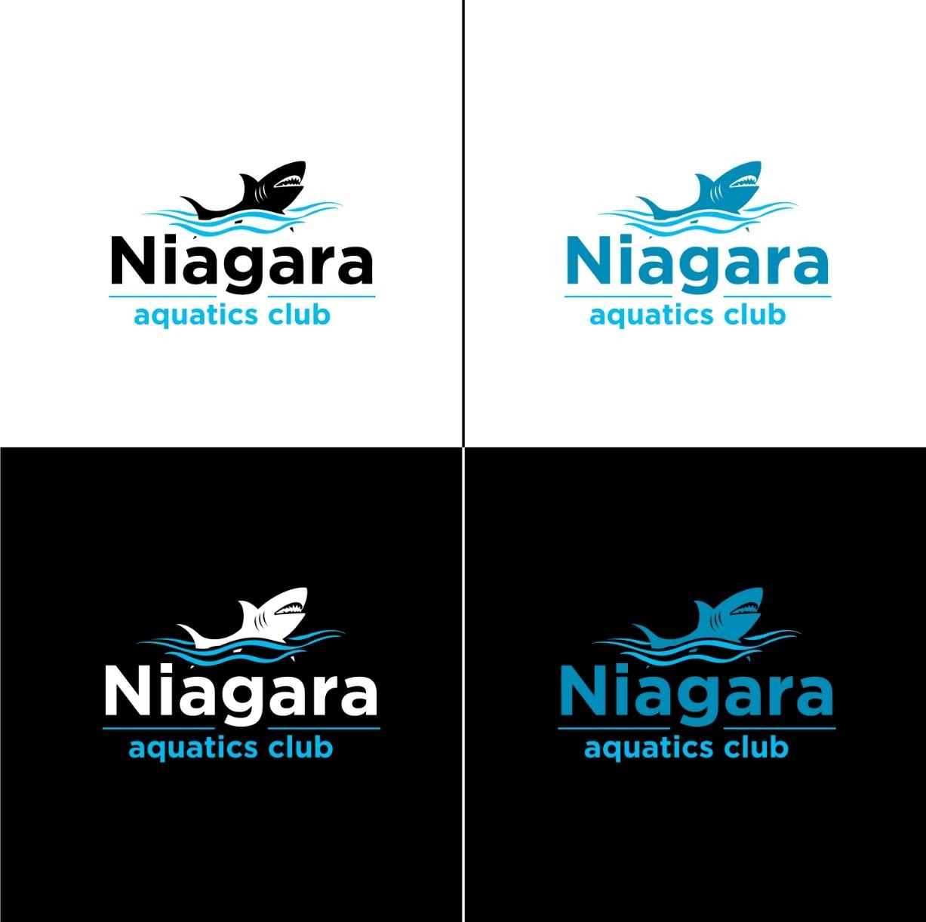
December 10, 2020

Michelle T. Bradley
Superintendent Lockport Schools
Lockport School Board
Dear Michelle and School Board members,
I am writing you to see if there is anything we can do to utilize your pool once again. I realize that the Board of Education is hesitant to allow outside groups in, however our team of swimmers has been safely swimming together since July 1, 2020. We swam at the Lockport Town & County Club from July 1, 2020 to September 30, 2020. Since then, we have a swim mini pool trainer with jets that we have been using at the Cornerstone Ice Arena, and we also swim 2 times a week at the University at Buffalo, even though Erie County is in the orange zone currently. The Erie County Health Department has allowed pools to open in Erie County and the Y is open in Niagara County, as well as college pools. We would like to return closer to home and provide our community with a program that offers something positive for children in the area. We have a safe plan and I am attaching it to this email. I am attaching what was approved by both the University at Buffalo and the Board at the Cornerstone Ice Arena. Would you please consider allowing our team back in? Perhaps there is a way where we could also trade services, I could provide lifeguards free of charge for high school meets or community events.
Reasons to allow swimming to return:
Safety: Drowning rates and the current facility shutdown during this pandemic is exacerbating this reality. According to the CDC, drowning remains the leading cause of death among children ages 1 – 4 and the second leading cause of unintentional death among children ages 1-14 in the U.S.
Initial studies show that COVID-19 is not transmitted through chlorinated water, and by paying greater attention to proper air quality measures and distancing techniques, the spread of respiratory disease can be mitigated.
The closing of aquatic venues has abruptly halted the conduct of learn-to-swim programs for children who most need those lessons. Swim lesson providers have already developed comprehensive plans and protocols to reduce transmission risk during these vital activities.
Mental and Physical Health: Exercise done in water such as physical therapy, lap swimming, competitive swimming, water aerobics, and other aquatic instruction are critical activities for mental and physical health. Further, regular exercise can reduce risk factors for severe COVID19
Like with walking, running, and cycling, aquatic sports under instruction can easily comply with standards for social distancing and safety.
https://www.cdc.gov/healthywater/swimming/index.html 2
https://www.cdc.gov/homeandrecreationalsafety/water-safety/waterinjuries-factsheet.html
United States Swim Schools Association COVID19 Action Plan: www.aquatics-coalition.org
https://www.cdc.gov/coronavirus/2019-ncov/need-extra-precautions/people-at-higher-risk.html
Purposeful Aquatics
Purpose-driven, coached, aquatic activity—swim lessons, pool-based physical therapy, and competitive swimming—are essential to public safety and health. Therefore, it is vital that these activities be allowed to resume immediately with continued availability for local communities. Each of these aquatic activities can recommence in a way that minimizes the risk of COVID-19 transmission.
Learn-to-Swim
Swim lessons are a critical resource given that drowning is the number one cause of accidental death for children under the age of four. Yet the closing of aquatic venues has abruptly halted learn-to-swim programs for months, denying children the opportunity to acquire this life-saving skill. People should be aware that swim lessons can be safely administered with proper protective equipment and protocols.
Safer Facilities
According to the CDC, there is no evidence that COVID-19 can spread to people through chlorinated water. Aquatics facilities can allow purpose-driven swimming to take place by following strict safety protocols in and around the pool, maintaining proper water sanitation levels and air quality measures, performing frequent cleaning and sanitization, and conducting regular health checks of staff and participants.
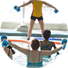
Community Health
Exercise done in water such as physical therapy, lap swimming, competitive swimming, water aerobics, and other aquatic instruction are essential for mental and physical health. Further, regular exercise can reduce risk factors for severe COVID-19. Facilitating a safer return to water can only elevate social and fitness well-being in our communities.
Sincerely,
Danielle Andalora
Niagara Aquatics Club Owner
716-857-0755, danielleandalora@gmail.com

