Riverbank RedTails Swim Team
17th International LC Invitational
June 25th & 26th, 2022
Lehman College APEX Center
250 Bedford Park Blvd. West
Bronx, NY 10468
212-960-1134
Metropolitan Swimming Sanction # 220606

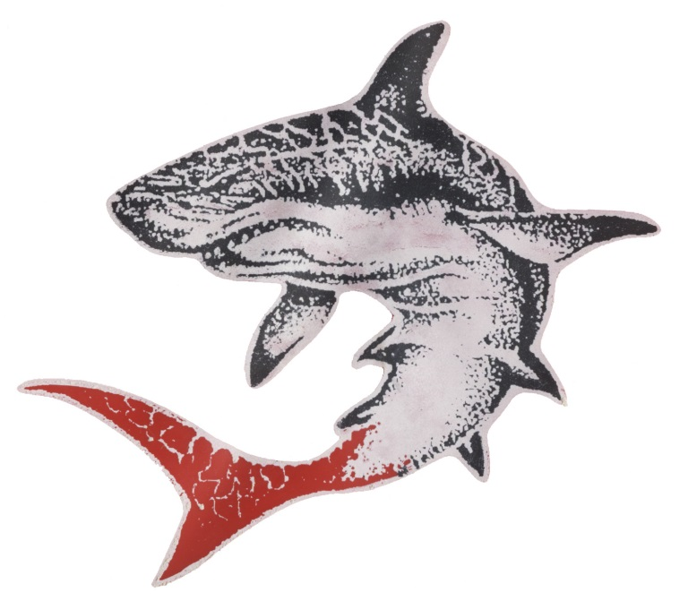

2022-MR RedTails International LC Invitational

June 25-26, 2022

Invited Teams: LaGuardia Aquatic Club, NuFinmen, APEX, Kips Bay Makos, Rivertown Aquatics, WEST, Blue Seals, Flying Dolphins, Flushing Flyers, Cross Island Y, Club Fit-JV, CAS Stingrays, Queens Aquatic Club, Match Point

*Other interested clubs should contact the meet director
2022 MR-RedTails International LC Invitational
June 25-26, 2022

SANCTION: | Held under the sanction of USA Swimming/Metropolitan Swimming, Inc., # 220606
LOCATION: | Lehman College APEX Center;  250 Bedford Park Blvd. West Bronx, NY 10468
FACILITY: | Eight lanes 50 Meters Olympic size indoor pool, pool depth is 4ft to 13ft. Electronic timing system and non-turbulent lane lines will be used.  The pool has been certified in accordance with Article 104.2.2C (4)
SESSIONS: | Saturday, June 25, 2022- Session I: 8:00am warm up- 9:00am Start  Saturday, June 25, 2022- Session II: 2:00pm warm up- 3:00pm Start  Sunday, June 26, 2022 Session III: 8:00am warm up- 8:00am Start  Sunday, June 26, 2022- Session IV: 2:00pm warm up- 3:00pm Start
FORMAT: | All events are Timed Finals
 | The meet will Deck Seeded
ELIGIBILITY: | Open to all Invited USA Swimming/Metropolitan Swimming Inc. registered swimmers.  All swimmers participating in this meet must be registered by the first day of the meet.  No “Deck Registrations” will be accepted  Age on June 25th will determine age for the entire meet.
DISABILITY  SWIMMERS: | Swimmers with disabilities are encouraged to attend. Contact the meet director if you need special consideration.  The athlete (or the athlete’s coach) is also responsible for notifying the meet referee of any disability prior to the competition.
ENTRIES: | Swimmers are allowed only 3 individual events and 1 relay per day.  Entries will be cut by team in order to maintain Metro swimming guidelines.  HY-TEK entries w/ printout are preferred.  U.S. Mail Entries/Payment to: Riverbank State Park – Aquatics Complex:  679 Riverside Drive. New York, NY 10031  Email Entries/Confirm Entry Receipt: RedTailsswimming@gmail.com or Luis.trinidad@parks.ny.gov
DEADLINE: | Entries must be received by: June 3, 2022. Metro Teams may enter prior to May 21, 2022
 | An email confirming receipt of entries if you provide an email contact. Please contact Meet Director if you do not receive such a report within 2 days of your original email.
ENTRY FEE: | An entry fee of $7.00 per individual event and $10.00 per Relay event must accompany the entries.  Make check payable to: RedTails “NHT”  Payment must be received by entry deadline for email entries. Payment must be included with all mail entries. Failure to pay entry fees by this deadline could result in teams being barred from the meet.
WARM-UP: | Lane assignments will be posted, if necessary, prior to each warm up session
SCRATCHES: | Coaches will be given scratch sheets upon check-in for each session. All scratches are due no later than 30 minutes prior to the start of the session. Coaches are asked to indicate clearly individual events scratches and which swimmers will not be participating in the session.
COACHES: | In accordance with Metropolitan Swimming Inc. Policy, only those coaches who display current, valid USA Swimming credentials will be permitted to act in a coaching capacity at this meet. Coaches who do not possess these credentials will be required to leave the deck area.
AWARDS: | A distinctive medal will be given to 1st, 2nd, and 3rd places. Ribbons for places 4 through 8.  High Point awards will be given to top three individuals in each age division and top three teams.
OFFICIALS: | Meet Referee: Elaine Ang elaineang68@yahoo.com  Officials wishing to volunteer should contact Meet Referee by June 9th
ADMIN.
OFFICIAL: | Wendy Martinez bellamiamour@usa.net
MEET DIRECTOR: | Luis Trinidad: RedTailsswimming@gmail.com or Luis.Trinidad@parks.ny.gov
RULES: | The current USA Swimming Rules and Regulations will apply.  The USA Swimming Code of Conduct is in effect for the duration of the meet.  The overhead start procedure may be used at the discretion of the meet Referee.
SAFETY: | Metropolitan Safety and Warm-up procedures will be in effect. Marshals will be present throughout warm-ups and competition, and have the authority to remove, with the concurrence of the meet Referee, any swimmer, coach, club, or spectator for failure to follow the safety rules.  “Any swimmer entered in the meet must be certified by a USA Swimming member coach as being proficient in performing a racing start or must start each race from within the water. When unaccompanied by a member-coach, it is the responsibility of the swimmer, or the swimmer’s legal guardian, to ensure compliance with this requirement”
WATER DEPTH: | USA 2011 - 202.3.7 "The meet announcement shall include information about water depth measured for a distance of 3 feet 3½ inches (1.0 meter) to 16 feet 5 inches (5.0 meters) from both end walls."  Pool depth is 4ft to 13ft.
DISCLAIMER: | DISCLAIMER: Upon acceptance of his/her entries, the participant waives all claims against "Lehman College, New York State Parks and The Riverbank RedTails", Metropolitan Swimming Inc., USA Swimming Inc., their agents or representatives for any injury occurring as a result of the meet. "It is understood that USA Swimming, Inc. and Metropolitan Swimming, Inc. shall be free from liabilities or claims for damages arising by reason of injuries to anyone during the conduct of the event." An inherent risk of exposure to COVID-19 exists in any public place where people are present. COVID-19 is an extremely contagious disease that can lead to severe illness and death. According to the Centers for Disease Control and Prevention, senior citizens and individuals with underlying medical conditions are especially vulnerable. USA Swimming, Inc., cannot prevent you (or your child(ren)) from becoming exposed to, contracting, or spreading COVID-19 while participating in USA Swimming sanctioned events. It is not possible to prevent against the presence of the disease. Therefore, if you choose to participate in a USA Swimming sanctioned event, you may be exposing yourself to and/or increasing your risk of contracting or spreading COVID-19. BY ATTENDING OR PARTICIPATING IN THIS COMPETITION, YOU VOLUNTARILY ASSUME ALL RISKS ASSOCIATED WITH EXPOSURE TO COVID-19 AND FOREVER RELEASE AND HOLD HARMLESS USA SWIMMING AND METROPOLITAN SWIMMING, INC. AND EACH OF THEIR OFFICERS, DIRECTORS, AGENTS, EMPLOYEES OR OTHER REPRESENTATIVES FROM ANY LIABILITY OR CLAIMS INCLUDING FOR PERSONAL INJURIES, DEATH, DISEASE OR PROPERTY LOSSES, OR ANY OTHER LOSS, INCLUDING BUT NOT LIMITED TO CLAIMS OF NEGLIGENCE AND GIVE UP ANY CLAIMS YOU MAY HAVE TO SEEK DAMAGES, WHETHER KNOWN OR UNKNOWN, FORESEEN OR UNFORESEEN, IN CONNECTION THEREWITH.
AUDIO/VISUAL STATEMENT: | Use of Audio or visual recording devices, including a cell phone, is not permitted in changing areas, rest rooms, locker rooms, or behind the starting blocks.
DRONE  OPERATION  DECK  CHANGING: | Operation of a drone, or any other flying apparatus, is prohibited over the venue (Pools, athletic/ coach areas, spectator areas and open ceiling locker rooms) any time athletes, officials, coaches and or spectators are present.  Deck Changing is prohibited.
MAAPP POLICY | All applicable adults participating in or associated with this meet, acknowledge that they are subject to the provisions of the USA Swimming Minor Athlete Abuse Prevention Policy (“MAAPP”), and that they understand that compliance with the MAAPP policy is a condition of participation in the conduct of this competition.
ADMISSION: | Spectators may be prohibited. If spectators are permitted, they will be limited and required to purchase tickets in advance on line for admission to each session. Meet Mobile may also be available.
MERCHANTS: | Refreshments and food will not be available
PARKING: | Street parking will be available.
PHOTOGRAPHY | Any photographer or videographer, who intends to take pictures at a Metropolitan Swimming  Sanctioned meet, must complete and submit a Photographer Registration Form to the Meet Director  before commencing Activity. Forms are available on the Metropolitan Swimming website as well as  from the Meet Director and included in this announcement.
DIRECTIONS: | Please use google Maps

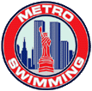

As of 05/18/16

All Metropolitan Teams need to include this in the meet information packet as well as file this form with Safety in Sport Coordinator, prior to the start of the meet.

Policy: Any photographer or videographer, who intends to take pictures at a Metropolitan Swimming sanctioned meet, must complete and submit a Photographer Registration Form to the Meet Director before commencing activity. Forms are available on the Metropolitan Swimming website as well as from the Meet Director.

Swimmer’s families, taking photos of their children from the spectator area, are not subject to this policy.

Notes:
The above policy will be published in meet announcements and programs.

It is the Meet Director’s responsibility to have forms available at the meet.

The Meet Director should check the actual ID against entry on form, and keep a file of submitted forms.

The intent is to promote accountability and to give Meet Directors and Referees a tool for managing concerns about photographers. Teams should consider providing a lanyard indicating that the photographer is registered.

See form, below.

Metropolitan Swimming

Photographer Registration Form

This form must be completed by any photographer (video or still) who intends to take pictures at an Metropolitan Swimming sanctioned meet, and is taking those pictures of anyone other than his or her own child, from any location on deck. Submit the form to the Meet Director prior to commencing activity.

THERE WILL BE NO FLASH PHOTOGRAPHY PERMITTED AT THE START.

Name___________________________________________________________________

Phone Number___________________________________________________________

Government ID (driver’s license preferred) or USA Swimming Registration Card:

Type of ID_____________________ #________________________

Taking photos of________________________________________________________________

On behalf of____________________________________________________________________

Purpose _______________________________________________________________________

Professional photographers/videographers will be allowed on deck at the discretion of the Meet Director and Meet Referee, and must adhere to the following guidelines:

Do not stand on the starting end of the pool, or in the starter’s box; use of the bulkhead is at the discretion of the Meet Director and Meet Referee.

Do not stand on the edge of the pool (leave approximately two feet for officials and coaches).

Leave the deck when not actively photographing.

Respond immediately to direction from the Meet Referee.

Signature ______________________________________________ Today’s Date____________

Meet_____________________________________________ Location_____________________

Date(s) of meet_________________________________

Riverbank RedTails Swim Team
17th International Meet Event List

Session I

Saturday, June 25, 2022 8:00am Warm-up
9:00am Start time

Women Men

1 15 & Over 200 Meter Individual Medley 2
3 11-12 200 Meter Freestyle 4
5 15 & Over 100 Meter Breaststroke 6
7 11-12 50 Meter Breaststroke 8
9 15 & Over 200 Meter Butterfly 10
11 11-12 100 Meter Butterfly 12
13 15 & Over 100 Meter Freestyle 14
15 11-12 50 Meter Freestyle 16
17 15 & Over 200 Meter Backstroke 18
19 11-12 100 Meter Backstroke 20
21 15 & Over 400 Meter Freestyle Relay 22
23 11-12 200 Meter Medley Relay 24

Session II

Saturday, June 25, 2022 2:00pm Warm-up
3:00pm Start time

Women Men

25 13-14 200 Meter Individual Medley 26
27 10 & U 200 Meter Freestyle 28
29 13-14 100 Meter Breaststroke 30
31 10 & U 50 Meter Breaststroke 32
33 13-14 200 Meter Butterfly 34
35 10 & U 100 Meter Butterfly 36
37 13-14 100 Meter Freestyle 38
39 10 & U 50 Meter Freestyle 40
41 13-14 200 Meter Backstroke 42
43 10 & U 100 Meter Backstroke 44
45 13-14 400 Meter Freestyle Relay 46
47 10 & U 200 Meter Medley Relay 48

Page 1

Riverbank RedTails Swim Team
17th International Meet Event List

Session III

Sunday, June 26, 2022 8:00am Warm-up
9:00am Start time

Women Men

49 15 & Over 200 Meter Freestyle 50
51 11-12 200 Meter Individual Medley 52
53 15 & Over 100 Meter Butterfly 54
55 11-12 50 Meter Butterfly 56
57 15 & Over 200 Meter Breaststroke 58
59 11-12 100 Meter Breaststroke 60
61 15 & Over 50 Meter Freestyle 62
63 11-12 100 Meter Freestyle 64
65 15 & Over 100 Meter Backstroke 66
67 11-12 50 Meter Backstroke 68
69 15 & Over 400 Meter Medley Relay 70
71 11-12 400 Meter Freestyle Relay 72

** High Point Awards Presentations **

Session IV

Sunday, June 26, 2022 2:00 pm Warm-up
3:00 pm Start time

Women Men

73 13-14 200 Meter Freestyle 74
75 10 & U 200 Meter Individual Medley 76
77 13-14 100 Meter Butterfly 78
79 10 & U 50 Meter Butterfly 80
81 13-14 200 Meter Breaststroke 82
83 10 & U 100 Meter Breaststroke 84
85 13-14 50 Meter Freestyle 86
87 10 & U 100 Meter Freestyle 88
89 13-14 100 Meter Backstroke 90
91 10 & U 50 Meter Backstroke 92
93 13-14 400 Meter Medley Relay 94
95 10 & U 400 Meter Freestyle Relay 96

** High Point Awards Presentations **
**Team Trophy Presentations**

Page 2

Riverbank RedTails Swim Team
17th International LC Invitational
June 25th & 26th, 2020

Meet Entry Summary & Waiver

Team Name____________________________ Team Code _____________
Address_____________________ City________ State ______ Zip _______

Head Coach’s Name __________________________
Day Phone # __________________________
Evening phone # __________________________
E-Mail: __________________________

Fee Summary:
Female Individual Entries ______ x $ 7.00 = _______

Male Individual Entries ______ x $ 7.00 = _______

Female Relay Entries ______ x $10.00 = _______

Male Relay Entries _______ x $10.00 = _______

Total of entry fees = _________

*Make check payable to Riverbank RedTails NHT. Deadline: Friday, 6/3/2022

Event Waiver:
Upon acceptance of entries, swimmers, coaches, parents and spectators waive their right to all claims against New York State Office of Parks, Recreation and Historic Preservation, Riverbank State Park, Riverbank RedTails Swim Team, Lehman College, Metropolitan Swimming, their agents and representatives for any injury or loss of property occurring as a result of this meet.

I hereby certify that all swimmers that I am entering at the: 2022 MR- RedTails International LC Invitational Meet is currently registered with USA, FINA, other Swimming Federation. Verification is needed.

Print Name_______________________ Title_______________________
Signature ________________________ Date_______________________
(Team official/coach)

Certified Coaches and team officials attending this meet: ______________________________________
*Entries will not be accepted without this signed waiver

