GLT Group Required Equipment List
We encourage our families to shop through our online provider: SwimOutlet.com. Swim Outlet has the best prices for our members, and will ship directly to your home. GLT will also receive a commission of 8% on all orders. In order for GLT to receive the 8% donation back to the club, you must click on the "Swim Outlet" logo on the bottom toolbar on our website, which will link you directly to SwimOutlet.com. When shopping, the logo "GLT Swimming" will be displayed at the top of the webpage. To locate each item below, you can simply put the product name (e.g. fins, pull buoy) in the search box.
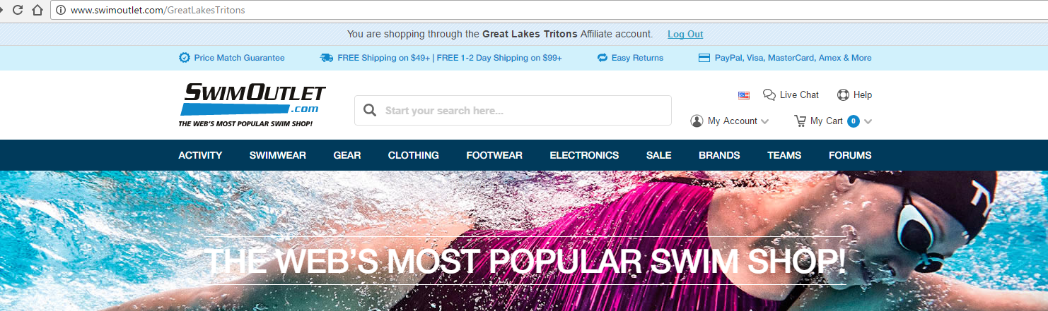

DEVELOPMENTAL
Fins: Any of the following brands are acceptable: SPORTI Floating Fins, SPEEDO Triathlon Rubber Swim Fins, FINIS Floating Swim Fins
A mesh equipment bag is recommended, but not required.

NOVICE
Fins: Any of the following brands are acceptable: SPORTI Floating Fins, SPEEDO Triathlon Rubber Swim Fins, FINIS Floating Swim Fins
A mesh equipment bag is recommended, but not required.

INTERMEDIATE
Mesh Equipment Bag: Any mesh equipment bag is acceptable. Examples are: of the following brands are acceptable: SPORTI Mesh Bag, SPORT Equipment Mesh Bag, SPORTI Premium Mesh Bag, BETTERTIMES Mesh Bag, TYR Mesh Equipment Bag, TYR Big Mesh Mummy Backpack III, FINIS Mesh Gear Bag, AQUA Sphere Deck Bag, FINISH Ulta Mesh Backpack
Snorkel: FINIS Swimmer’s Swim Snorkel
Fins: Any of the following brands are acceptable: SPORTI Floating Fins, SPEEDO Triathlon Rubber Swim Fins, FINIS Floating Swim Fins
Tennis Shoes: athletic tennis shoes/gym shoes with laces (not soft canvas, etc). These shoes will be used in the water for kick sets. They must be able to go in the pool.

JUNIOR
Mesh Equipment Bag: Any mesh equipment bag is acceptable. Examples are: of the following brands are acceptable: SPORTI Mesh Bag, SPORT Equipment Mesh Bag, SPORTI Premium Mesh Bag, BETTERTIMES Mesh Bag, TYR Mesh Equipment Bag, TYR Big Mesh Mummy Backpack III, FINIS Mesh Gear Bag, AQUA Sphere Deck Bag, FINISH Ulta Mesh Backpack
Snorkel: FINIS Swimmer’s Swim Snorkel
Fins: Any of the following brands are acceptable: SPORTI Floating Fins, SPEEDO Triathlon Rubber Swim Fins, FINIS Floating Swim Fins

SENIOR COMPETITIVE
Mesh Equipment Bag: Any mesh equipment bag is acceptable. Examples are: of the following brands are acceptable: SPORTI Mesh Bag, SPORT Equipment Mesh Bag, SPORTI Premium Mesh Bag, BETTERTIMES Mesh Bag, TYR Mesh Equipment Bag, TYR Big Mesh Mummy Backpack III, FINIS Mesh Gear Bag, AQUA Sphere Deck Bag, FINISH Ulta Mesh Backpack
Snorkel: FINIS Swimmer’s Swim Snorkel
Fins: Any of the following brands are acceptable: SPORTI Floating Fins, SPEEDO Triathlon Rubber Swim Fins, FINIS Floating Swim Fins
Paddles: Speedo IM Tech Paddle. Distance specialty swimmers, talk to Coach Dave: TYR Catalist 2 Training Paddles

SENIOR ELITE
Mesh Equipment Bag: Any mesh equipment bag is acceptable. Examples are: of the following brands are acceptable: SPORTI Mesh Bag, SPORT Equipment Mesh Bag, SPORTI Premium Mesh Bag, BETTERTIMES Mesh Bag, TYR Mesh Equipment Bag, TYR Big Mesh Mummy Backpack III, FINIS Mesh Gear Bag, AQUA Sphere Deck Bag, FINISH Ulta Mesh Backpack
Snorkel: FINIS Swimmer’s Swim Snorkel
Fins: Any of the following brands are acceptable: SPORTI Floating Fins, SPEEDO Triathlon Rubber Swim Fins, FINIS Floating Swim Fins
Paddles: Speedo IM Tech Paddle. Distance specialty swimmers, talk to Coach Dave: TYR Catalist 2 Training Paddles

