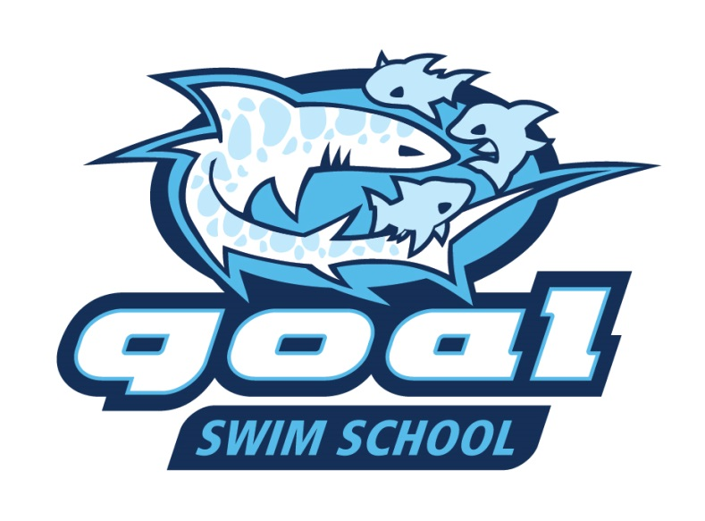
GOAL is excited to announce the sixth season of the GOAL Swim School beginning this June at Westgate Pool. GOAL Swim School will again offer: 1) small-group lessons for kids not yet ready for swim team; and 2) private lessons by the GOAL coaches for competitive swimmers. The GOAL coaches have continued to fine-tune their learn-to-swim curriculum design to help kids acquire skills all the way from the basics of getting comfortable in the water, to achieving basic water safety, to the building of sound fundamentals in the 4 competitive strokes. Skills progression is designed to allow for the child to become safe in and around the water, and eventually be well equipped to join a swim team if they so desire! Current or recent GOAL swimmers and coaches are among those being hand-selected to teach these lessons this summer. We have lessons coaches returning from last summer as well.
Information on the small-group lessons:
- Offered at Westgate Pool, with Session 1 beginning on June 11.
- Children must be potty trained and at least 2 years of age.
- Ratio of ≤ 3 swimmers for each teacher
- Three sessions will be run from June 11-July 26, with each session having 8 30-min. lessons.
- Session 1- June 11,12,13,14,18,19,20,21; Session 2- June 25,26,27,28, July 9,10,11,12; Session 3 – July 16,17,18,19,23,24,25,26
- Class start time options: 11:00 Am, 11:30 Am, and 12:00 Pm (Noon)
- Cost per session is $104. Westgate Pool members get $29 discounted from the full session price. Just e-mail Vickie Beck (vsaibeck@aol.com) for the discount code.
Register Now at www.goaquatics.com by clicking on the GOAL Swim School button.
Information on the private lessons:
- Offered only at Westgate Pool (starting June 11, continuing thru July 26), with class times 10:30 Am, 11:00 Am, & 11:30 Am. Lessons offered on June 11,12,13,14,18,19,20,21, 25,26,27,28 July 9,10,11,12,16,17,18,19,23,24,25,26.
- GOAL coaches offering lessons this Summer are Astin Sibbernsen, Becky Yungbluth and Tom Beck.
- See the exact dates/times offered along with cost info while registering on the GOAL website. The Westgate private lessons will be the same days as the small-group lessons, with the private lessons running until 12:00 and the small group lessons running until 12:30.
- If you have a specific preference on what you would like covered in the lesson, please e-mail the coach.
- Cost per 30 minute lesson is $40 for the lessons ($50 for Coach Tom Beck’s lesson).
Register Now at www.goaquatics.com by clicking on the GOAL Swim School button.

