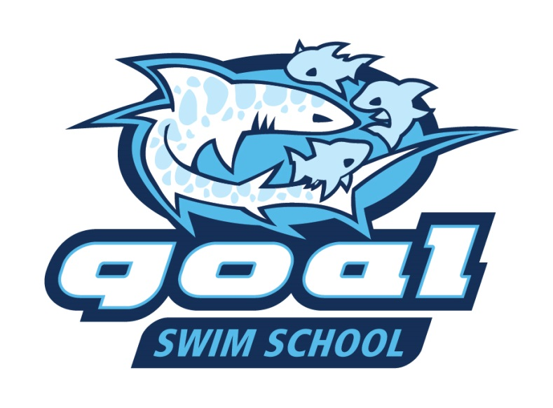
GOAL is excited to announce the eighth season of the GOAL Swim School beginning this June at Westgate Pool. GOAL Swim School will again offer: 1) small-group lessons for kids not yet ready for swim team; and 2) private lessons by the GOAL coaches for competitive swimmers (info to come on these lessons). The GOAL coaches have continued to fine-tune their learn-to-swim curriculum design to help kids acquire skills all the way from the basics of getting comfortable in the water, to achieving basic water safety, to the building of sound fundamentals in the 4 competitive strokes. Skills progression is designed to allow for the child to become safe in and around the water, and eventually be well equipped to join a swim team if they so desire! Current or recent GOAL swimmers and coaches are among those being hand-selected to teach these lessons this summer.
Information on the small-group lessons:
- Offered at Westgate Pool, with Session 1 beginning on June 6.
- Children must be potty trained and at least 2 years of age.
- Ratio of ≤ 3 swimmers for each teacher
- Two sessions will be run from June 6-July 8, with each session having 8 30-min. lessons.
- Session 1- June 6,7,8,9,14,15,16,17; Session 2- June 28,29,30, July 1,5,6,7,8
- Class start time options: 10:10 Am, 10:45 Am, and 11:20 Am
- Cost per session is $120. Westgate Pool members get $40 discounted from the full session price. Just e-mail Vickie Beck (vsaibeck@aol.com) for the discount code.
Register Now at www.goaquatics.com by clicking on the GOAL Swim School button.

