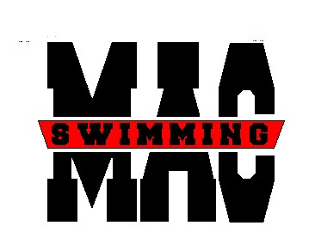

2008 Banquet
Join us for food and fun!

Who: All swimmers and their families
When: Sunday May 4th 5:30 p.m.
Where: Dutch’s Daughter Restaurant
581 Grimes Avenue
Frederick, MD 21703

Cost: $20 per person
Children under 3 free
Children 12 and under must be accompanied by an adult.

There will be a slide show presentation. Please send photos from this swim season to Territbush@aol.com or place in Terri’s folder by April 20th.

Questions: Please contact Helene Williams at dandhwilliams@aol.com or 301-607-6475 or Lisa Maruca at MarucaL@comcast.net

Name:__________________________

# Attending____ Payment amount______ Check#____

Make checks payable to MAC. Space is limited. Please place slip and payment in the Banquet folder by April 21st.

