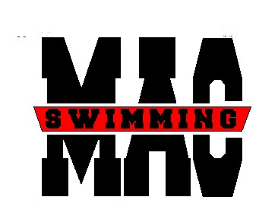
Monocacy Aquatic Club
905 W 7th Street, #211

Frederick, MD 21701

www.macswim.net

________________________________________________________________________

Dear Friends and Patrons,

The Monocacy Aquatic Club (MAC) is hosting its annual Robert Hogan Memorial Mini Meet on February 1-2, 2008. The meet attracts young athletes across the state from Maryland Swimming and draws approx. 1,000 spectators. In order to offset the costs of running the meet, we are selling advertising space in the meet program.

Rates for the advertising space are as follows:

Full Page $100 (Front or Back Cover 200.00)
Half Page $ 75
Quarter Page $ 50
Business Card $ 25
Event Sponsor $ 20

Please attach your ad to this sheet and provide the information set below.

Business/Family Name of Ad Sponsor:____________________________________________________
Ad size:_____________________________________________________
Swimmer who secured ad:___________________________________
Amount Enclosed: (checks made payable to “MAC”)___________

Ad deadline is Jan. 20, 2008. Please send copy to: Renee Hyrkas, rhyrkas@hyrk1.com.

The Monocacy Aquatic Club is a year-round, non-profit swimming program dedicated to advancing the sport of swimming. It serves the community in a positive manner by offering an instructive, disciplined environment for over 150 children ages 5-18, who are involved in the program.
The skill level of MAC swimmers ranges from those just learning to swim to those competing at regional and national levels.

