TM Lite 7.0 Meet Entries
Software Instructions

Swim 2017
(Instructions for Windows XP & Internet Explorer 8)

Step 1: Download TM Lite 7.0

TM Lite is FREE to download from the Hy-Tek Limited website’s Download Centre at http://www.hy-tekltd.com/downloads.html. The free version of TM Lite has the key options enabled to allow a team entering a meet to key in their meet entries and export those entries via e-mail to the Meet Host.

FREE Tech Support is available by e-mail at tm@hy-tekltd.com. No telephone tech support is offered by the vendor for TM Lite.

Using your internet browser go to http://www.hy-tekltd.com/downloads.html

This brings you to Hy Tek’s Download Centre:

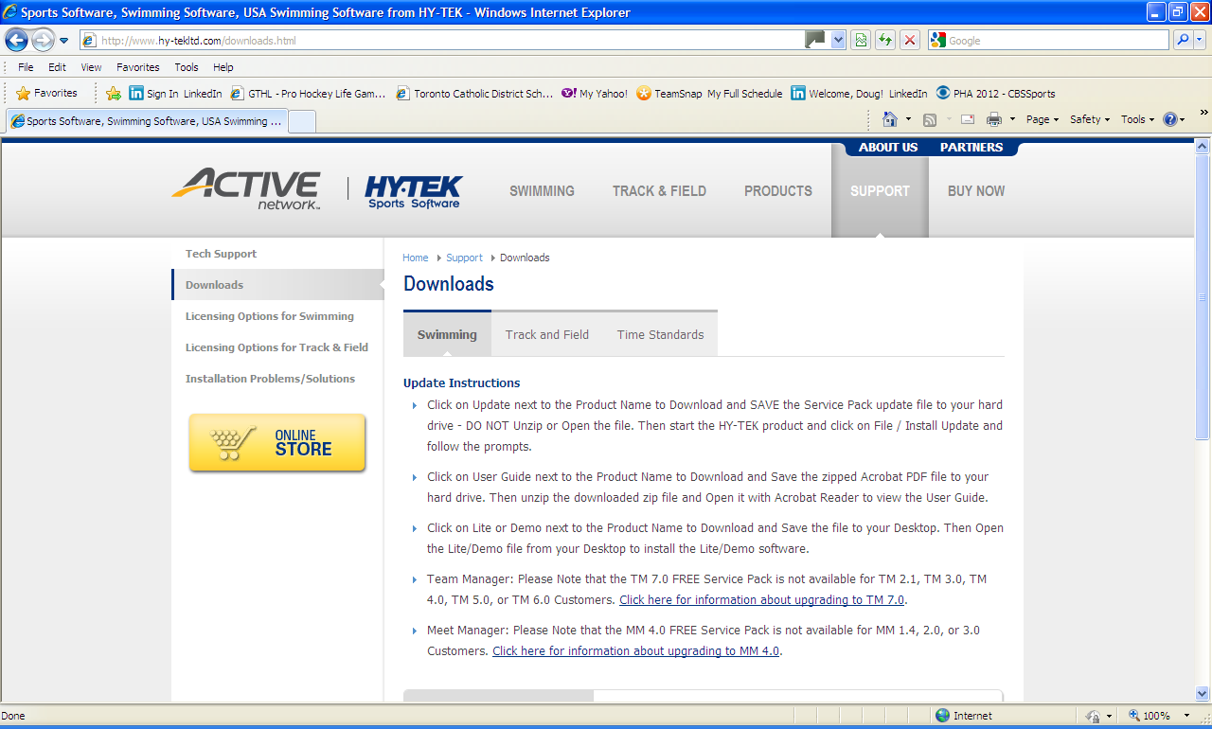

Scroll down to the bottom of the DOWNLOADS centre page to the chart at the bottom (you are downloading TM Lite (freeware) not the Full Meet Manager package):

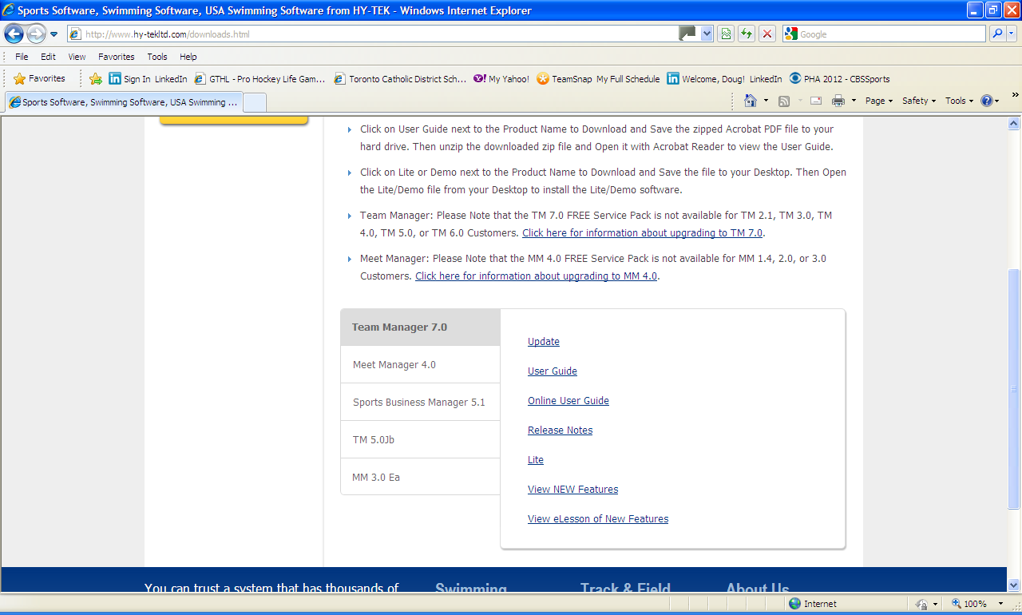

- Click on the word Lite.
- A pop up will ask: “Do want to run or save this file?” Click on Save.

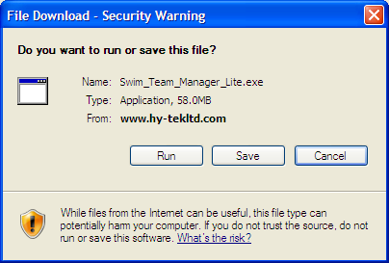

Depending on your operating system, the file download may launch automatically and be saved in the “Downloads” directory on your hard drive.

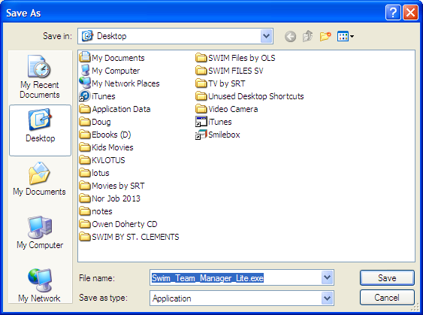

ALTERNATIVE:
If the file did not automatically save to your download directory then you may be prompted to enter a destination or folder where the file will be saved and the file name.

We suggest saving to the Desktop of your computer. The default file name is Swim_TEAM_MANAGER_Lite.exe. Click on Save. The download will take several minutes to complete. Click Close when the Download complete window appears.

  - To load the software do ONE of the following depending on where you saved the Swim_TEAM_MANAGER_Lite.exe file
    - If it saved to your Download Folder automatically, right click on the file name in your Download directory or folder and select OPEN
OR
    - Double click on the Swim_TEAM_MANAGER_Lite.exe icon on your desktop if you saved the file to your desktop.

Once you click on the file the InstallSheild Wizard will launch and will look something like the next two screens (again, depends on which operating system you are running)

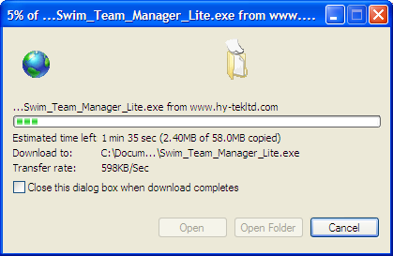

Click on Close

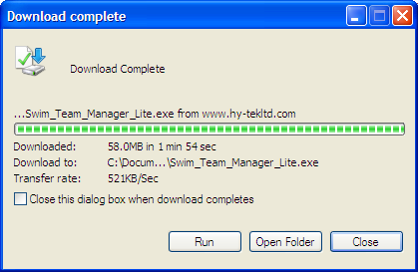

  - If an Open File – Security Warning window appears, then click on Run. Accept the License Agreement, continue to click on the Next> buttons, and finally click on the Finish button. This takes several minutes.

  - Next, go to your desktop and click on the icon – SWIM_TEAM_MANAGER_LITE.exe. (It’s blue and white). This will be the next screen:

Click on Run

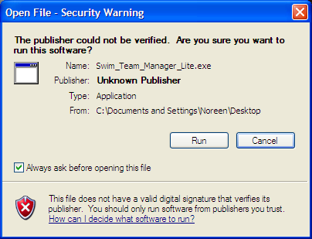

  - If the InstallSheild Wizard for TEAM MANAGER Lite 7.0 displays, click “NEXT” to continue the installation.

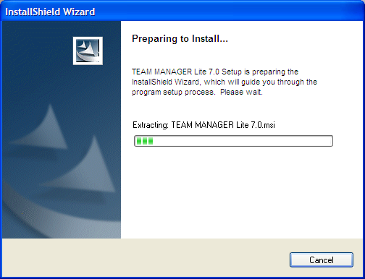

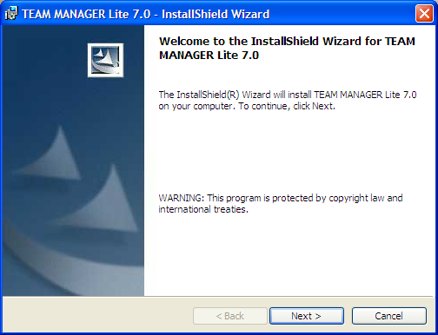

  - When prompted for the License Agreement, click on “I accept the terms in this license agreement” as in the screen shot below. Click on Next.

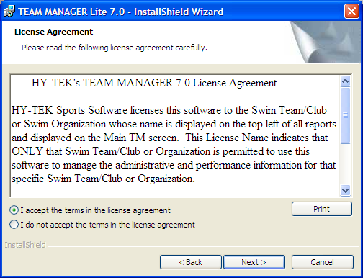

  - The system will default to creating & installing the software in a folder named C:/Hy-Sport/Swim TEAM MANAGER 7.0 Lite\. Click “NEXT” to proceed.

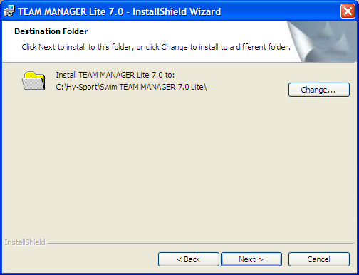

The InstallSheild Wizard will system will display a status on the progress of the installation as follows:

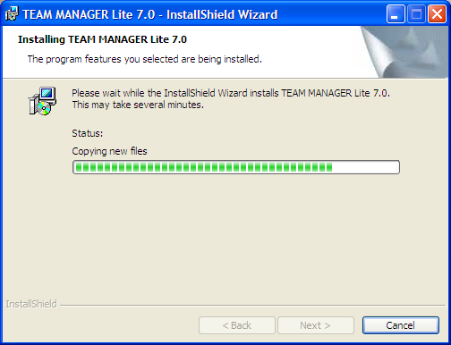

Once complete, the InstallSheild Wizard will advise that the install is completed. At this point, click on “FINISH”.

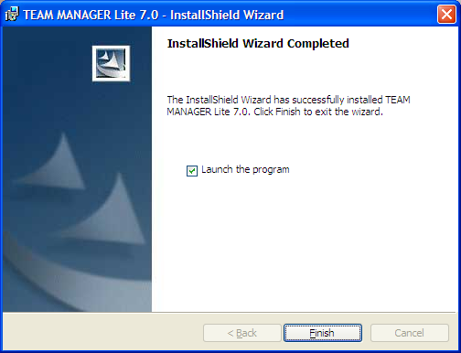

  - A Select Language window appears when TM Lite software first launches. Select the language of your choice and click OK. (English is the default)

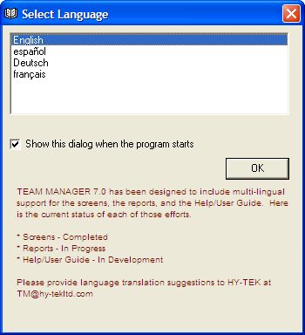

Once you click OK after language selection the TM Lite software will launch – click OK to continue.

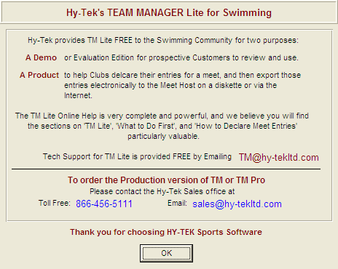

Step 2: Save Meet Events File

- Save the file:

Meet Events-MAIS State Swimming Championships 2017-20Sep2017-001.zip
that was included as an attachment to the email or on www.msmakos.org website with these instructions in a directory of your choosing. We suggest you save it in the TM Lite working directory (C:/Hy-Sport/Swim TEAM MANAGER 7.0 Lite\) which was created when you installed the TMLite software, or directly to your DESKTOP.

Either way, PLEASE make note of where you saved your file

- The first time that you use the software, it will load up, but there will be a message at the top left of the screen that says “NO DATABASE OPEN”.

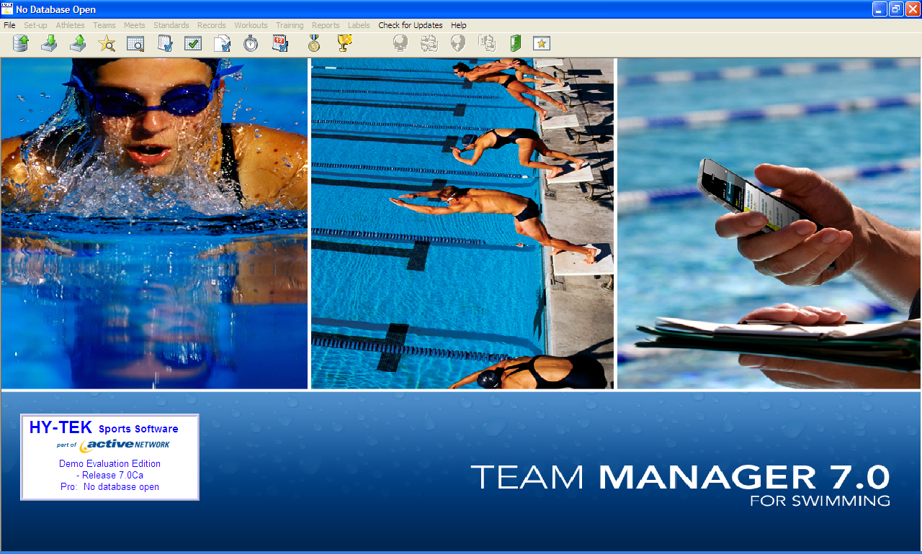

- Click on the File option on the main menu and select Open/New. You will see the following screen – enter the name of your database. Example: “JA 2014”

Step 3: Import Meet Events

- Now return to the top level menu. You now need to import the Meet Events file using File/Import/Meet Events. You will look in your directory where you saved the file.
Meet Events-MAIS State Swimming Championships 2017-20Sep2017-001

File, then scroll down to Import, then scroll down to Meet events

This will import the meet and the events for you.

Step 4: Create Team Information

- Next you will create your team in the database. From the top level menu select Teams from the menu bar.

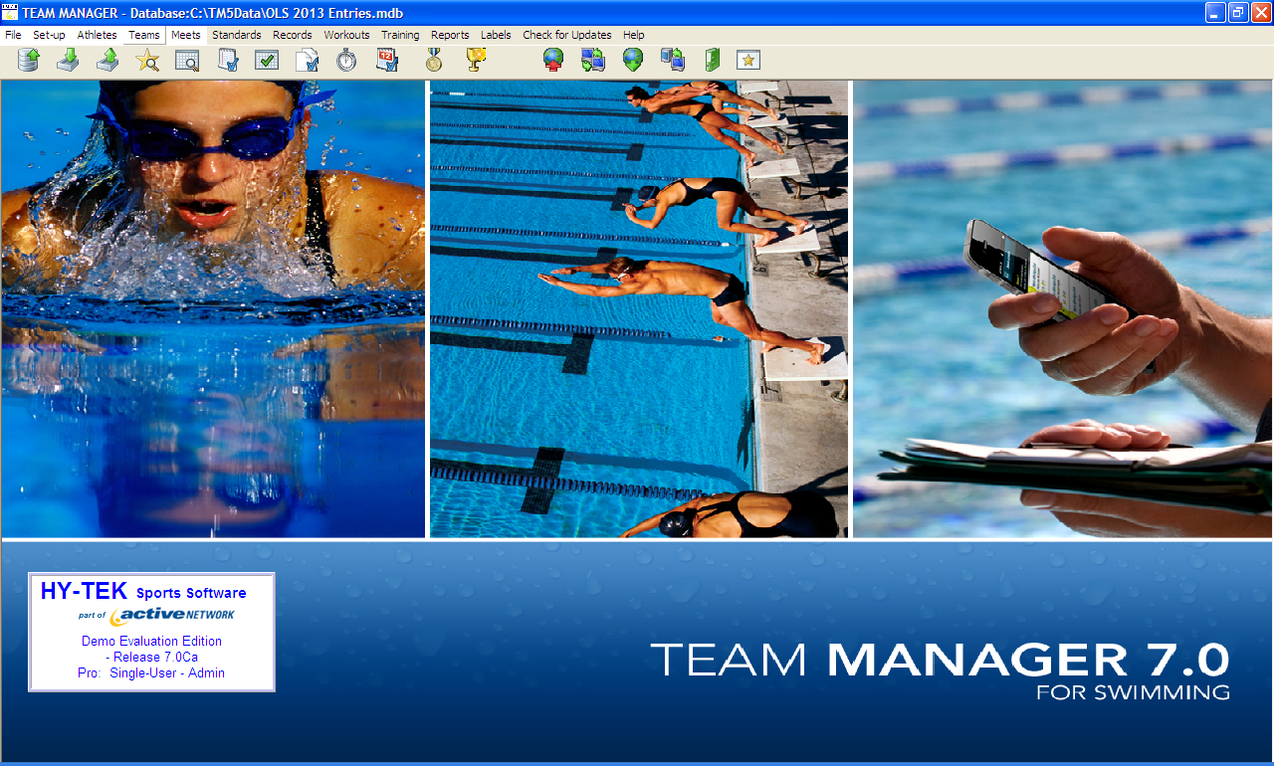

- The Team Manager window appears.
- Menu Select Add. The Team Maintenance Window below appears.

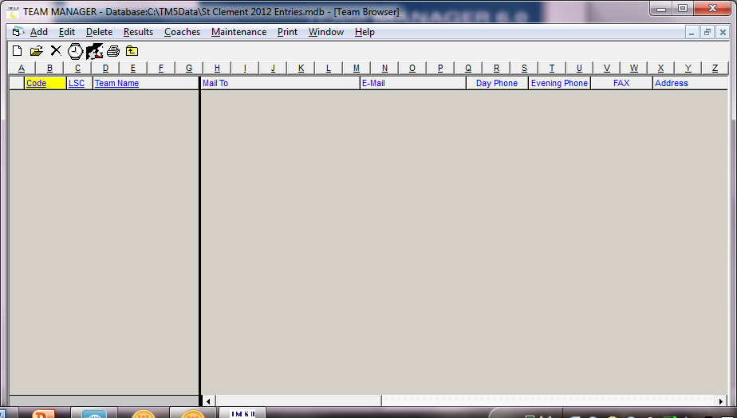

- Enter up to a five digit abbreviation for your team name under Team Abbr (this appears in the Program Guide) and your full school name under Team Name. Click OK.
- After you Click OK, the screen remains so click Cancel to exit.

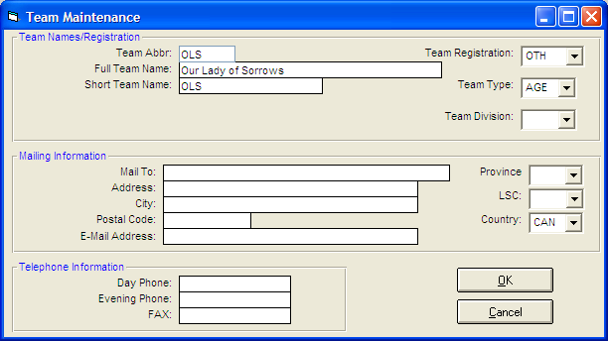

- From the top menu select Coaches. Menu Select Add. The Coach Maintenance dialogue box will appear.

- Enter the name of the head coach and key contact information. Enter OK. Exit the Team Manager window and return to the top level menu by clicking on the big Black up arrow. This will always take you to the HOME PAGE.

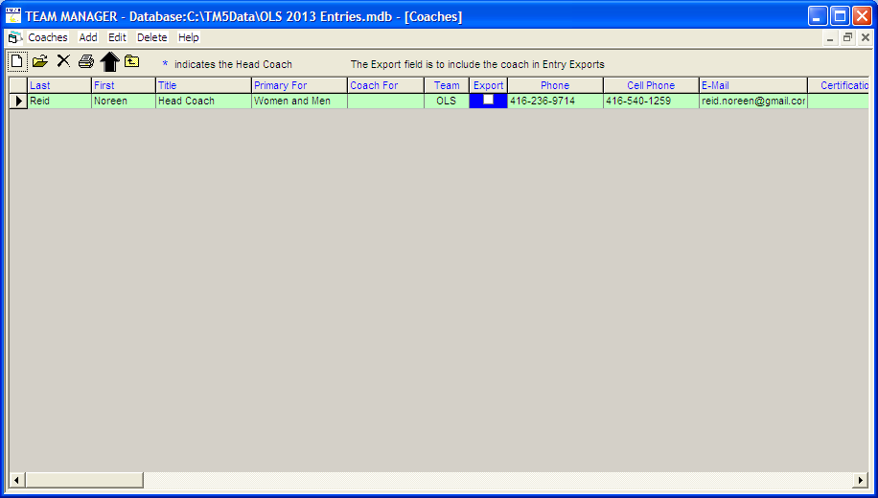
Next you will need to add athletes under the athletes tab.
Once you have entered your athletes in the database, now you will enter under the Meets tab.

