Mathew Mixon will be joining the Sunkist Swim Team as Head Coach. A native of Brandon, Mississippi, he started recreational youth sports at an early age and continued through the collegiate level. He attended nationally ranked Division II Delta State University where he earned several top 8 finishes at the NSISL Conference Championship. Mathew graduated with a bachelor degree in Commercial Aviation with a specialization in Aviation Management.
Coach Mixon has over 32 years of experience and knowledge in the sport of swimming. Mixon joined the Vicksburg Swim Association (VSA) as Head Coach in November 2008. Since then, the swim team has grown in size, sportsmanship and achievement. Years of practice paid off, and twice (2016 and 2018) Mixon was named Mississippi Swimming’s Age Group Coach of the Year. Mathew has previously served as Head Women’s and Men’s Coach at Madison Central, Brandon, Warren Central, and St Aloysius High Schools. In addition to leading the VSA Killer Whales, Mathew has had the privilege to serve on the Mississippi Swimming Board of Directors for the past seven years in various roles including Technical Planning Chair, Age Group Chair, and as the Administrative Vice-Chair. Mathew has represented our state as an All-Star Coach and three times as the Mississippi Zone Team Coach, twice as an assistant and once as head coach. He continues to devote hours of time towards his passion for the sport. He is constantly continuing his pursuit of updated education and advancements in the sport by attending clinics such as: ASCA World Clinic in Vegas, USA Swimming Convention in Anaheim, Kansas City, and Atlanta.
Mathew is owner and CEO of Live Slow Swim Fast LLC, a learn to swim company, and has provided thousands of private stroke lessons for the past 21 years ranging from very beginners to nationally ranked USA Swimming age group swimmers. In 2016, he developed and implemented a water safety and learn to swim program called Schools Practicing Life Altering Swim Habits (SPLASH) in over 250 2nd and 3rd grade students throughout the community were given the lifesaving opportunity of learning water safety and water awareness.
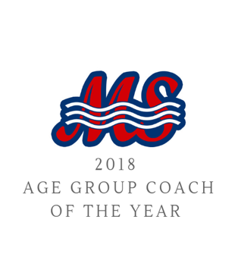
Some fun facts about Mathew are he has been skydiving twice, is a 2 x Full Distance Ironman Finisher, and he recently completed the 10.6 mile Viking Swim across Lake Tahoe. He and his wife Lindsay have two beautiful girls named Vida and Layla.
