“Home” - Navigate to www.teamunify.com/msswsc.
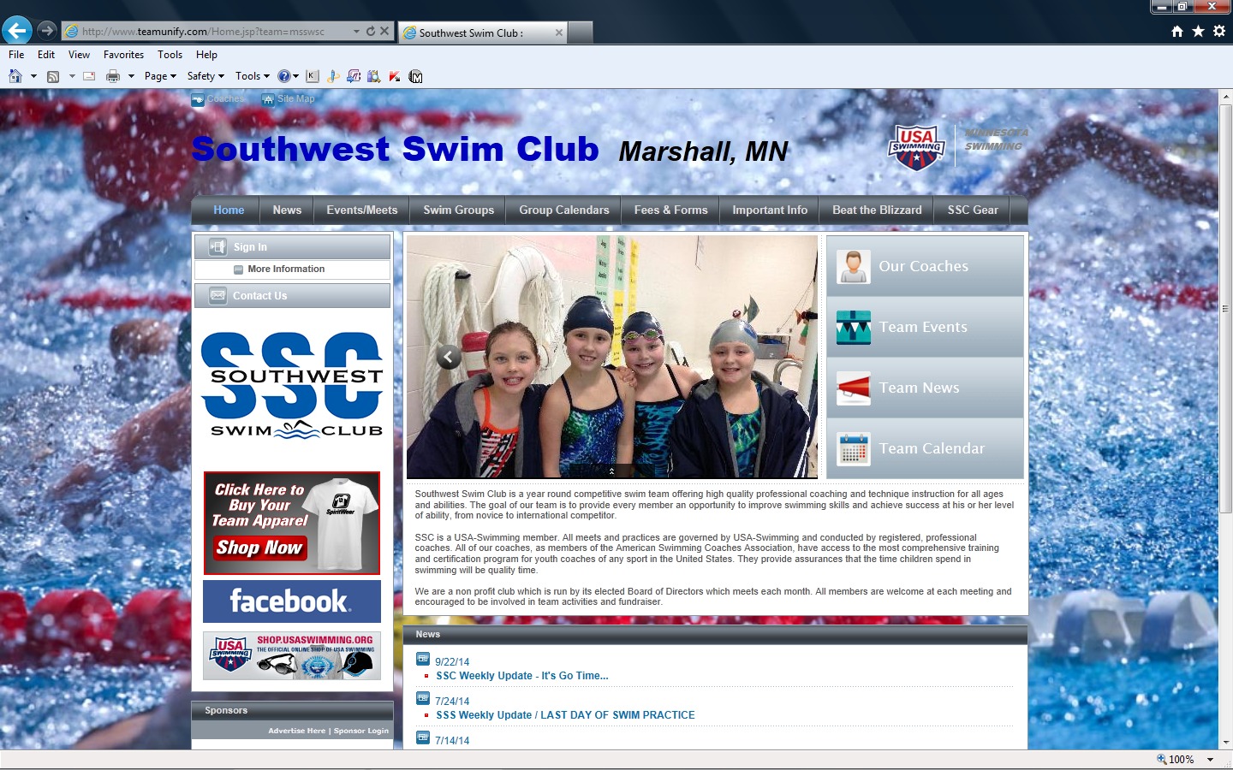
“Sign In” - Click on “Sign In” (top left). Enter E-mail and password. Click “Sign In”.
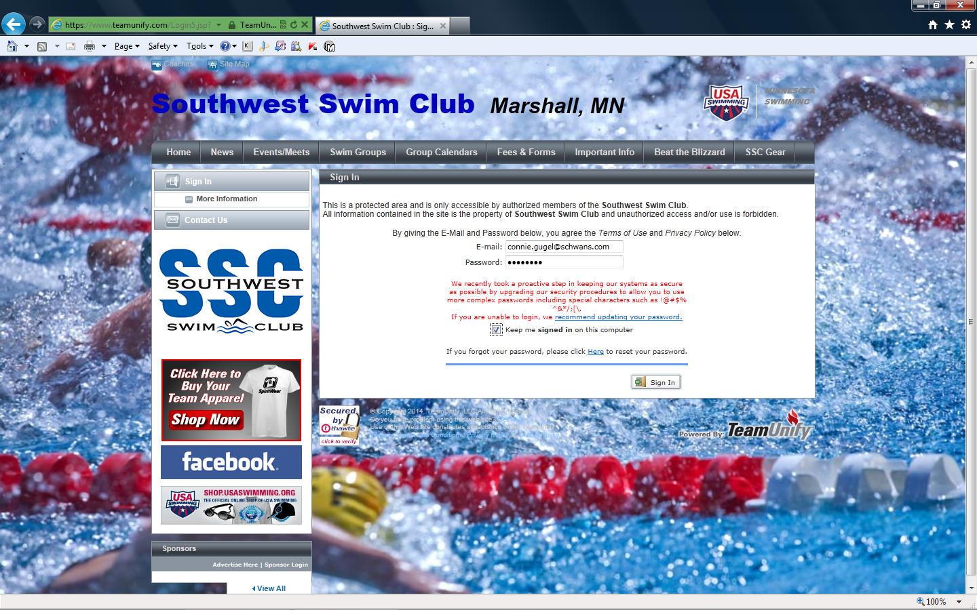

“News” – Weekly updates, weather announcements, etc.
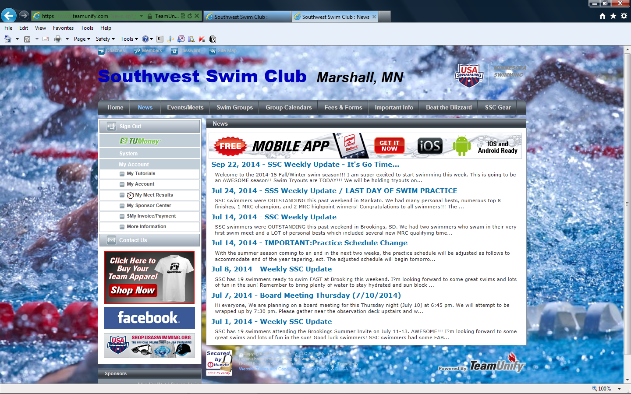

“Group Calendars” – Calendars for General Events and Practice Schedules for each swim group
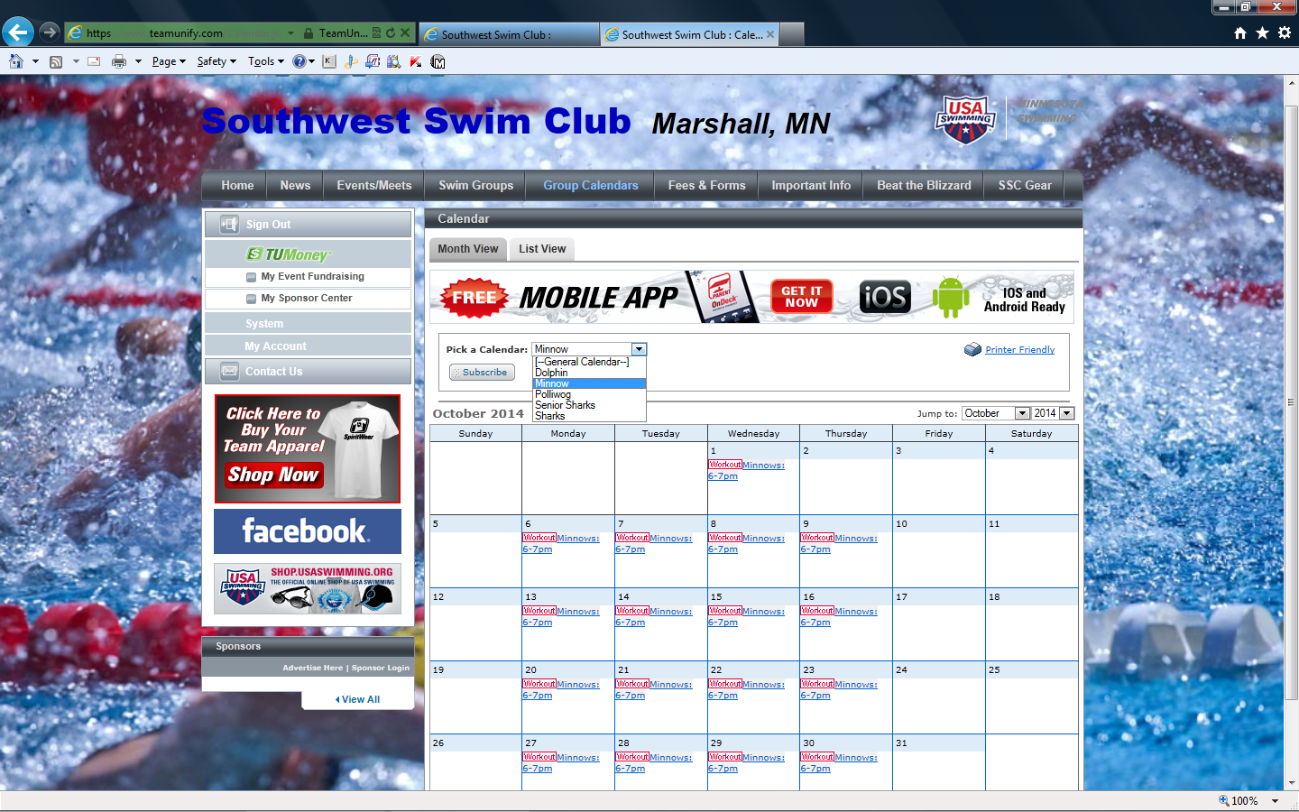
“My Account” – General Account Information
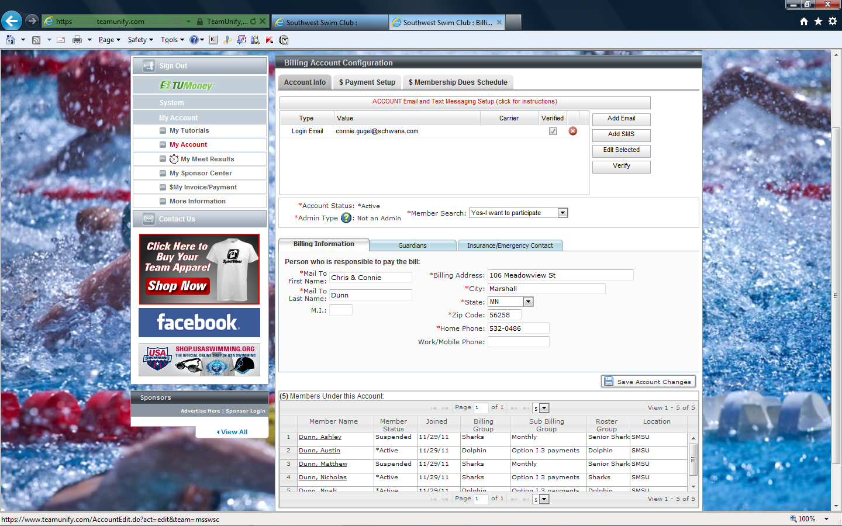

“My Meet Results” – Swim meet results for your swimmer(s)
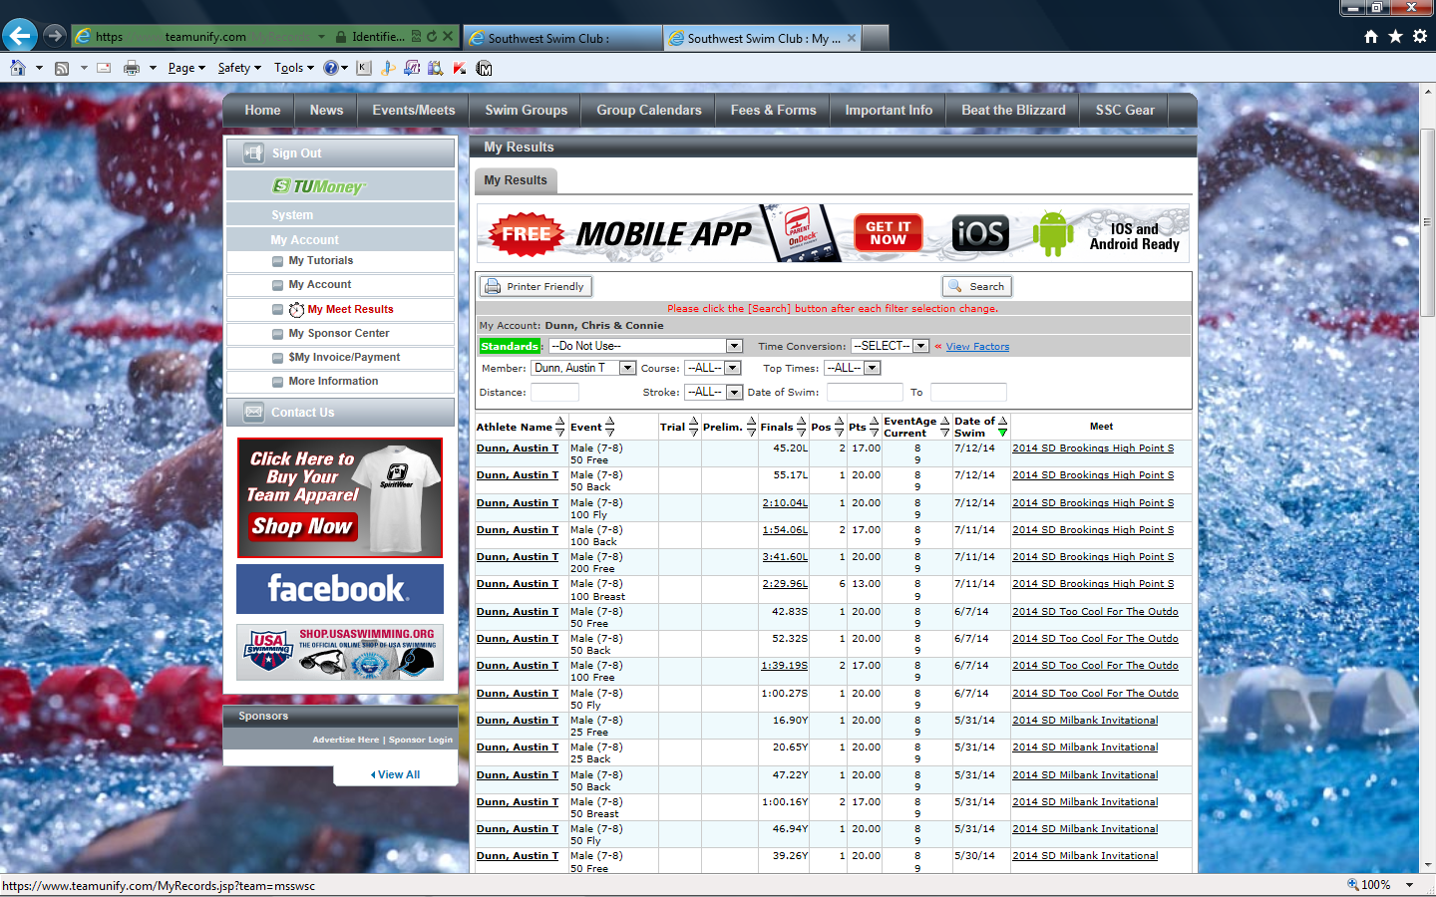
“My Invoices/Payments” – Account Information including current invoice summary, projected amount owed, and history. NOTE: Recurring charges (i.e. SSC Fees) are billed on the 1st of each month. Non-recurring charges/credits and payments/refunds are recorded during the month (i.e. swim meet fees).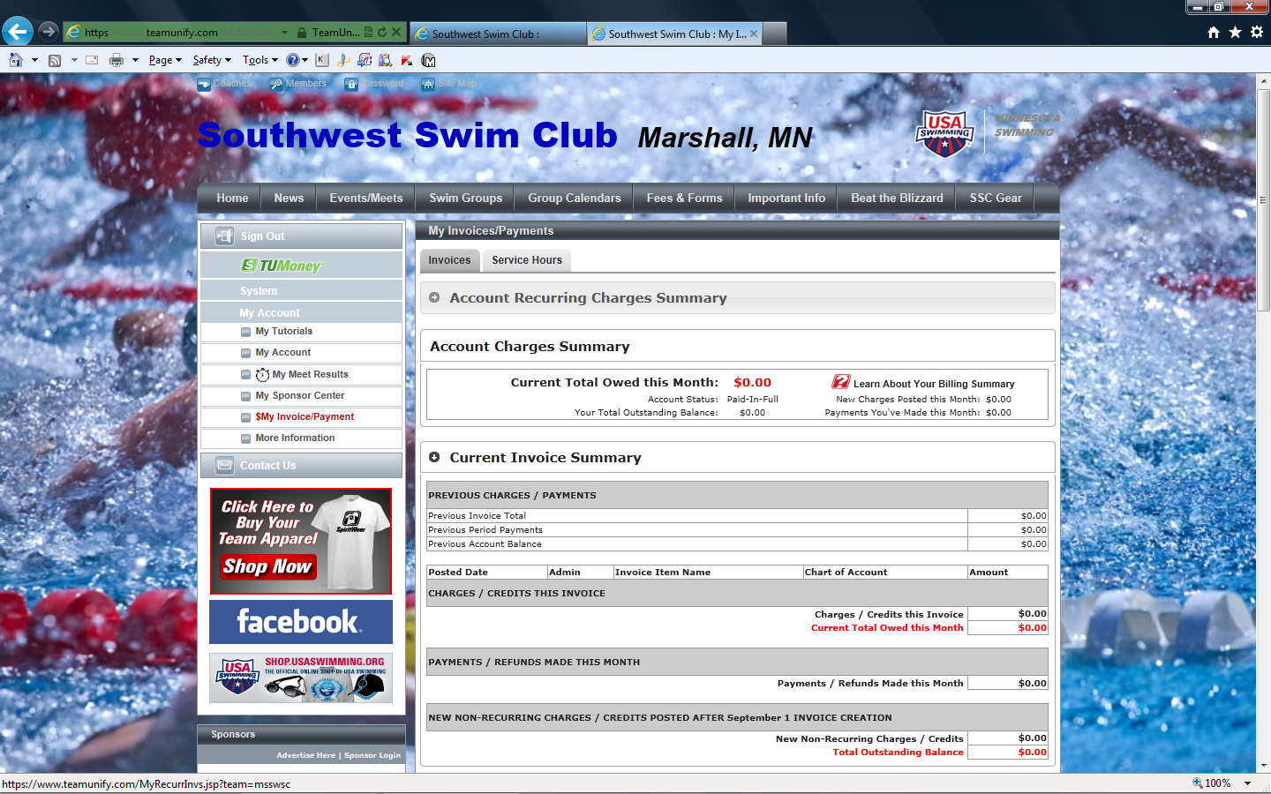 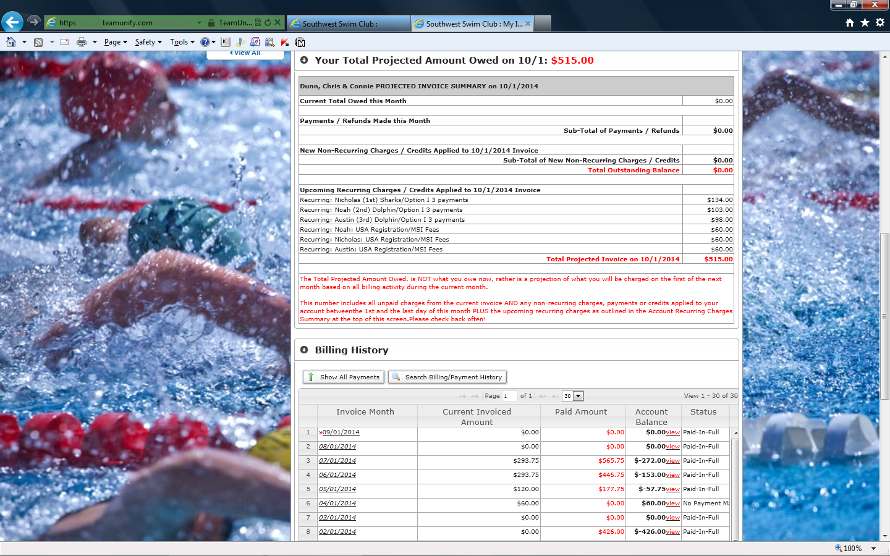
“Events/Meets” – Information concerning upcoming events. For events that require a commitment, the site will display an “Attend/Decline” button. Click on the button to indicate if you wish to attend or not.
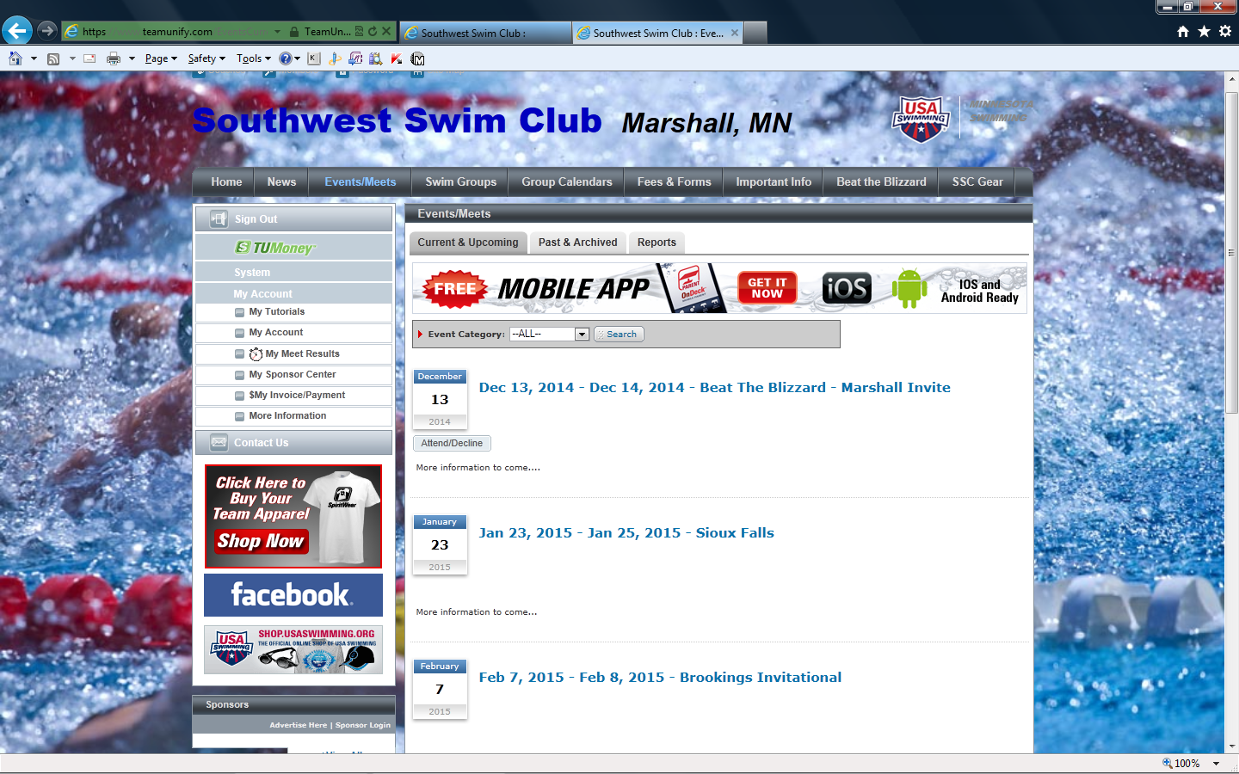
Select your member that you are making the commitment for.
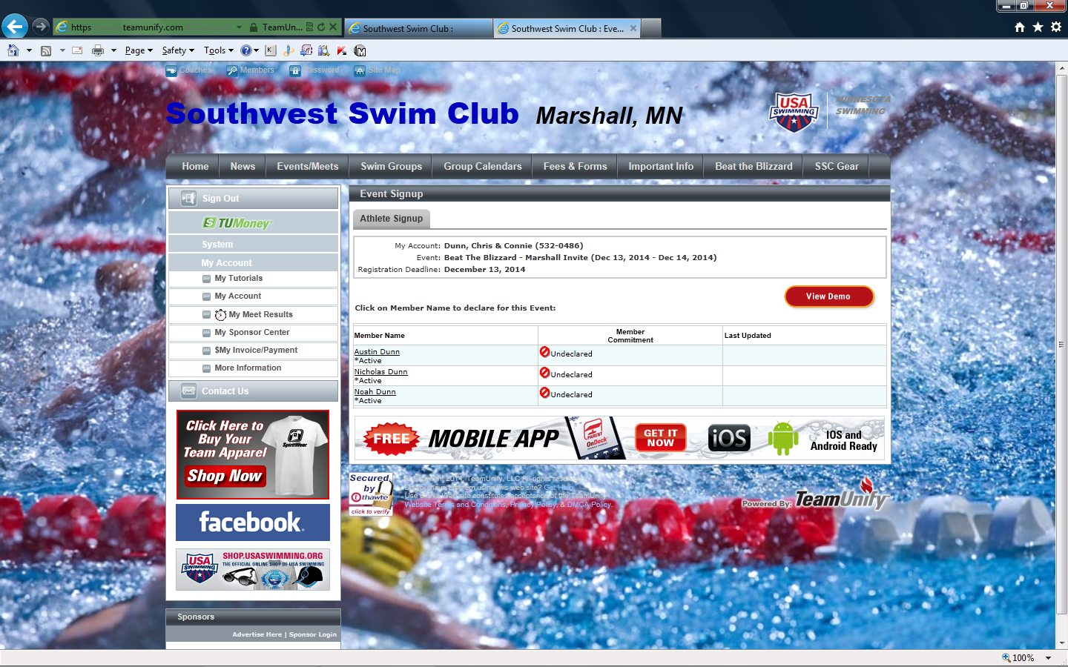
Indicate if your swimmer will be attending the event.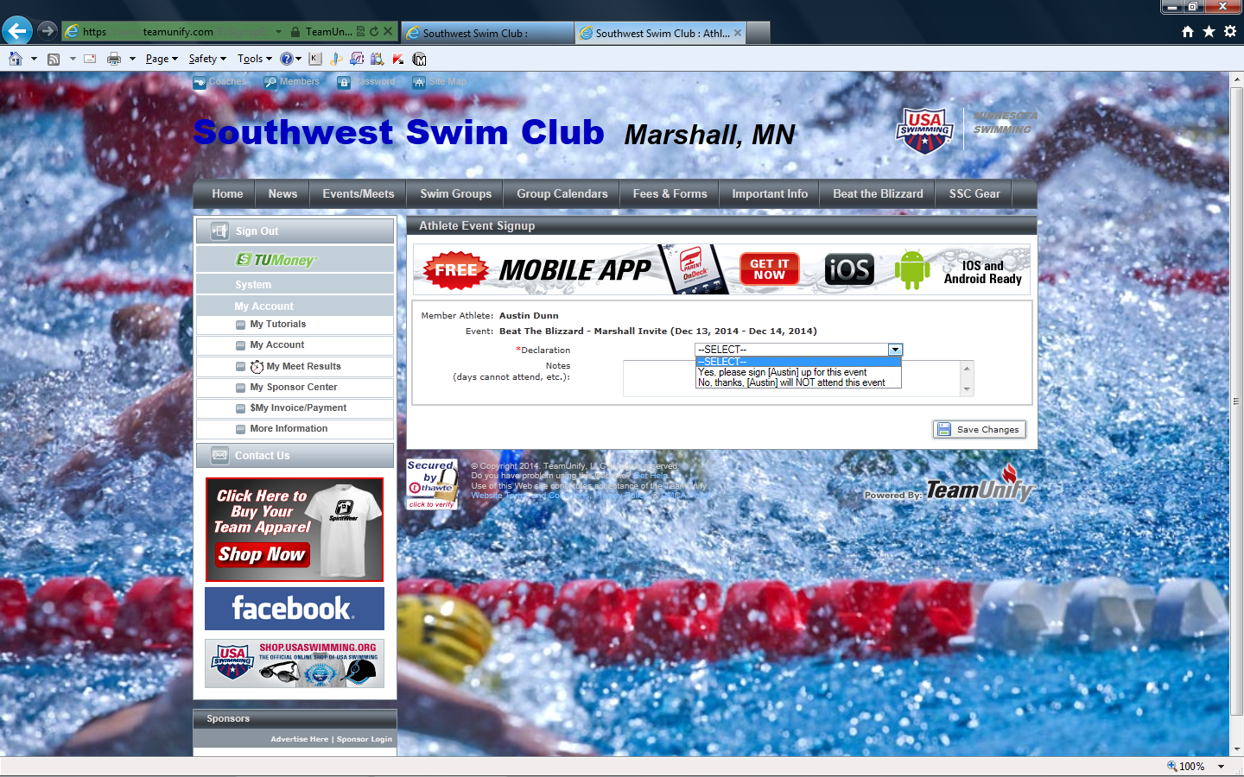
If the event is a swim meet, you will be able choose the events for your swimmer(s). Check the events for you swimmer and choose the “SAVE CHANGES” at the bottom.
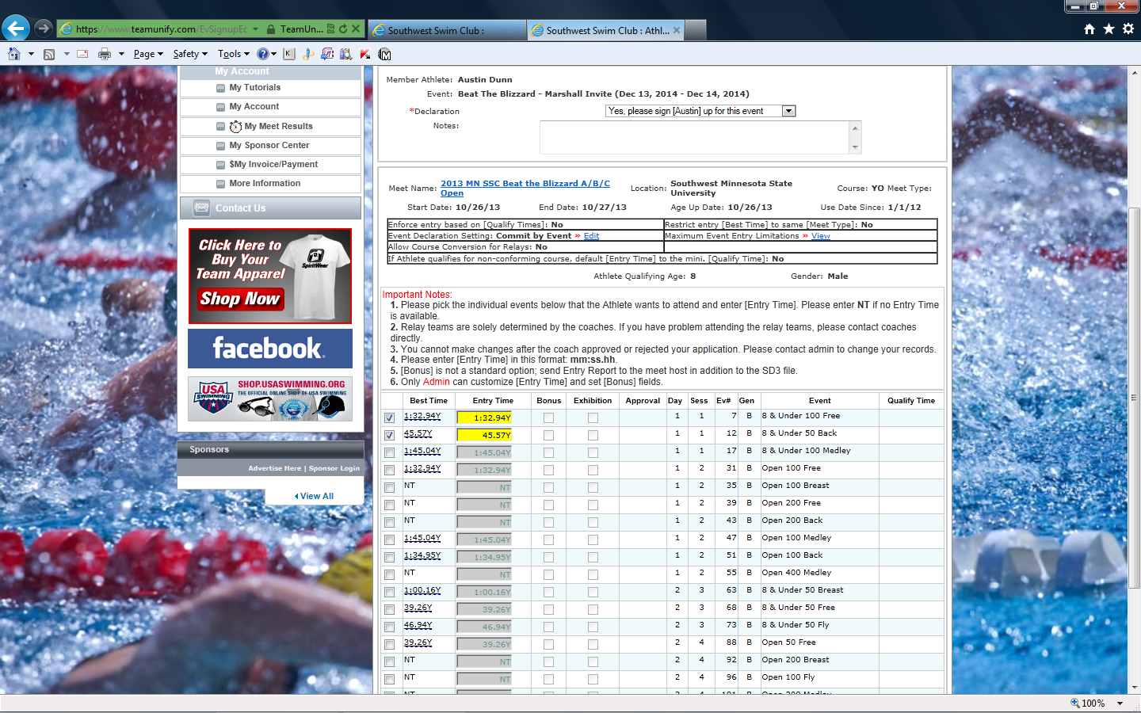
Your swimmer(s) is now signed up for the event.
