Instructions for Attending Your First Swim Meet
Note that these instructions are directed towards parents, so you can be as prepared as possible. Use your judgement to determine how much to tell your children. Often, nervous swimmers can be overwhelmed with information and make them too uneasy to swim. Always remember that the most important thing at a swim meet is to have fun! We’d like each swimmer to get to their races and do their best and we can build up to the rest!

What to do in advance

Meet registration
Make sure you have registered for the meet correctly. The team will have sent out an email with the registrations deadline and the appropriate process to register on your team’s website. When you register, it is best to take note of the events your child will be swimming and which days those events are on. This will make the day of the meet much easier. Please double check events right before the meet as the coach might add or subtract events based on what they feel your swimmer is capable of swimming.

The meet contract
Once you have registered your child for the meet, you should familiarize yourself with the meet contract. It can be found at montanaswimming.com under ‘Meets’. There, choose which meet you are attending and the link to the contract and any other related documents will be posted. The contract is a long document but it has a ton of important information. You can find the location of the pool, the structure of the meet and any specific rules swimmers and parents must follow. Most meet contracts have similar content so you will become more comfortable with them as you become more familiar with the swim meet process.

Make your hotel reservation
Unless the meet is in Bozeman or you are willing to commute every morning, you will likely be staying in a hotel. The team usually has a block of rooms at a hotel where most of our families stay at a slight discount. That information might be sent out by email prior to the meet. It is always on our webpage under events and the specific meet.

What to bring

Food
Swim meets can last the entire day and your swimmer is going to need fuel. There is a concession stand, but the food is usually not very healthy. It is best to bring healthier food from home that can fuel your swimmer through the weekend. Some families even bring a small cooler with sandwiches, fruit, yogurt and other healthy snacks.

Camping
Camping is almost exactly what it sounds like, at every pool there is room for teams and families to spread out their things and get comfortable. You will be at the pool for almost the entire weekend and you might have younger children who will not be able to sit in the bleachers all weekend. They need an area to play and your swimmers need space to relax and refuel. Most families bring plenty of blankets and towels that can be laid out on the ground. Camping chairs also serve as a good spot to rest for both children and adults.

What to do when you get there

Warm ups
Your first priority as a parent is to make sure your swimmer gets adequate warm up time. Warm up is vital to not only warming up the muscles but also getting used to the pool. Every pool is different and the swimmers need a chance to get as comfortable in it as possible before racing. If you are running late, make sure your swimmer goes straight to the locker rooms to change and then straight to find their coaches who can direct them to the correct warm up lane. Warm up times and instructions will be emailed out about 2 days before the start of the meet.

Camping
The next thing to do would be to set up camp. Everyone usually camps with their team so you should find other families from your team and try to set up near them.

Programs
After you have claimed your spot, you can buy a program. They usually run $5-$10 and can be found at a table usually near the building’s entrance. Your program will tell you everything you need to know about when your child will swim.

How does a swim meet work?
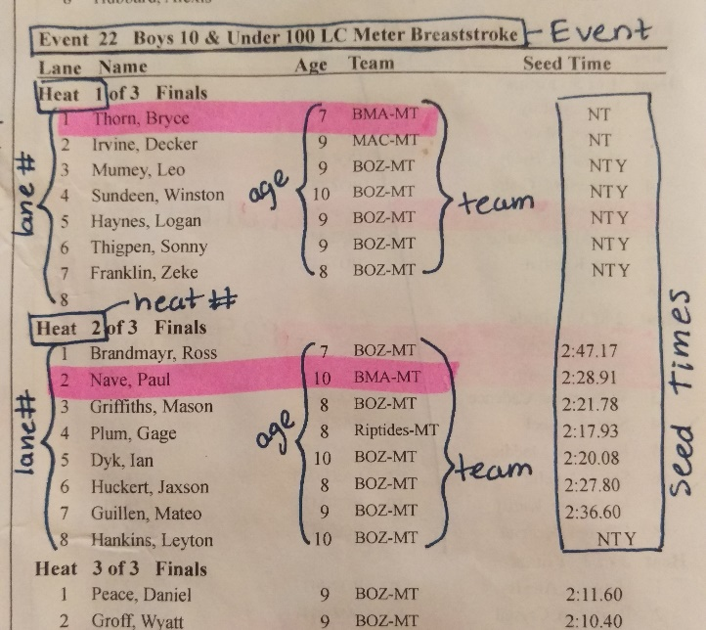
Your program will be your guide throughout the entire meet. This is where the list of events you signed up for comes in handy. You use that list to go through the program and highlight your swimmer’s name (note the example on the right). Your swimmer will be assigned an event, heat, and lane for each race. The swimmers are split into heats of 8 (sometimes 6 or 7, depending on how many lanes the pool has) based on their seed time. A seed time is the swimmer’s previous personal best time. There is a big screen at every pool that will have the current event and heat displayed.
Event | Heat | Lane
3 | 5 | 1 | 50 Free
7 | 2 | 7 | 25 Breast
13 | 1 | 3 | 25 Fly
The best way for your swimmer to keep track of when they are supposed to swim is to write their event, heat and lane in permanent marker on their leg or arm in the following format:
Note: the more you can abbreviate the table above, the less ink you are putting on your child’s skin. Event, Heat, and Lane can be shortened into E, H, L and the strokes can be even further condensed into FL, BK, BR, FR, as long as your swimmer will still be able to understand when and what they need to swim.
Tip: Goo Gone is a great tool to get the permanent marker off the skin after the meet.

Getting ready to race

When to head down
You want to send your swimmer down to the coaches about 15 minutes before their race. To figure out when that will be, count backwards in your program, paying attention to the seed times for each heat and estimate that that heat will take just under that amount of time. Example: if the races before your child’s are the 50 freestyle’s, they can run as quickly as 30 seconds each, but the 200 breaststroke heats can be closer to 3 minutes.

Talking to your coaches
Before each race (unless you are running very late) your swimmer should go talk to their coach about their race. Coaches will give tips, things to remember, and as they get older, a racing strategy. This can be helpful if your child is nervous, so the coaches can reassure and encourage them.

Getting ready to swim
After talking to your coaches, your swimmer should head to the lane where they will swim and wait for their turn. When the heat before them dives in, your swimmer should be ready to go next standing right behind the block. (If they aren’t ready to go off the blocks yet, they can dive off the side)

The race
When the last person in the heat before your swimmer finishes, the starter will blow three short whistles. These just mean ‘get ready’. Then, when all swimmers are accounted for, one long blast will be blown. This means ‘get up on the block’ (or ‘step down into the water for a backstroke start). All swimmers must set their feet and then the starter will say “take your mark” and then a beep will sound to signal the start of the race. At this point, the swimmers dive in and race. For the younger swimmers, it is usually a good idea to remind them to touch the wall hard at the end. There are touch pads at the end of each lane that serve as 1 of 3 methods of stopping the clock and getting your swimmers time. If they do soft touch, the secondary time will be taken, but the touchpad time would have been more accurate. If there is a soft touch the clock will not display a time. Please know this does mean a disqualification.
In the event a swimmer does something in a race that they aren’t supposed to do (such as turn onto their stomach during backstroke) they will be disqualified by an official. The coach will get the disqualification slips so that we know why the swimmer was disqualified. We view disqualifications as a learning opportunity and a way to get better. Please do not ever approach an official to ask why your child was disqualified, always ask the coach if you have a question.
Note: Sometimes, when the starter says, “take your mark” the swimmers are moving too much, so they will say “stand” (or “relax” if they are in the water for a backstroke start). If this happens, the swimmers should all relax and get ready to “take your mark” again. If a swimmer is too tense and falls off the blocks because they are expecting the beep, they should just relax, get out of the water and back on the blocks to try again.

After the race
After the race, make sure your swimmer has a towel to dry off with and some clothes to put on if it’s cold. Then they should head back to the coaches so they can get feedback on their race. Coaches will share their time, splits, what they did well, and how they can improve next time.

Being part of a team
Even though your child will be racing alone in the lane, swimming is entirely a team sport. How your swimmer places in their event gets added to the scores of the other swimmers on our team and the teams are placed accordingly. Being part of a team is part of what makes swimming such a fun sport. You represent yourself as well as your team and that is something to be proud of.

Warm up
Each team has an assigned lane and all the swimmers from each team warm up together. Immediately after warm up the teams meet and have a team meeting. Here, most teams will also do a team cheer.

Camping
Teams usually camp together. This serves as a great bonding experience for the swimmers and parents. When a swimmer has a good race, it’s a great feeling to come back to camp to all your friends congratulating you.

Racing
Even though your swimmer isn’t racing all the time, the team almost always has someone in the water. It is encouraged that all the swimmers who aren’t swimming at the time, cheer for the swimmers that are in the pool. Seeing a group of your teammates standing at the end of your lane before you dive in and hearing them yell for you while you turn is incredibly encouraging and hopefully that swimmer will return the favor when your child swims.

Team dinners
Sometimes on one of nights of the meet, the families of the team all meet and have dinner together. This is always organized by the parents and is not required but encouraged to build team spirit.

