Bozeman Multisport Aquatics (BMA)
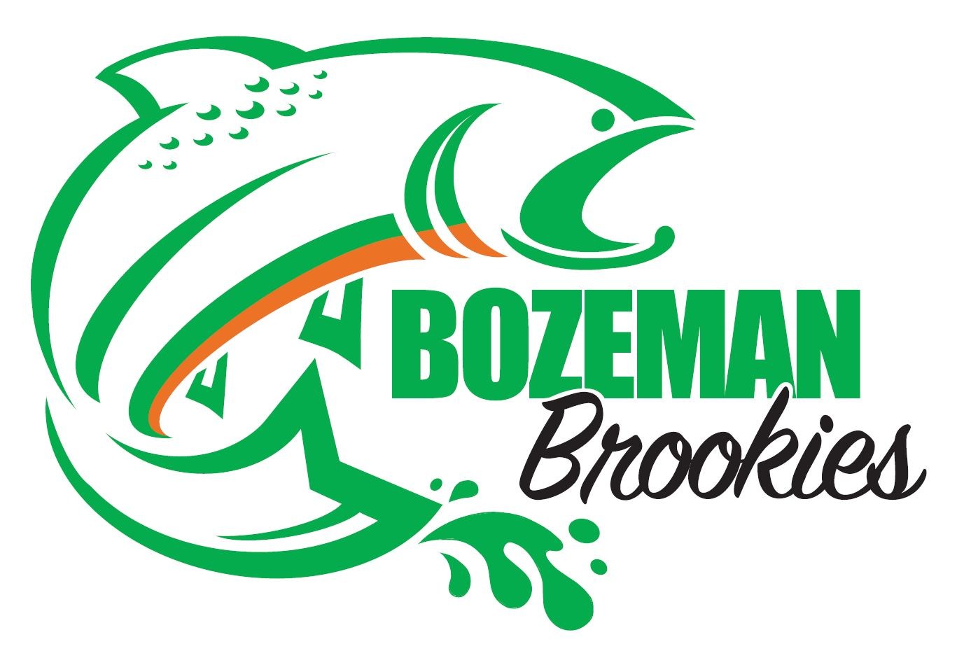
Swimmer and Parent
Handbook

Introduction
Welcome to the Bozeman Multisport Aquatic Swim Team.
The BMA Swim Team was founded on the basic principle that swimming should be a fun activity, as well as a sport with lifelong rewards for the swimmers. Bozeman Multisport Aquatics strives to provide a healthy, positive, and motivating environment to train for competition, fitness, and fun.
BMA is a member of the USA Swimming team program and all BMA swimmers must also join USA Swimming. Membership in USA Swimming provides many benefits at a nominal cost.
The success of any swim team depends both on having good coaches and also on the support of the parents. Our coaches are focused on giving swimmers individual attention regarding their training and positive encouragement to help them succeed. Parents help by volunteering their talents to the swim club and by providing the love and support that their swimmer needs to be successful.
Based on the founding principles, the BMA Swim Team will continue to grow as swimmers benefit from the fun and healthy environment we provide.

BMA Mission Statement
A swim club for competitive swim athletes, Bozeman Multisport Aquatics provides a healthy, positive, and motivating environment to train for competition, fitness, and fun. Our athletes have opportunities to engage in activities designed to foster leadership and communication skills while promoting a healthy lifestyle.

BMA Swim Team Goals
1. To provide a positive, fun, and motivating environment where the swimmers are encouraged to set goals, learn technique, improve their performance, and enjoy swimming.
2. To provide a comprehensive swim program that includes swim training and dryland conditioning which promote a healthy balance in physical development.
3. To establish a swim club that provides advanced technique training for competitive swimming as well as an opportunity for beginners and part-time swimmers to improve their swimming skills.
4. To establish a swim club that is fun.

Financial Obligations as of April 1, 2019
Group | Practices Per Week | Monthly Fee
Orange | Up to 3 | $75
Green | Up to 3 | $75
Black | Up to 4 | $90
Part-Time Seniors | Up to 4 | $100
Full-Time Seniors | Up to 8 | $125

All athletes must complete a USA Swimming Athlete Application before attending their first practice (see USA Swimming information below).
BMA fees may be paid by credit card or bank withdrawal through our website, or the entire season may be paid by check at the beginning of the season for a 5% discount. Thirty days notice must be given if an athlete wishes to withdraw mid-season. Fees are paid for the entire month with no prorating.
BMA Meet fees: BMA charges meet fees for every meet attended. Most meets have a $50 surcharge plus a $2-$3 event splash fee. BMA sends the host team $18-$25 per swimmer surcharge plus the per event splash fee. BMA also pays for relays from the excess surcharge monies. BMA uses the rest of the surcharge to pay coaching meet salaries and expenses. Typical meets will cost approximately $74 if the swimmer swims the whole slate of events.
BMA has a mandatory fundraising requirement of $100 per swimmer. There will be one annual fundraising Swim-a-thon held at the beginning of each short course swim season. The proceeds that swimmers raise are applied to the operating budget, making the monthly fees listed above more affordable.

Practice Group Definitions and Expectations
Orange
Requirements:
Ages 6+
Swimmers in this group need to be able to complete one length of the pool in either Freestyle or Backstroke to join.
Focus of group:
Main focus for this group is learning all 4 competitive stroke techniques as well as proper starts, turns, and streamlines. The will begin to learn lane etiquette and proper spacing between swimmers.
Move up requirements to Green:
6 x 50 free swim on 1:30
6 x 50 kick on 1:40
Practice attendance advised for optimal results 3 practices a week. Dues for this group are $75/month.

Green
Requirements:
Ages 7-13
Swimmers in this group need to have a knowledge of all 4 competitive strokes.
Focus of group:
Main focus is completing the 100 IM legally by the end of the season, technique is still a focus in this group not training, 50% of practices are kick and drill based with the intention of developing good habits and a good foundation for the future. They will start learning how to read the pace clock and understand the concept of intervals.
Move up requirements to Black:
Ages 10+
6 x 100 free swim on 2:15
6 x 100 kick on 2:30
Practice attendance advised for optimal results 3 practices a week.Dues for this group are $75/month.

Orange/Green Plus Starts and Turns
These groups practice with their same roster group but have an additional practice on Friday each week consisting of working on starts and turns specifically. Dues for this group are $80/month.

Black
Requirements:
Ages 10-15
Swimmers in this group need to be able to train all four competitive strokes.
Focus of group:
The main focus is to swim the 200 IM legally at most meets. Swimmers will train both aerobically and race pace and will see complete sets that will prepare them for the move to Seniors.
Move up requirements to Seniors:
Ages 13+
8 x 100 free swim on 1:40
8 x 100 kick on 2:00
Practice attendance advised for optimal results 4-5 practices a week. There are 2 black groups. Black - 4 may attend practice up to 4 days per week. Dues for Black - 4 are $85/month. Black - 5 may practice up to 5 times a week. Dues for Black - 5 are $100/month.

Part-time Seniors
Requirements:
Ages 13+
Swimmers in this group need to be able to train all four competitive strokes.
A member of this group can swim all 4 strokes legally and is capable of interval training and endurance work. The purpose of this group is to provide a training opportunity for those athletes who are involved in multiple sports or who want to stay in shape for High School swimming. This group will practice 3-4 times a week for 2 hours. Dues for this group are $100/month.

Full-time Seniors
Requirements:
Ages 13+
Swimmers in this group need to be able to train all four competitive strokes.
Focus of group:
The main focus is to swim the 400 IM legally as well as complete the IMX ranking. Swimmers will have the option to do doubles on Monday by attending morning practice. The group focus is on preparing swimmers to swim collegiately at the next level.
Practice attendance advised for optimal results 7 practices a week.
Dues for this group are $125/month.

Long Course Practice Schedule
Orange: Mon & Wed 6:15-7:15 pm; Friday 4:00-5:00 pm, Sat 9:00-10:00 am. (Choose up to 3 including Saturday if possible)
Green: Mon & Wed 6:15-7:15 pm; Friday 4:00-5:00 pm, Sat 8:00-9:00 am. (Choose up to 3 including Saturday if possible)
Orange/Green Plus Starts and Turns: Same practice options but includes Friday 5:00-6:00 pm for concentrated start and turn practice.
Black: Mon, Tues, Wed, & Thur 6:15-7:45pm; Friday 4:00-5:30 pm, Sat 8:00-10:00 am Mon & Fri 5:45-7:15am (Choose up to 4 or 5 depending on if your swimmer is registered in Black - 4 or Black - 5).
Seniors Part-time: Mon, Tues, Wed, & Thur 6:15-8:15pm; Friday 4:00-6:00 pm, Sat 8:00-10:00 am Mon & Fri 5:45-7:15am (Choose up to 4).
Seniors Full-time: Mon, Tues, Wed, & Thur 6:15-8:15pm; Friday 4:00-6:00 pm, Sat 8:00-10:00 am Mon & Fri 5:45-7:15am (Choose up to 8).
All groups practice at Bozeman Swim Center.
Not all Saturday practices will be available either because the Swim Center is booked or the team is away at meets.

Swimming Plus Other Activities?
One of the most important and often-asked question is whether or not swimmers should participate in other activities. The BMA position is that it is beneficial for swimmers to participate in activities other than just swimming.From a physical viewpoint, cross training and/or participation in other sports is known to help swimmers improve their overall athleticism, avoid injury, and have better muscle balance. Participating in other activities besides swimming also helps avoid burnout. The BMA approach to training includes dryland workouts designed to supplement the in-pool workouts. Also, the BMA practice schedule is designed to accommodate those swimmers who want to participate in other activities.

Required Items for Practice
Swimsuit, cap, goggles, water bottle, fins, pull buoy, and kickboard (pull buoys and kickboards are available at the Swim Center, but the swimmer may provide their own).

Parent’s Role
- Support and encourage your swimmer and also the other swimmers.
- Support the coaches.
- Support the program by volunteering.
- At any BMA event, be enthusiastic, courteous, respectful, and helpful.
- Contact a coach or Board Members with concerns. When contacting a coach, please wait until after practice so as not to distract the coach from coaching. You may contact by email or phone also.

Parent Support
The USA Swimming community depends on parents to participate at meets as timers, officials (this requires special training), and other support roles, as well as, to be volunteer board members, to provide carpooling, and more. In addition, the BMA swim club has certain administrative tasks that must be met, such as providing qualified coaches, ensuring the safety of swimmers, program planning, and budgeting. Parents are encouraged to volunteer their individual talents and abilities which will help run a productive and successful swimming club.

Swim Meet Information
Each season’s meet schedule is posted on the team website. These are meets that the BMA coaches will attend and all qualified swimmers are encouraged to attend. If a swimmer would like to swim at a meet that is not on our schedule, they are welcome to do that but may need to make special arrangements for coaching at that meet. It is not required that swimmers attend meets, but it helps swimmers track their training progress, and it can be a fun and rewarding experience.

Age Group Classifications
There are seven age groups recognized by USA Swimming: 8 & under, 10 & Under, 11-12, 13-14, 15-16, and 17-18, and Senior. The swimmer’s age on the first day of the meet will govern the swimmer’s age group for the entire meet. Within each age group, there are different “ability levels” or “classifications” (AAAA, AAA, AA, A, BB, B). Time standards for each classification are established and published each year by USA Swimming.

Types of Meets
The types of meets that BMA will participate in are:
- Age Group Meets: Swimmers compete in events designated for their age group.
- Qualification Meets: These meets have some type of qualification time standard(s) that a swimmer must meet in order to enter the meet.
- Montana Age Group State Championships: These qualifying meets are held at the end of each short course and long course season. All qualified age-groupers are encouraged to attend the State Championship meets. The Short Course Championship Meet is held annually in early March and the Long Course Championship Meet is held in late July.
- Higher Level Meets: These qualifying meets include Jr. Nationals, Senior Sectionals, Age Group Regionals, Summer Senior Sectionals, Age Group and Senior Zones. Please contact coaches or www.usaswimming.org for more information.

A Guide for New Swimmers and Their Parents

What to Bring to a Meet
- Water and healthy snacks.
- Blanket or old sleeping bag.
- A couple of towels.
- A T-shirt and/or sweats (to put on between races to keep warm).
- Extra set of cap and goggles.
- Games, cards, etc. to pass the time between events and have fun with teammates.
- Lawn chairs (and a tent or shelter for outdoor meets).
- Highlighters and permanent marking pen.
- Money for program and concessions.

Arriving at the Swim Meet
You should plan to arrive at least 15 minutes before the beginning of your team’s warm-up time. The scheduled time will be sent to the swimmers/parents by e-mail from the coach.
Once at the meet, the swimmer should change, while the parent purchases a program which is usually available for sale near the entrance to the pool area or near the concessions.
At some meets, the program may list estimated times for the events. These are only approximate times, so you and your swimmer will always need to stay aware of the progress of the events. It is the swimmer’s responsibility to be at the start blocks before their races begin, but for new swimmers, some parental help may be needed.

Event Number-Heat-Lane
It is a good idea to bring a highlighter to mark all of your swimmer’s events in the program. You may also want to mark other team members’ events (having different colors can be helpful).
The swimmer’s “Event-Heat-Lane” information for every event that day should be written on an arm or leg using a permanent marker (it will come off in a few days). An example is given below:
E | H | L
3 | 3 | 3 | 25 back
17 | 2 | 2 | 50 fly
23 | 4 | 6 | 100 free
31 | 1 | 8 | 25 breast

“Camping” at the Meet
During a meet, there is usually plenty of time waiting between events. That time is often spent in the team “camp” which is an informal gathering area for swimmers and parents. In the summer, this area will normally be outside, while during the colder months, it may be in the pool area or in a nearby gym. At the camp, you can set up lawn chairs, spread out sleeping bags or blankets, and/or set up a tent or shelter. This is where you will leave your cooler and other personal items, although care should be taken with any valuables.

What to Expect Each Day
- Warm-ups.
- After warm-ups the coaches will gather the swimmers together and announce relays, changes, etc.
- The team then gets together on deck for cheers.
- After warm-ups (and cheers) conclude, there will be the National Anthem.
- Immediately after the National Anthem, the meet begins with Event 1.
- For each event/heat, there will be a first call, second call, and third or last call. These calls will be made over the PA system. Also, the current event will normally be displayed on the scoreboard and possibly on a remote display in the ‘camping’ area.
- Girls always have "odd event" numbers and boys have "even event" numbers.
- Swimmers are placed in heats from slowest to the fastest based on their seed time. New swimmers without an established race time ("no time" or "NT") will always be in one of the first heats. The fastest swimmer in a heat is in Lane 4, second fastest in Lane 5, third fastest in Lane 3, and so forth.

First Call, Second Call, Third Call
- First Call: The swimmer should take their cap/goggles and go talk with the coach about the race, then immediately go to the starting blocks. The 25 yard races are very quick, so do not wait for First Call before going to the coach.
- Second Call: The swimmer should be behind the starting blocks in the correct lane.
- Third or Last Call: The heat before the event being called has started and your race is next! By now, cap/goggles should be on and the swimmer should be directly behind the block in their lane.

At the Start Block
Once the swimmers are on the blocks, there are two steps to begin the race:
- "Take your mark." The official starter will make this announcement. The swimmer should go down into the starting position. It is important that the swimmer not move at this point.

- Shortly after that, the starting horn will sound, and the race starts.
Sometimes, there may be a "false start". In this case, the swimmers will be alerted by a continually beeping horn. If this happens, stop swimming and return to the block. The race will start over.

After Each Race
Immediately after each race, the swimmer should go talk to the coach about the race. The coach will usually be seated on the side of the pool. It is important to talk to the coach to get pointers while the race is still fresh in the swimmer's mind.
Immediately after the race, the scoreboard should display the results including the 1st, 2nd, 3rd, etc. ranking. However, these results are not official and can have errors. Sometime later (from 10 minutes to maybe an hour), the official results for each event will be posted in an area away from the pool deck. If you discover a discrepancy in the posted results, bring it to the coach's attention as soon as possible.

Disqualification (DQ)
Almost every swimmer will get a “DQ” at some point. The coach will be notified by an official immediately after the race with an explanation for the DQ. Getting a DQ can be a learning experience and should not discourage a new swimmer.
Common violations that result in a DQ include:
Freestyle:
- Not touching the wall at a turn
- Walking on the bottom of the pool
- Pulling on the lane line
- Not swimming the full distance

Breaststroke:
- Illegal kick such as flutter (freestyle), dolphin (butterfly), or scissors (side stroke)
- Taking two arm strokes or two leg kicks while the head is under water
- Alternating movements of the arms
- Touching with only one hand at the turns or finish

Backstroke:
- Pulling or kicking into the wall on a turn afterthe swimmer has turned passed the vertical onto the breast
- Turning onto the breast before touching the wall with the hand at the finish of the race

Butterfly:
- Breaststroke style of kick
- Pushing the arms forward under the water surface instead of over the water surface
- Alternating movements of the arms or legs
- Touching with only one hand at the turns or finish

For more information, the USA Swimming Rulebook can be downloaded from the USA Swimming website.

End of Day at Swim Meet
The last events each day are often team relays. Well before these relays start (perhaps 30 minutes to an hour), your swimmer should check with the coach to see if they are on a relay. If your swimmer is on a relay, be sure that they will be there to compete, since other team members are depending on them.
If your swimmer is not on a relay and your assistance is not needed, you can leave after their last event. Be sure to clean your ‘camp’ area of garbage. For multi-day meets, you can sometimes leave your camp set up overnight.

USA Swimming

What is USA Swimming?
USA Swimming is the national organization which governs competitive swimming in the US. Swimmers and parents are encouraged to visit the official USA Swimming web site at www.usaswimming.org to review the many helpful and informative pages they provide.
In order for a swimmer to be eligible to compete in sanctioned USA Swimming competitions, the swimmer must be a member of USA Swimming.

USA Swimming Insurance
Membership in USA Swimming provides Secondary Accident Insurance which covers sanctioned competition, practices, and team functions and is included in the annual USA Membership fee.

USA Swimming Membership Fee
Full Year: $90 (as of August 1, 2018)
Outreach Membership - $7 must provide proof of qualification. Talk to the head coach for more information.

USA Swimming Glossary of Terms
For a glossary of swimming terms, visit:
http://www.usaswimming.org/DesktopDefault.aspx?TabId=1703

