Sports drinks role often overplayed

Gatorade, Powerade and other bottles of candy-colored drinks are a common sight at athletic events. And not just on the playing fields. But are they really helpful? New research suggests water, in moderation, may be best.
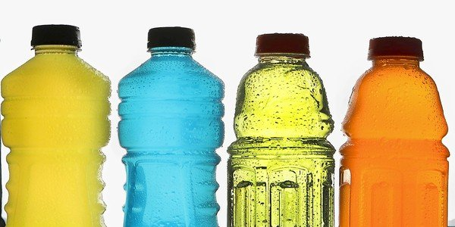
Gatorade, Powerade and other sports drinks are ubiquitous at sports events and in the stands too. But are they the best option for young athletes? (Kirk McKoy / Los Angeles Times)
By Chris Woolston

The Los Angeles Times, Health section, http://www.latimes.com/health/la-he-sports-drinks-20121103,0,1196806.story

November 3, 2012
Anywhere someone is lifting a weight, strapping on a football helmet or lacing up running shoes, there's probably a big bottle of green, blue or neon orange liquid nearby. Gatorade, Powerade and other sports drinks have drenched just about every sport in America, from triathlons to pee-wee soccer.
But sports drinks are also popular with spectators in the stands, kids playing video games, long haul truckers and office workers. Lots of people chug down sports drinks without ever breaking a sweat.
It raises the question: Who really needs this stuff? While TV ads suggest that sports drinks are the key to athletic success, there's a growing backlash in some medical circles against these salty, sugary beverages.
"Sports drinks are oversold and over-hyped," says nutrition expert Kelly Brownell, director of the Rudd Center for Food Policy and Obesity at Yale University. "If I were Coke or Pepsi, I would sell off these brands. People are starting to figure out sports drinks, and criticism against them is only going to grow."
Some of that criticism showed up in the July issue of the prestigious British Medical Journal. A series of articles suggested that the benefits of sports drinks are meager at best, especially when compared with plain water, the original sports drink.
Gatorade (a product of PepsiCo), Powerade (from the Coca-Cola Co.) and the like promise to replace the three basic things lost during intense exercise: fluids, electrolyte minerals (mostly sodium) and carbohydrate fuel. An 8-ounce serving of original Gatorade — now sold as Gatorade Perform 02 — contains 110 milligrams of sodium and 14 grams (3.5 teaspoons) of sugar. Regular Powerade is a bit less salty but has a little more sugar.
Many athletes believe they need sports drinks to replace the salt lost in sweat, but most of them can get by just fine with regular water, says Michael Bergeron, a fellow of the American Academy of Sports Medicine and executive director of the National Institute for Athletic Health & Performance. "Most people in most situations do not need electrolytes during physical activity, but the longer you go, the harder you go, the more you sweat, the more sports drinks can potentially play a role."
Bergeron says that he often runs for an hour at a time in hot weather — and he doesn't bring water, let alone a big bottle of sports drink. "A lot of people don't need anything when they exercise, as long as they start out hydrated and nourished." He adds that, like most recreational runners, he gets plenty of sodium in his regular diet.
When athletes sweat enough to shed large quantities of salt, sports drinks may not help much, Bergeron says. He often works with young football players who can lose as much as 4,000 mg of sodium in an hour in an especially sweaty workout. "A kid can drink a 32-ounce bottle of Gatorade Endurance [800 mg of sodium] every hour and still be cramping up at the end of the day," he says. "Sometimes we'll add a half-teaspoon of salt to the bottle."
As noted in the British Medical Journal, there isn't much evidence that sports drinks improve athletic performance. Most studies over the years have been very small, and the results have been hard to interpret. For one example, a 2007 study of 16 male soccer players published in Medicine and Science in Sports and Exercise found that players who drank a sports drink during a workout could sprint a bit faster and shoot better than players who drank plain water, but they didn't do any better on a passing drill.
The marketing of sports drinks has helped feed a dangerous obsession with hydration, says Dr. Arthur Siegel, an associate professor of medicine at Harvard Medical School who volunteers for the medical team at the Boston Marathon. He warns that drinking too much water or sports drink before, during or after physical activity can lead to potentially fatal water intoxication. "It's far more dangerous than dehydration," he says. Siegel urges runners and other athletes to drink enough to control thirst, no more and no less. "I wish sports drinks would come with a warning telling people to drink responsibly."
health@latimes.com

