Top Healthy High Fat Foods

9/24/2012

By Chris Rosenbloom, PhD, RD, CSSD
Athletes know to avoid high-fat foods, right? Nutritionists and coaches tell you to stay away from fatty burgers, fries and fried chicken. However, there are some high-fat foods that are good for you so no need to adopt a fat-free diet. Just be smart about fat. For those of you trying to gain weight, fat provides more than twice the calories of carbohydrate or protein, so try these healthy, high-fat foods to increase calories and make a part of your performance diet.
1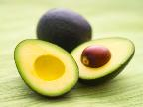. Avocado is one of the few fruits that contain fat, and it is the heart-healthy type of fat called monounsaturated fats or MUFAs. You might only think of avocado as guacamole served in a Mexican restaurant, but there is a lot more you can do with it. Slice avocado on a sandwich for a creamy alternative to mayonnaise, or dice into a salad and use less salad dressing. People in Brazil even use avocado in ice cream. Ask your mom or dad to buy some “alligator pears” (another name for avocado because of their appearance) and after you eat it, save the pit and try to grow your own avocado tree.
2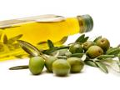. Olives and olive oil are also good sources of MUFAs. Try olives (green, black, Greek olives) as a topping on cheese pizza for a salty, meaty topping to replace pepperoni. Add olives to pasta and salads, or make a paste of chopped olives and spread on bread instead of butter.

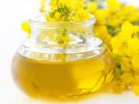
3. Canola oil is another healthy fat to use in cooking if you don’t like the strong taste of olive oil. Canola oil gets its name from a contraction for “Canada” and “oil” as most of the oil comes from Canada, although many U.S. farmers are now growing canola plants for the healthy oil. Canola oil is also found in margarines and mayonnaise as heart-healthy spreads.

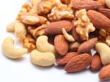
4. Nuts and nut butters make great snacks for swimmers, and nuts have the advantage of containing protein along with the fat. Another plus for nuts is that they are a good source of the fat-soluble vitamin E which is in short supply in many diets. Vitamin E is a potent anti-oxidant that can help your muscles recover after a hard workout.

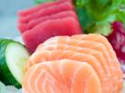5. Salmon and tuna are fatty fish with essential fats that have many health benefits. Tuna canned in water is just as healthy as tuna canned in oil (the healthy fats are in the flesh of fish, not in the oil). Try grilled salmon or a tuna sandwich as a recovery meal for high quality protein and fats. If you don’t like fatty fish, how about scallops or shrimp? Or if seafood isn’t your favorite, try flax seeds, walnuts or soy nuts for the essential fats that are also found in fatty fish.
Chris Rosenbloom is the sports dietitian for Georgia State University Athletics and is the editor of the Academy of Nutrition and Dietetics Sports Nutrition Manual, 5th edition, 2012.

http://www.usaswimming.org/ViewNewsArticle.aspx?TabId=1&itemid=4754&mid=8712

