Butterfly Breathing Patterns

1/22/2013

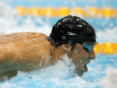BY RUSSELL MARK//HIGH PERFORMANCE CONSULTANT
It’s easy to get fixated on breathing patterns in fly, but with certainty the most important part of breathing in fly is the technique.
- Breathe forward, not up. Keep your head low to the water during the breath.
- Don’t lift your head up. The arm pull alone will lift your body enough so you can take the breath without picking your head up.
- Breathe in the middle of the arm pull. Don’t lift your head up as soon as you start the pull. Be patient and you’ll catch the breath just fine.
Whether you breathe every stroke or maintain a breathing pattern, working on the technique is a highest priority.
With that said, breathing patterns are one of the most frequent things I get asked about. Looking at each of the finals at the 2012 Olympics, here is what I observe:
- Men are breathing more frequently than women
- Men’s 100 fly: Half of the Olympic final are breathing every stroke. The other half hold some degree of 1-up 1-down or 2-up 1-down pattern.
- Women’s 100 fly: 1-up 1-down for the most part.
- Men’s 200 fly: Breathing every stroke for the most part.
- Women’s 200 fly: Every Olympic finalist breathed 1-up 1-down or some degree of 2-up 1-down for the entire race.
- Most people breathe on the 3rd stroke off the start in the 100 fly.
- Breathing into and out of turns is becoming more common, maybe because of the use of extended underwater dolphin kicks.
- Most swimmers don’t breathe into the finish.
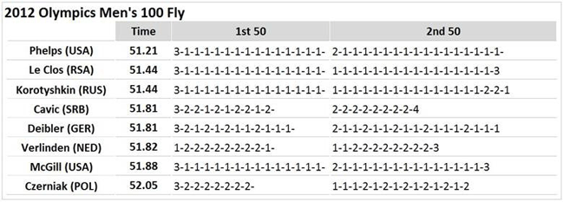
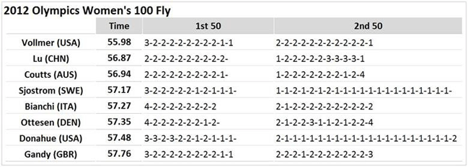

http://www.usaswimming.org/ViewNewsArticle.aspx?TabId=1&itemid=4988&mid=8712
