2016 Fall Diversity and Inclusion Chair report for Montana Swimming
Montana Swimming was well represented at the 2016 Western Zone Diversity and Inclusion Camp and Regional Diversity Summit held June 16-19 at the University of Utah in Salt Lake City. KATS swimmer AJ Popp was the lone Montana athlete at the camp and she enjoyed two a day practices designed by the five camp coaches along with other fun activities. She's a champion s'mores fixer too! (AJ's report on the camp is also posted on the website.) Mrs. Toni Popp (KATS) attended as a Regional Summit participant and she found the camp to be a great learning experience and met several new friends. She is excited to help with plans for a Western Zone diversity and inclusion camp planned for 2018. I attended as the Montana Swimming diversity and inclusion chair. I am also a member of the WZ diversity and inclusion committee that hosts the camp and is planning a multicultural heritage meet in 2019. I enjoyed meeting all the committee members that I’ve spoken with over the years via the phone and am thrilled that the camp had 40 athletes in attendance from across the Western Zone and over twenty participants in the regional diversity summit. As part of the leadership team, I presented a workshop on outreach membership.
Sabir Muhammad joined the campers as the national athlete. Sabir is one of the most well known African American swimmers. He swam for Stanford and was the first African American to compete for a men's varsity swim team. In 2000, Muhammad competed in the Short Course World Championships, winning silver and bronze medals and becoming the first African American to win a medal at a major international swimming competition. He competed as a championship finalist at the 2000 Olympic Trials in the 100 meter freestyle and as a semi-finalist in the 50-meter free, unfortunately missing the cut to make the Olympic team. In his career, Sabir broke 10 American records, became a two time Short Course World Championship medalist, a four-time U. S. Open champion, a five-time World Cup Swimming champion and two-time runner-up at U. S. Nationals. In 2009, Muhammad made a comeback after years off and earned another National Team spot in the 50 freestyle during ConocoPhillips USA Swimming National Championships. Sabir is 6'7" tall.
Montana Swimming paid the $240 registration fee for each participant and up to a maximum of $300 for travel for each participant based on submitted receipts as budgeted.
The next Western Zone Diversity and Inclusion Select Camp will be June will be June 14-17 at San Diego State University in beautiful San Diego, California. Camp applications will be available from the WZ diversity and inclusion committee by fall 2017. (Think outdoor pools, an ocean swim, and more!)
I also chair the WZ outreach membership eligibility sub-committee. This spring I compiled a document listing all the outreach eligibility criteria and outreach/diversity activities by LSC in the United States. That information was provided to USA Swimming and the national diversity and inclusion committee. At convention in September, the national committee provided that information to everyone in attendance at the national meeting. The next topic the sub-committee will address will be meet fee waivers for outreach athletes and how LSCs can incorporate these waivers into their meets and budgets. Many LSCs already offer meet fee waivers for low income athletes and this document will aid other LSCs in adding these waivers to their program.
For the fall Montana Swimming HOD meeting I am proposing that Montana Swimming set aside a $3000 annual budget appropriation to fund two one-day LSC diversity and inclusion camps each year. Eligible swimmers include those who are ethnic minorities, outreach members, LGBTQ, and disability members. We hope to hold camps at Polson and Hardin in the upcoming year. Many other LSCs in the western zone have held such camps and it is my hope Montana Swimming will join those moving forward with these camps. The Montana Swimming camps can be used as a stepping stone to the WZ diversity and inclusion select camp and the USA Swimming National Diversity Select Camp. I used the mixer meet model to help develop the budget for the camp. The camp budget request is very modest. Montana Swimming has allocated $12,000 to hold two mixer meets per year ($6000 per camp). Camp coaches received a stipend to coach at the mixer meet (the 2016 mixer meet had 6 coaches paid a total of $990 or $165 each). In the future, the diversity camp could be held as a two day camp and western zone recognized diversity and inclusion coach may be asked to lead the camp. While I do not have exact numbers on how many athletes may be eligible for the camp, I believe it could be 250-300 athletes. Along with the camp, a diversity summit will be held for interested parents, coaches, officials, and volunteers.
Finally the diversity tab on the website has several useful documents dealing with diversity, inclusion, outreach, and disability swimming. It has been my pleasure to serve as the diversity and inclusion chair for Montana Swimming.

Respectfully submitted,

Susan Huckeby
Montana Swimming Diversity and Inclusion Chair

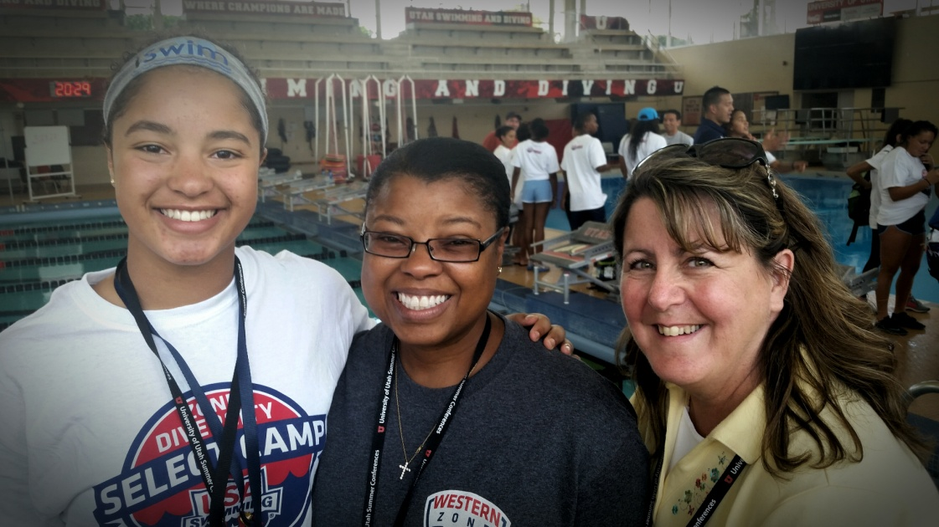

AJ Popp, Toni Popp, and Susan Huckeby at the 2016 Western Zone Diversity and Inclusion Select Camp at Salt Lake City, Utah.

