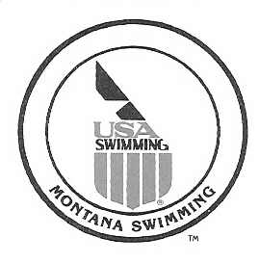

April 12, 2016

Montana Swimming House of Delegates,

I would like to report that as of April 12, 2016 we have 83 registered officials with 80 certified and 3 currently working on their stroke and turn certification.

We had a very successful short course season that concluded with the 2016 Montana Swimming SC State Championship Meet in Missoula February 19-21, 2016. We had 34 officials that worked the meet over the three days. With this many officials working, the meet was run extremely well and the comments which were made during and after the meet were all positive and, with around 376 swimmers, the meet was completed ahead of the projected time line each day.

Montana Swimming had Don Hougardy work as a National Certification official at the 2016 Short Course State Meet and we had numerous officials get new or renew national certifications that were expiring and I would like to congratulate all for their hard work and dedication to the sport of swimming.

The BC Championship Meet was held in Polson, MT. March 5-6, 2016 and had 9 officials work the meet and with 150 swimmers it was a great meet for all that attended. It would have be better if the meet would have been held before short course state so the swimmers that made qualifying time could have swam in that meet.

Montana Swimming had several officials who traveled and worked the upper level and will have officials working the meets this summer.

As we get ready to start the 2016 long course season, I would like to ask that we continue to recruit new officials from all the teams as we will continue to lose officials each year and the need for trained officials will grow each year. I would like to ask that we continue to add two officials from each team every year.

In conclusion, I would like to thank all the officials that have worked meets throughout the last year, the officials that have helped me this year and for all their efforts in training and mentoring our new officials. I would encourage all our officials to continue with the training and mentoring of all the officials. We have a great group of officials in our LSC and I know we all learn something at the meets we work.

If anyone has questions or need anything please feel free to contact me.

Respectfully Submitted,

Merle L Gunderson
Montana Swimming Officials Chairman
mtgunders@outlook.com

