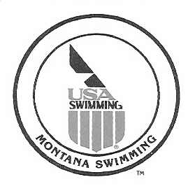

To Montana Swimming Officials, September 7, 2016

Montana Swimming Officials Organization will hold its annual Officials Meeting on October 1, 2016.

The meeting location is the Butte Family YMCA, 2975 Washoe Street, Butte, MT 59701. The meeting will run from 9:00 AM to 4:00 PM or earlier if business is completed.

The meeting will be set up in the Officials Tracking System as a clinic to satisfy that requirement.

We will view the Officiating Swimming and the Start DVD’s, discuss any rules changes from the USA Swimming Convention, review and update the requirements for officials, select the Excellence in Officiating and Mark Hallgrimson’s Stroke and Turn Awards and select the Official’s Chairman for Montana Swimming.

I would encourage all our officials to attend and any individuals interested in becoming swimming officials.

If you have any questions or concerns please let me know.

Respectfully Submitted,

Merle L Gunderson
MT Officials Chairman
mtgunders@outlook.com
727-2724

