Frequently Asked Questions
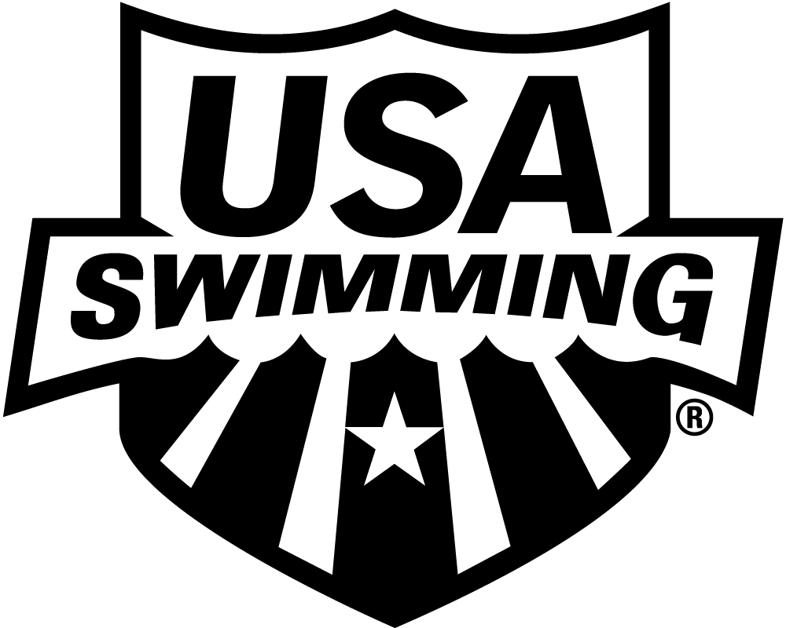
Pre-Employment Screening Program

- Is pre-employment screening required for all coach members?
Yes. Effective August 31, 2011, clubs are required to conduct pre-employment screening on all newly-hired coaches. Existing USA Swimming coaches are subject to the pre-employment screening program when they seek employment at a different club.
- Are other club employees subject to the pre-employment screening requirement?
Possibly. All club employees that are required to be non-athlete members of USA Swimming are subject to this screening requirement.
Article 305.4 of the USA Swimming rules requires that club employees who interact directly and frequently with athletes as a regular part of their duties must be non-athlete members. It is the responsibility of the club to self-determine which employees other than coaches interact directly and frequently with athletes as a regular part of their duties. Any new employee that the club determines must be a member of USA Swimming is subject to the pre-employment screening requirement.
- What constitutes a past employment reference check?
A past employment reference check typically involves speaking to a former or current supervisor to gather information about the applicant’s job performance, work ethic, personality and attitude. An attorney or local Chamber of Commerce, Better Business Bureau, or human resources organization, such as the Society for Human Resource Management (SHRM), can provide you with information about typical employer policies, practices, and obligations with regard to employment references. Information about reference checks is also available online, for example, through websites such as:
http://www.bridgestar.org/Library/HiringToolkit/ReferenceCheck.aspx
(Note: USA Swimming is not responsible for the content of external internet sites.)
- Can clubs fulfill the pre-employment screening requirements in-house or must they utilize the services of an outside vendor?
Clubs are not required to use one of the recommended service providers. Clubs are also not required to contract for services that they would rather perform themselves. However, please note that federal regulations require employers to use a consumer reporting agency to acquire the state motor vehicle reports.
- Does USA Swimming require that the club contact all previous employers?
Where there have been multiple employers, a minimum of the 3 most recent employers must be contacted.
- What is the purpose of the education verification and the motor vehicle record examination requirements?
Education history is the most common falsified information on resumes and job applications.
A motor vehicle report examination is the best way to identify prospective employees with unsafe driving records. In some states, convictions for driving under the influence of alcohol or drugs cannot be found on the criminal court record and can only be revealed with a motor vehicle record examination. Reported information typically includes state of issuance, issue and expiration date, license status, and any accident or violation history.
- Are the staff members of a newly approved USA Swimming club subject to the additional screening requirements?
Whether the new club is a newly created entity or an existing program choosing to join USA Swimming, any new employee that the club determines must be a member of USA Swimming is subject to the pre-employment screening requirement.
- What will clubs need to do to start working with a consumer reporting agency?
In order to utilize the services of a consumer reporting agency, clubs will need to establish an account and provide the paperwork required by state and federal regulations. It typically takes 2 days or less to accomplish the account set-up.
- How will the required pre-employment screening information be reported by the consumer reporting agency to clubs?
Typically, the consumer reporting agency will send an electronic report or the club can go online to a secured webpage to retrieve the information.
- Once ordered, how long will it take for clubs to receive screening reports?
Once a club submits the necessary information to request screening services for an applicant, the club will usually receive all parts of the report within 2-5 business days. Clubs should check with the consumer reporting agency they plan to work with to find out their specific policies and practices with regard to this information.
- Will USA Swimming receive a copy of the screening information sent to the club?
No. As the employer, clubs will contract directly with the consumer reporting agencies to provide pre-employment screening services. USA Swimming is not a party to this transaction and will not receive the screening information provided to clubs.
- How will USA Swimming monitor compliance with the pre-employment screening requirement?
In order to ensure compliance with the pre-employment screening program, a club representative must certify on the annual club membership application that the club is conducting pre-employment screening as required by Article 502.6.8 in the USA Swimming rulebook. Failure to certify and sign this section of the club application form will result in the club application being rejected.
- Where do I go for more information?
Please refer to the Program Summary available on the USA Swimming website at www.usaswimming.org/preemploymentscreens.
If you have additional questions after reviewing the Program Summary, please contact preemploymentscreening@usaswimming.org.

Created 8/30/11

