BOZEMAN BARRACUDA SWIM CLUB
hosts the
TEDDY BEAR CLASSIC
December 9-10, 2017 in Bozeman, Montana

Held under the Sanction of USA Swimming, Inc., issued by Montana Swimming, Inc. Sanction #1059
This meet is dual sanctioned with Montana Masters Sanction #317-S006

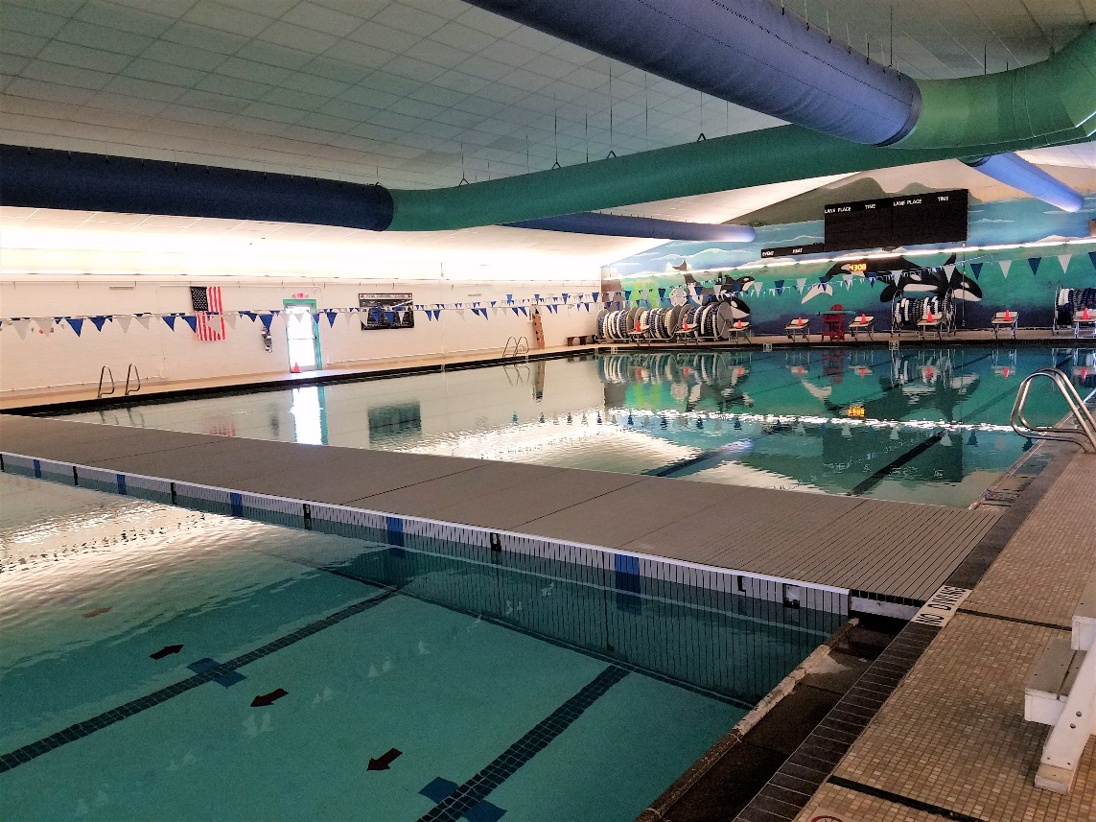

Meet Referee Co-Meet Directors Meet Registrar
Lon Huckert Elizabeth Kendall Nannette DuCuennois
(406)581-0458 (703) 801-5077 (406)920-1702
lonhuckert@gmail.com lizkendall2005@hotmail.com bozemanbarracudas@yahoo.com
Jane Mittelsteadt
(406) 600-6641 Bozeman Swim Club
janemitt@gmail.com attn Nannette DuCuennois
Box 804
Bozeman, MT 59771

Facility The Bozeman Swim Center, located on the west side of Bozeman High School at 1211 West Main Street, is an 8-lane, 50-meter regulation long course pool. New this year, a bulkhead has been installed dividing the pool into both 25-yard and 25-meter courses. This meet will be held in the regulation 25-yard course. The 25-meter course will be available for coach-monitored warmup/cool down as described herein. The racing course is equipped with new Kiefer Advantage I non-turbulent lane lines and Spectrum Xcellerator starting blocks.
The altitude is 4793 feet. The competition pool is 9-feet deep at the start end and 5-feet deep at the turn end. The competition course has not been certified in accordance with 104.2.2C(4).

An automatic Colorado Timing System will be used with touch pads at both ends in addition to three backup times. An 8-line LED scoreboard will be in use.

Directions: From I-90, arriving either east or west bound, take exit 306 onto N 7th Avenue. Turn south onto North 7th Avenue and travel 1.2 miles to West Main Street. Turn right (west) onto W Main Street. The Bozeman Swim Center will be on your right in 0.5 miles, just past the Bozeman High School. OVERNIGHT PARKING OR CAMPING IS NOT PERMITTED IN THE PARKING LOTS ADJACENT TO THE SWIM CENTER.

Meet Format This will be a split-session meet. Events will be swum 11 & Over in the early morning sessions, and
10 & Under in the mid-day sessions.

The 1650 Free and the 400 IM will be available to 11 & Over swimmers.
The 500 Free will be available for 9 & Over swimmers.

Events will be swum as listed on the schedule of events. All events are timed finals.

Swimmers entered in the 500 Free, the 1650 Free, and the 400 IM must provide their own timers. Swimmers entered in the 500 Free, and the 1650 Free must also provide their own counters.
Positive check-in will be required for all swimmers in these three (3) events.

Relay entries may be girls, boys and/or mixed gender and will be seeded and swum in combined heats.

Based on the meet timeline and for the benefit of the swimmers, the Meet Referee reserves the right to run all or any portion of the meet with 6, 7, or 8 lanes, or insert warm-up/cool down breaks throughout the meet.

Formal warmup times for Sessions 2 and 5 will be limited to 15 minutes.

Safety The Montana Swimming Safety guidelines are in effect for this meet and will be enforced. For circle swimming during warm-ups and cool-downs, swimmers must enter the pool using a three-point entry. Coaches are advised to closely supervise their swimmers at all times. NO running or horseplay will be tolerated. A safety marshal will be on deck.

Racing Starts Any swimmer who is entered in the meet and is unaccompanied by an USA Swimming member coach, must be certified by a USA Swimming member coach as being proficient in performing a racing start or must start each race from within the water. It is the responsibility of the swimmer or the swimmer’s legal guardian to ensure compliance with this requirement. Any swimmers who must start in the water shall be listed in a separate document returned with the entries.

Rules This meet will be conducted in accordance with the current USA Swimming and Montana Swimming Rules and Regulations, except where rules therein are optional and exceptions are stated.

Use of audio or visual recording devices, including a cell phone, is not permitted in changing areas, rest rooms or locker rooms. Except where venue facilities require otherwise, changing into or out of swimsuits other than in locker rooms or other designated areas is not appropriate and is prohibited.
Visual recording devices, including a cell phone, are not permitted behind the starting blocks.
Operation of a drone, or any other flying apparatus, is prohibited over the venue (pools, athlete/coach areas, spectator areas and open ceiling locker rooms) any time athletes, coaches, officials and/or spectators are present.

No glass containers, tobacco, or alcoholic beverages are allowed in the swimming venue.

The USA Swimming Code of Conduct and athlete protection provisions will be enforced.

All persons acting in any coaching capacity on deck must be currently registered coach members of USA Swimming.

Swimmer, official, and coach registration will be confirmed with Montana Swimming Registration Chairperson prior to the start of the meet.

This meet may be covered by the media, including photographs, video, web casting and other forms of obtaining images of athletes participating in the meet. Entry into the meet is acknowledgement and consent to this fact.

Eligibility All swimmers must be registered with USA Swimming Inc., the Canadian equivalent, or US Masters Swimming (USMS) prior to the entry deadline. Masters swimmers are welcome and encouraged to compete. There will be no on-deck USA Swimming registration available at this meet. Teams entering swimmers who are not currently registered USA Swimming athlete members may be fined $25 per swimmer by the Montana Swimming Registration Chair. Age as of the first day of the meet (December 9th, 2017) shall determine the age group in which the swimmer must compete.

Swimmers with The Bozeman Barracuda Swim Club welcomes all swimmers with disabilities as described in the Disabilities USA Swimming Rules and Regulations, Article 106, to compete at the meet. Disabled swimmers or their coaches are required to provide advance notice in writing to the Meet Referee and Meet Director to arrange for any needed accommodations including personal assistants required and/or registered service animals by the meet entry date. The Meet Referee in his/her sole discretion shall determine whether the needed accommodations can be met. Failure to provide advance notice may limit the Bozeman Barracuda's ability to accommodate all requests.

Entries Team entries must be submitted by email to bozemanbarracudas@yahoo.com using Hy-Tek or Team Unify software. Additionally, team entries (both relay and individual entries) should be accompanied by a meet entry report and the attached team Entry Fee Summary and Waiver/Release form.

Entries from individual USA Swimming or US Masters athletes without access to Hy-Tek or Team Unify software may be submitted by providing all information identified on the enclosed ‘Individual Entry Sheet. This form may be emailed or mailed to the registrar by the entry deadline.

Entries from US Masters Athletes must be submitted using the attached ‘Master Swimmer Entry Form’. This form may be emailed or mailed to the registrar by the entry deadline.

Entry Limits Each swimmer may compete in a maximum of eight (8) individual events, with a maximum of four (4) individual events plus one (1) relay on Saturday and four (4) individual events plus one (1) relay on Sunday.

Entry Verification An email will be sent to the person submitting the entry confirming receipt of the entry within 48 hours of receipt.

Entry Deadline All entries must be received in Bozeman no later than Friday, December 1, 2017 either by Hy-Tek entry file via email (required for teams) or by mail.

All entry fees (and paperwork if entries are mailed or emailed) must be postmarked no later than Wednesday, November 29, 2017.

E-mail entries to: bozemanbarracudas@yahoo.com
Mail paperwork to: Bozeman Swim Club
attn: Nannette DuCuennois
P.O. Box 804
Bozeman, MT 59771

Entries must be made through the swimmer’s club with a team check.
Unattached swimmers may make direct entries by mail or email.
Phone entries will not be accepted.
Late entries, if accepted, will require double entry fees.

Entry Fees An entry fee of $18.00 plus $3.00 per event will be charged. The relay fee for each relay is $6.00. Make checks payable to the ‘Bozeman Swim Club’. No entries will be accepted without payment of fees. There will be no refunds.

Seeding Each swimmer will be seeded according to the age group and submitted times in short course yards. Failure to convert meter times before submitting could result in a swimmer being incorrectly seeded. Meter times will be entered as submitted and will not be converted. “No time” entries will be accepted. Deck seeding may be provided if there are open lanes, at the discretion of the Meet Referee.

The 1650 Free, 400 IM, and 500 Free will be seeded and swum fastest to slowest alternating between girls’ and boys’ heats.

The Meet Referee may modify the seeding of the 1650 Free, the 400 IM and the 500 Free based on entries, check-in and anticipated meet timeline.

Positive Check-in Positive check-in, located at the announcer's table is required for the following events:
- 11 & Over 1650 Free swimmers must check in prior to the start of Event 7
- 11 & Over 400 IM swimmers must check in 15 minutes prior to the end of warmups for Session 4
- 9 & Over 500 Free swimmers must check in prior to Event 55

Failure to check in for these event by the stated deadline will result in the swimmer being scratched from the event and not seeded.

Swimmers entered in the 500 Free, the 1650 Free, and the 400 IM must provide two timers. Swimmers in the 500 Free and the 1650 Free must also provide their own counters.

Scratches Coaches should report scratches on the scratch sheet or to the Meet Referee prior to the start of every session. There will be no penalty for swimmers who fail to scratch from an event.

Scoring Individual 20-17-16-15-14-13-12-11-9-7-6-5-4-3-2-1

Awards High point "Teddy Bear" awards will be given for 1st - 16th places for the following age groups:
8&U, 9-10, 11-12, 13-14, and 15 & Over.

Results Meet results will be posted to the Montana Swimming website at: www.mtswimming.com

Warm Ups In accordance with USA Swimming guidelines, there will be a published warm-up procedure for all swimmers and coaches attending the meet. The Safety Marshal will ensure that all teams, coaches, and swimmers follow all warm-up procedures. Meet Management reserves the right to change general warm-up times and general meet-start times according to the number of entries or other appropriate logistical considerations. Check your program or the Montana Swimming website (www.mtswimming.com) after Wednesday, December 6, for the actual warm-up and start times.

An open warm-up session will be available to all swimmers on Friday from 5:00-6:00 p.m.
All swimmers must have a certified coach overseeing them during this warm-up.

Officials/Timers To the extent possible, teams are asked to provide timers and other certified meet officials. On-deck training time will be available for those wishing to train as an official. E-mail the Meet Referee prior to the meet if you plan to officiate and sign in at the officials’ meeting each day in the hospitality room. Trainees should attend the pre-meet officials’ meetings daily and sign in. All officials on deck must be registered and certified with USA Swimming and registrations will be verified by the MT Swimming Registration Chair. Any assistance by officials will be greatly appreciated and will help ensure a great meet for the swimmers.

Each club will be responsible for providing timers to the best of their ability based on their athlete numbers. A sign-up sheet will be posted at the announcer's table.

The officials’ meetings will be held in the hospitality room during warmups for each session on both Saturday and Sunday.

Coaches All coaches on deck must be registered and certified with USA Swimming. Coach registration will be verified by the MT Swimming Registration Chair.

A coaches' meeting will be held 15 minutes prior to the start of the first session of warm-ups on Saturday. Other meetings may be held at the Meet Referee’s discretion.
Meet Management requests that at least one coach representative from each team attend all coaches’ meetings.

Protests All protests should be given to the meet referee.

Hospitality A hospitality room will be available for all coaches and officials.

Concessions Concessions will be available. Absolutely no glass containers are allowed in the locker rooms or deck areas.

Swim Shop T-shirts and/or clothing will be available for sale as well as an array of swim items at the Swim Shop.

Spectators The west and north sides of the deck (coaches side and start end) and the bulkhead will be a "Closed Deck" area.
It will be open to coaches, swimmers, and meet officials only.

Spectrum Xcellerator Starting Blocks:
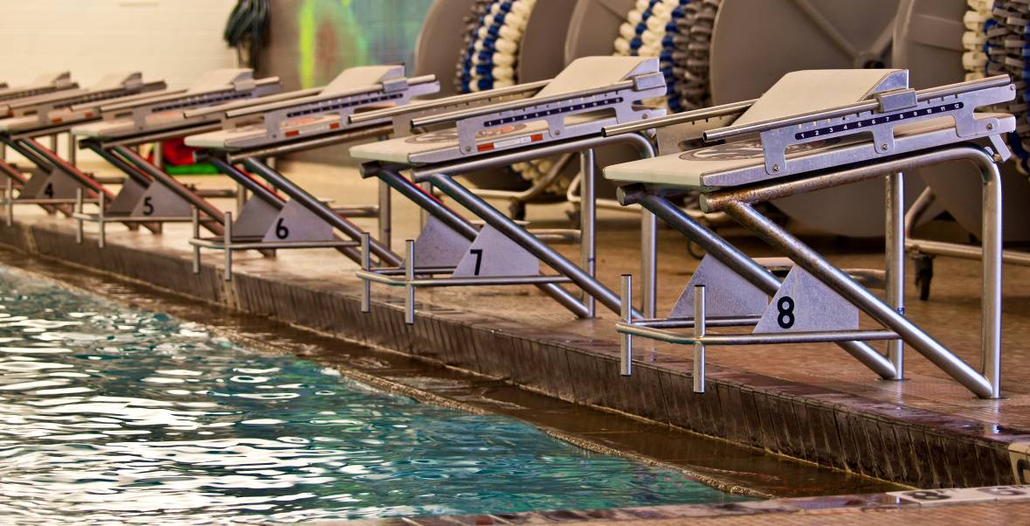
Hotel Information

Best Western, 587-5261

City Center Inn, 587-3158

Comfort Inn, 587-2322

Comfort Suites, 587-0800

C’Mon Inn, 587-3555

Days Inn, 587-5251

Fairfield Inn, 587-2222

Hampton Inn, 522-8000

Hilton Garden Inn, 582-9900

Holiday Inn, 587-4561

Holiday Inn Express, 582-4995

Homewood Suites, 587-8180

La Quinta Inn and Suites, 585-9300

My Place, 586-8228

Super 8, 586-1521

Saturday, December 9, 2017 |  |  |  |  |  |  |  |  |  | Sunday, December 10, 2017
Girls | Session 1 |  |  |  |  | Boys |  |  | Girls |  | Session 4 |  |  |  |  | Boys
1 | 11 & Over 200 IM |  |  |  |  | 2 |  |  | 41 |  | * 11 & Over 400 IM |  |  |  |  | 42
3 | 11& Over 100 Back |  |  |  |  | 4 |  |  | 43 |  | 11 & 12 50 Back |  |  |  |  | 43
5 | 11 & 12 50 Fly |  |  |  |  | 6 |  |  | 45 |  | 11 & Over 100 Fly |  |  |  |  | 46
7 | 11 & Over 200 Free |  |  |  |  | 8 |  |  | 47 |  | 11 & Over 200 Breast |  |  |  |  | 48
9 | 11 & Over 200 Fly |  |  |  |  | 10 |  |  | 49 |  | 11 & Over 100 Free |  |  |  |  | 50
11 | 11 & Over 50 Free |  |  |  |  | 12 |  |  | 51 |  | 11 & 12 50 Breast |  |  |  |  | 52
13 | 11 & Over 100 Breast |  |  |  |  | 14 |  |  | 53 |  | 11 & Over 200 Back |  |  |  |  | 54
15 | ** 11 & Over 200 Medley RELAY |  |  |  |  | 16 |  |  | 55 |  | ** 11 & Over 200 Free RELAY |  |  |  |  | 56
17 | ** 11 & Over Mixed 200 Medley RELAY |  |  |  |  | -- |  |  | 57 |  | ** 11 & Over Mixed 200 Free RELAY |  |  |  |  | --
 | Session 2 |  |  |  |  |  |  |  |  |  | Session 5
19 | *11 & Over 1650 Free |  |  |  |  | 20 |  |  | 59 |  | * 9 & Over 500 Free |  |  |  |  | 60
 | Session 3 |  |  |  |  |  |  |  |  |  | Session 6
21 | 10 & U 200 Free |  |  |  |  | 22 |  |  | 61 |  | 10 & U 200 IM |  |  |  |  | 62
23 |  | 8 & U 25 Back |  |  |  | 24 |  |  | 63 |  |  | 8 & U 25 Free |  |  |  | 64
25 | 10 & U 100 Back |  |  |  |  | 26 |  |  | 65 |  | 10 & U100 Free |  |  |  |  | 66
27 | 10 & U 50 Free |  |  |  |  | 28 |  |  | 67 |  | 10 & U 50 Back |  |  |  |  | 68
29 | 10 & U 50 Fly |  |  |  |  | 30 |  |  | 69 |  |  |  | 8 & U 25 Fly |  |  | 70
31 |  |  | 10 & U 100 IM |  |  | 32 |  |  | 71 |  | 10 & U 100 Fly |  |  |  |  | 72
33 | 8 & U 25 Breast |  |  |  |  | 34 |  |  | 73 |  | 10 & U 50 Breast |  |  |  |  | 74
35 | 10 & U 100 Breast |  |  |  |  | 36 |  |  | 75 |  | 10 & U 200 Medley  RELAY ** |  |  |  |  | 76
37 | 10 & U 200 Free  RELAY ** |  |  |  |  | 38 |  |  | 77 |  | 10 & U Mixed 200 Medley RELAY **  RELAY |  |  |  |  | --
39 | 10 & U Mixed 200 Free  RELAY ** |  |  |  |  | --
* These longer events will be run FASTEST to SLOWEST alternating heats between girls and boys
** Girls, Boys and Mixed Relays will be swum in combined heats for each session. Relay entries desiring official times must comply with age and gender requirements for the event entered and must submit official relay cards during the meet.

Entry Fee Summary and Waiver/Release Form

Complete and email or mail this form along with entry fees to (checks payable to Bozeman Swim Club).
Mail entries to: Bozeman Swim Club Email entries to: bozemanbarracudas@yahoo.com
attn: Nannette DuCuennois
P.O. Box 804
Bozeman, MT 59771

Team Name
Club Code
Coach
Coach Phone
Coach Email
Team Address

Item | Total Number | Cost per | Total
Swimmer Surcharge |  | $18.00 per event
Individual Entries |  | $3.00 / swimmer event
Relay Entries |  | $6.00 per relay
Total Fees Due

Waiver, Acknowledgement and Liability Release:
I, the undersigned coach or team representative, verify that all of the swimmers and coaches listed on the enclosed entry are registered with USA Swimming. Swimmer and coach registration will be verified. I acknowledge that I am familiar with the Safety Rules of USA Swimming, Inc. and Montana Swimming, Inc. regarding warm-up procedures and meet safety guidelines, and that I shall be responsible for the compliance of my swimmers with those rules during this meet. Bozeman Barracuda Swim Club, Bozeman Swim Center, Montana Swimming, Inc., and USA Swimming, Inc., their agents, employees, and coaches shall be held free and harmless from any and all liabilities or claims for damages arising by reason of illness or injury to anyone during the conduct of this meet. I also acknowledge that by entering this meet, I am granting permission for the names of any or all of my team’s swimmers to be published on the internet in the form of Psych Sheets, Meet Results, or any other documents associated with the running of this meet. This meet may be covered by the media, including photographs, video, web casting and other forms of obtaining images of athletes participating in the meet. Entry into the meet is acknowledgement and consent to this fact.
We hereby submit our team’s entry sheets and fees for your upcoming meet and verify that the above named coaches will be in attendance. These coaches are current in all the requirements set forth by USA Swimming; Red Cross Safety Training for Swim Coaches or Lifeguard Training, First Aid and CPR.

________________________________________________________________________________
SIGNATURE (Coach or Club Representative) CLUB

________________________________________________________________________________
TITLE DATE

Individual Entry Sheet

Club:________________________ Age Group__________ Coach:_______________________
Contact:______________________ Phone:_______________
Name |  | Age  Sex | USA # | Event # | Event # | Event # | Event # | Event # | Event # | Event # | Fees
 |  |  |  | Time | Time | Time | Time | Time | Time | Time

Tally:

Swimmers this sheet X $18.00= $________

Events this sheet X $ 3.00= $________

Total $ this sheet $________

Master Swimmer Entry Form

Master swimmers, please include full payment with this completed form.
Make checks payable to ‘Bozeman Swim Club’.
All entries must be received in Bozeman no later than Friday, December 1, 2017.
Mail entries to: Bozeman Swim Club
attn: Nannette DuCuennois
P.O. Box 804
Bozeman, MT 59771

Swimmer's Full Name_______________________________________________

Please refer to Sessions 1, 3, 4, and 6 on page 7 of the contract for Event Numbers.

Events (max of 4 per day) Seed Times

1. ____________________ ____________

- ____________________ ____________

3. ____________________ ____________

4. ____________________ ____________

5. ____________________ ____________

6. ____________________ ____________

7. ____________________ ____________

8. ____________________ ____________

Date of Birth _________________________

Masters # _________________________

Phone Number _________________________

Fees:

Swimmer surcharge: $18.00_____
$3.00 per Individual Event:$__________
$6.00 per Relay: $__________

TOTAL: $__________

