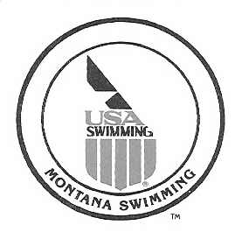

April 27, 2017

Montana Swimming House of Delegates,

I would like to report that as of April 27th Montana Swimming had 79 registered officials with only a few currently working on their stroke and turn certification.

We had a very successful short course season that concluded with the 2017 Montana Swimming SC State Championship Meet in Polson February 24-26, 2017 and 2017 Montana Swimming BC Championship Meet in Butte. We had 43 officials that worked the short course meet over the three days. With this many officials working, the meet was run extremely well and the majority of the comments which were made during and after the meet were all positive and, with around 374 swimmers, the meet was completed ahead of the projected time line each day. This was the first time most of the swimmers, coaches, officials and parents saw the great facility in Polson.
The 2017 Montana Swimming BC Championship Meet had enough officials to run the meet but there was not much relief for the officials. On Saturday we had 3 relief officials and on Sunday we had two relief officials and only one deck referee and starter for the meet. The meet had 180 swimmers and was completed early both days and all comments were positive.

Montana Swimming had several officials who traveled and worked the upper level and should have numerous officials working the upper level meets this summer.

As the 2017 long course season starts, I would like to reinforce the need for all teams to step up and work to recruit new officials as we will continue to lose officials each year and the need for trained officials will grow each year. I would like to ask that we continue to add two officials from each team every year.

In conclusion, I would like to thank all the officials that have worked meets throughout the last year, the officials that have helped me this year and for all their efforts in training and mentoring our new officials. I would encourage all our officials to continue with the training and mentoring of all the officials. We have a great group of officials in our LSC and I know we all learn something at the meets we work.

If anyone has questions or need anything please feel free to contact me.

Respectfully Submitted,

Merle L Gunderson
Montana Swimming Officials Chairman
mtgunders@outlook.com

