BOZEMAN BARRACUDA SWIM CLUB
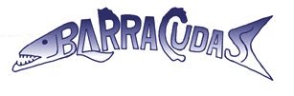
hosts the
BOZEMAN MAY CLASSIC
MAY 18-20, 2018 in Bozeman, Montana
Held under the Sanction of USA Swimming, Inc., issued by Montana Swimming, Inc. Sanction #1080
This meet is dual sanctioned with Montana Masters Sanction #318-S003

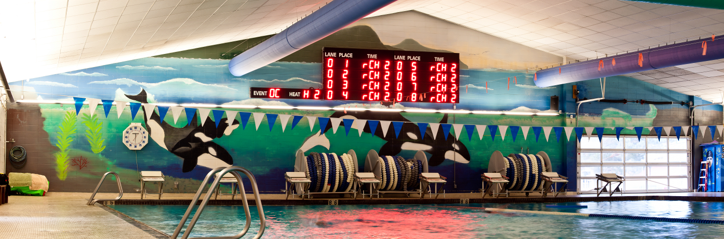

Meet Referee Co-Meet Directors Meet Registrar
Lon Huckert Elizabeth Kendall Matt Yovich
(406) 581-0458 (406) 219-7535 (406) 539-9802
lon.huckert@gmail.com lizkendall2005@hotmail.com bozemanbarracudas@yahoo.com
Todd Kendall Bozeman Swim Club
(406) 414-6942 attn: Matt Yovich
tkendall@bresnan.net P.O. Box 804
Bozeman, MT 59771

FACILITY The Bozeman Swim Center, located on the west side of Bozeman High School at 1211 West Main Street, is an 8-lane, 50-meter regulation long course pool. It is equipped with Kiefer non-turbulent lane lines and Spectrum Xelerator starting blocks. The pool is 9-feet deep at the start end and 3.5 feet deep at the turn end. The altitude is 4793 feet. No separate warm-up and cool-down facility is available. Therefore, the provision of a warm-up/cool-down lane and/or 10-minute warm-up breaks will be inserted into the meet schedule at the discretion of the meet referee. The competition course has been certified in accordance with 104.2.2C(4). The copy of such certification is on file with USA Swimming. The length of the competition course without a bulkhead is in compliance and on file with USMS in accordance with articles 105.1.7 and 106.2.1 An Automatic Colorado Timing System will be used with touch pads at both ends and 3 backup times. Display will be on an 8-line LED scoreboard. Each club will be responsible for providing timers in proportion to their team's athlete numbers at all sessions. A sign-up sheet will be posted at the announcer's table specifying lane assignments.

Directions: From I-90, arriving either east or west bound, take exit 306 onto N 7th Avenue. Turn south onto N 7th Ave and travel 1.2 miles to the intersection with West Main Street. Turn right (west) onto West Main Street. Bozeman Swim Center will be on your right in 0.5 miles, just past the Bozeman High School. OVERNIGHT PARKING OR CAMPING IS NOT PERMITTED IN THE PARKING LOTS ADJACENT TO THE SWIM CENTER.

MEET FORMAT This will be a split session meet.
10 & Under Events will be swum in the morning sessions.
11 & Over Events will be swum in the afternoon sessions.

The 200 Fly, 1500 Free, and 400 IM will be available to 11 & Over swimmers.
The 400 Free will be available to 9 & Over swimmers.
Events will be swum as listed on the schedule of events with the following possible exceptions:
Based on entries, the meet referee reserves the right to re-seed and swim the 200 Fly, 1500 Free, 400 Free, and 400 IM as mixed-gender heats.

Positive check-in will be required for athletes in the 200 Fly, 1500 Free, 400 Free, and 400 IM.

Swimmers entered in the 400 Free, and 400 IM must provide their own timers. Swimmers entered in the 1500 Free must provide their own counters.
Timing for the Friday night events will be performed by Bozeman volunteers.
All events are timed finals.

Events will not be scored, but they will be posted separately by age group and gender.

Relay entries, which may be mixed gender, must be included with individual entries.

SAFETY The Montana Swimming Safety guidelines are in effect for this meet and will be enforced. For circle swimming during warm ups and cool downs, swimmers must enter the pool using a three point entry. Coaches are advised to closely supervise their swimmers at all times. NO running or horseplay will be tolerated. A safety marshal will be on deck.

RACING STARTS Any swimmer entered in the meet, unaccompanied by an USA Swimming member coach, must be certified by an USA Swimming member coach as being proficient in performing a racing start or must start each race from within the water. It is the responsibility of the swimmer or the swimmer’s legal guardian to ensure compliance with this requirement. Any swimmers who must start in the water shall be listed in a separate document returned with the entries.

RULES This meet will be conducted in accordance with the current USA Swimming and Montana Swimming Rules and Regulations, except where rules therein are optional and exceptions are stated.
Use of audio or visual recording devices, including a cell phone, is not permitted in changing areas, rest rooms or locker rooms.
Except where venue facilities require otherwise, changing into or out of swimsuits other than in locker rooms or other designated areas is not appropriate and is prohibited.
Visual recording devices, including a cell phone, are not permitted behind the starting blocks.
Operation of a drone, or any other flying apparatus, is prohibited over the venue (pools, athlete/coach areas, spectator areas and open ceiling locker rooms) any time athletes, coaches, officials and/or spectators are present.
No glass containers, tobacco, or alcoholic beverages are allowed in the swimming venue.
The USA Swimming Code of Conduct and athlete protection provisions will be enforced.
All persons acting in any coaching capacity on deck must be currently registered coach members of USA Swimming.
Swimmer, official, and coach registration will be confirmed with Montana Swimming Registration Chairperson prior to the start of the meet.
This meet may be covered by the media, including photographs, video, web casting and other forms of obtaining images of athletes participating in the meet. Entry into the meet is acknowledgement and consent to this fact.

ELIGIBILITY All swimmers must be registered with USA Swimming Inc., the Canadian equivalent, or US Masters Swimming (USMS) prior to the entry deadline. Masters swimmers are welcome and encouraged to compete. There will be no on deck USA Swimming registration available at this meet. Teams entering swimmers who are not currently registered USA Swimming athlete members may be fined $25 per swimmer by the Montana Swimming Registration Chair.
Age as of the first day of the meet (May 18, 2018) shall determine the age group in which the swimmer must compete.

SWIMMERS WITH The Bozeman Swim Club welcomes all swimmers with disabilities as described in the
DISABILITIES USA Swimming Rules and Regulations, Article 106, to compete at the meet. Disabled swimmers or their coaches are required to provide advance notice in writing to the meet referee and meet director to arrange for any needed accommodations including personal assistants required and/or registered service animals by the meet entry date. It is at the discretion of the meet referee to determine whether the needed accommodations can be met by the meet resources. Failure to provide advance notice may limit the Bozeman Swim Club’s ability to accommodate all requests.

ENTRIES USA Swimmers: All entries must be submitted by email as a Team Manager file to: bozemanbarracudas@yahoo.com. Please include a printed copy of your entries with your payment. Also complete and return the USA Swimming Registration Confirmation, Waiver and Accounting Sheet with your entries (all enclosed in the entry packet).

Please email entries in a Hy-Tek entry file to: bozemanbarracudas@yahoo.com.
Mail waiver and entry fees to: Bozeman Swim Club
attn: Matt Yovich
P.O. Box 804
Bozeman, MT 59771

Entries must be made through the swimmer’s club with a team check.
No phone entries will be accepted.
Late entries, if accepted, will require double swimmer surcharge fee.

Unattached swimmers: Please email direct entries to bozemanbarracudas@yahoo.com. Include all information that is requested on the Master Entry Form and, additionally, the swimmer’s USA Swimming registration number.

Master Swimmers: Please complete the attached 'Master Swimmer Entry Form' and include full payment.

Mail entries and entry fees to: Bozeman Swim Club
attn: Matt Yovich
P.O. Box 804
Bozeman, MT 59771

ENTRY LIMITS Each swimmer may compete in a maximum of eight (8) individual events with a maximum of two (2) individual events on Friday, four (4) individual events on Saturday, and four (4) individual events on Sunday. Additionally, swimmers may enter into one (1) relay event on Saturday and one (1) relay event on Sunday.

ENTRY An email will be sent to the person submitting the entry confirming receipt of the entry within 48
VERIFICATION hours of receipt.

ENTRY All entries must be received by email no later than 11:59pm Thursday, May 10, 2018,
DEADLINES EXCEPT for Masters Swimmers entering by US Mail.

Masters’ Entries using the Masters Swimmer Entry Form by US Mail must be received at the Bozeman Swim Club post office box by Wednesday, May 9, 2018.

ENTRY FEES An entry fee of $18.00 plus $3.00 per event will be charged. The relay fee is $6.00 per relay.
Make checks payable to: Bozeman Swim Club.
No entries will be accepted without payment of fees. There will be no refunds.

SEEDING Each swimmer will be seeded according to age group and submitted times in meters. Failure to convert yard times before submitting could result in your swimmers being incorrectly seeded. Yard times will be entered as submitted and will not be converted. “No time” entries will be accepted. Deck seeding may be provided if there are open lanes and at the discretion of the meet referee.

The 1500 Free, 400 Free, and 400 IM will be seeded and swum fastest to slowest with heats alternating between women and men.
Based on entries, the meet referee reserves the right to re-seed and swim the 200 Fly, 1500 Free 400 Free, and 400 IM as mixed gender heats based on entries and positive check in.

POSITIVE Positive check-in, located at the announcer's table, will be required 30 minutes before the start of
CHECK-IN the session for which the event will be swum for the following events:

- 11 & Over 200 Fly & 1500 Free (Session 1)
- 11 & Over 400 Free (Session 3)
- 9-10 400 Free (Session 4)
- 11 & Over 400 IM (Session 5)

Failure to check in for these events by the stated deadline may result in the swimmer being scratched and not seeded.

Swimmers entered in the 400 Free, and the 400 IM must provide their own timers. Swimmers entered in the 1500 Free must provide their own counters. Bozeman volunteers will time for the 1500 Free on Friday Evening.

SCRATCHES Coaches should report scratches on the scratch sheet or to the meet referee prior to the start of the meet both days. There will be no penalty for swimmers who fail to scratch from an event.

SCORING No individual or team scoring will be kept.

AWARDS No high point prizes will be awarded. Participation awards, which will be given to each swimmer, can be picked up at the announcer’s table.

RESULTS Meet results will be posted to the Montana Swimming website at: www.mtswimming.com
Relays that wish to be submitted to USA Swimming for official times must meet the requirements of USA Swimming Relay teams and submit a relay slip to the Administrative Referee in order to be submitted to SWIMS.

WARM-UPS In accordance with USA Swimming guidelines, there will be a published warm-up procedure for all swimmers and coaches attending the meet. The marshal will ensure all teams, coaches, and swimmers follow all warm-up procedures. Meet management reserves the right to change general warm-up times and general meet-start times according to the number of entries. Check the Barracuda website (www.bozemanbarracudas.org) and/or the Montana Swimming website (www.mtswimming.org) after Wednesday, May 16th - or your meet program - for the actual warm-up and start times.

An open warm-up session will be available to all swimmers on Friday from 4:00 - 5:00 p.m.
All swimmers MUST have a certified coach overseeing them during this warm-up.

The meet referee reserves the right to provide a warm-up/cool-down lane or insert 10-minute warm-up breaks throughout the meet schedule for the benefit of the swimmers.

OFFICIALS/ To the extent possible, teams are asked to provide timers and other certified meet officials. On
TIMERS deck training time will be available for those wishing to train as an official. Email the meet referee prior to the meet if you plan to officiate and sign in at the officials meeting each day in the hospitality room. Trainees should attend the pre-meet officials meetings daily and sign in. All officials on deck must be registered and certified with USA Swimming and registrations will be verified by the MT Swimming Registration Chair. Any official’s assistance will be greatly appreciated and will help to ensure a great meet for the swimmers.

Each club will be responsible for providing timers in proportion to their team's athlete numbers at all sessions. A sign-up sheet will be posted at the announcer's table specifying lane assignments.

The officials’ meetings will be held in the hospitality room 30 minutes prior to the start of each session.

OFFICIAL All officials who contact Todd Kendall via email at tkendall@bresnen.net by May 1st with their shirt
SHIRTS size and their intent to work at least three (3) sessions at the meet will receive a dri-fit performance polo.

COACHES All coaches on deck must be registered and certified with USA Swimming. Coach registration will be verified with the MT Swimming Registration Chair.

Please check the Barracuda website (www.bozemanbarracudas.org) and/or the Montana Swimming website (www.mtswimming.org) after Wednesday, May 16th, for final warm-up times.

A coaches' meeting will be held in the hospitality room on Saturday, May 19, 2018, 15 minutes prior to the start of the first warm-up session.

Other meetings may be held at the meet referee’s discretion. Meet management requests that at least one coach representative from each team attend all coaches' meetings.

PROTESTS All protests should be given to the meet referee.

HOSPITALITY A hospitality room will be available for all coaches, officials, and meet administrative personnel.

CONCESSIONS Concessions will be available. Absolutely NO glass containers are allowed in the locker rooms or deck areas.

SWIM SHOP Personalized meet apparel will be provided by Fine Designs. An array of swim items will be available in the Barracuda Swim Shop.

SPECTATORS The west and north sides of the deck (coaches side and start end) will be a "Closed Deck" area, open to coaches, swimmers, and meet officials only. The High School Cafeteria will be open for family camps.

ANNOUNCEMENTS Montana Swimming’s Spring HOD Meeting will be held on Friday, May 18, approximately one hour after the completion of the final race at the Hilton Garden Inn at 2023 Commerce Way, Bozeman, MT 59715

Spectrum Xelerator Starting Blocks:

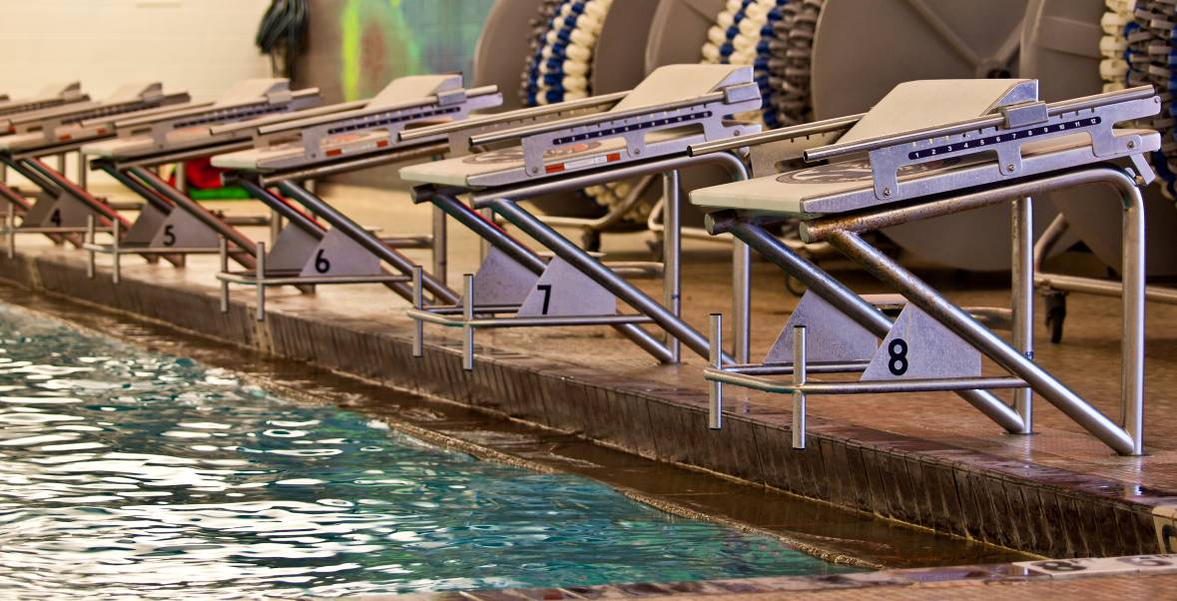

May Classic 2018 Schedule of Events

Friday, May 18, 2018
Girls | Session 1 | Boys
1 | 11 & Over 200 Fly | 2
3 | *11 & Over 1500 Free | 4

Saturday, May 19, 2018 |  |  |  | Sunday, May 20, 2018
Girls | Session 2 | Boys |  | Girls | Session 4 | Boys
5 | 10 & U 200 Free | 6 |  | 35 | 10 & U 200 IM | 36
7 | 10 & U 50 Free | 8 |  | 37 | 10 & U 100 Free | 38
9 | 10 & U 100 Back | 10 |  | 39 | 10 & U 50 Back | 40
11 | 10 & U 50 Fly | 12 |  | 41 | 9-10 100 Fly | 42
13 | 9-10 100 Breast | 14 |  | 43 | 10 & U 50 Breast | 44
15 | 10 & U Mixed 200 Free RELAY** |  |  | 45 | 10 & U 200 Mixed Medley RELAY**
 |  |  |  | 47 | *9-10 400 Free | 48
 | Session 3 |  |  |  | Session 5
17 | 11 & Over 200 IM | 18 |  | 49 | *11 & Over 400 IM | 50
19 | 11 & Over 50 Fly | 20 |  | 51 | 11 & Over 100 Free | 52
21 | 11 & Over 200 Free | 22 |  | 53 | 11 & Over 50 Back | 54
23 | 11& Over 100 Back | 24 |  | 55 | 11 & Over 200 Breast | 56
25 | 11 & Over 50 Free | 26 |  | 57 | 11 & Over 100 Fly | 58
27 | 11 & Over 100 Breast | 28 |  | 59 | 11 & Over 50 Breast | 60
29 | 11-12 Mixed 400 Free RELAY |  |  | 61 | 11 & Over 200 Back | 62
30 | 13-14 Mixed 400 Free RELAY** |  |  | 63 | 11-12 Mixed 200 Medley RELAY**
31 | 15 & Over Mixed 400 Free RELAY** |  |  | 64 | 13-14 Mixed 200 Medley RELAY**
33 | * 11 & Over 400 Free | 34 |  | 65 | 15 & Over Mixed 200 Medley RELAY**
* These longer events (1500 FR, 400 FR, 400 IM) will be run FASTEST to SLOWEST; alternating between women and men.
** Mixed Relays will be swum in combined heats for each session. Relay entries desiring official times must comply with age and gender requirements for the event entered and must submit official relay cards during the meet.

2018 BOZEMAN MAY SWIM CLASSIC
Entry Fee Summary and Waiver/Release Form

Complete and return this form along with entry fees. Make checks payable to: Bozeman Swim Club.
Bozeman Swim Club
attn: Matt Yovich
P.O. Box 804
Bozeman, MT 59771

Team Name
Club Code
Coach
Coach Phone
Coach Email
Team Address

Item | Total Number | Cost per | Total
Swimmer Surcharge |  | $18.00 per event
Relay Entries |  | $6.00 per relay
Individual Entries |  | $3.00 / swimmer event
Total Fees Due

Waiver, Acknowledgement and Liability Release:
I, the undersigned coach or team representative, verify that all of the swimmers and coaches listed on the enclosed entry are registered with USA Swimming. Swimmer and coach registration will be verified. I acknowledge that I am familiar with the Safety Rules of USA Swimming, Inc. and Montana Swimming, Inc. regarding warm-up procedures and meet safety guidelines, and that I shall be responsible for the compliance of my swimmers with those rules during this meet. Bozeman Barracuda Swim Club, Bozeman Swim Center, Montana Swimming, Inc., and USA Swimming, Inc., their agents, employees, and coaches shall be held free and harmless from any and all liabilities or claims for damages arising by reason of illness or injury to anyone during the conduct of this meet. I also acknowledge that by entering this meet, I am granting permission for the names of any or all of my team’s swimmers to be published on the internet in the form of Psych Sheets, Meet Results, or any other documents associated with the running of this meet. This meet may be covered by the media, including photographs, video, web casting and other forms of obtaining images of athletes participating in the meet. Entry into the meet is acknowledgement and consent to this fact.
We hereby submit our team’s entry sheets and fees for your upcoming meet and verify that the above named coaches will be in attendance. These coaches are current in all the requirements set forth by USA Swimming; Red Cross Safety Training for Swim Coaches or Lifeguard Training, First Aid and CPR.

____________________________________________________________________________________
SIGNATURE (Coach or Club Representative) CLUB

____________________________________________________________________________________
TITLE DATE

Master Entry Sheet – for unattached swimmers
Club: ________________________ Age Group: __________ Coach: ___________________
Contact: ______________________ Phone: _______________
Name |  | Age  Sex | USA # | Event # | Event # | Event # | Event # | Event # | Event # | Event # | Fees
 |  |  |  | Time | Time | Time | Time | Time | Time | Time

Tally

Swimmers this sheet X $18.00= $________

Events this sheet X $ 3.00= $________

Total $ this sheet $________
Masters Swimmer Entry Form – for Masters Swimmers

Please include full payment with this completed form. Make checks payable to: Bozeman Swim Club.
Mail entries to: Bozeman Swim Club
attn: Matt Yovich
P.O. Box 804
Bozeman, MT 59771

Friday, May 18, 2018
Girls | Session 1 | Boys
1 | 11 & Over 200 Fly | 2
3 | *11 & Over Mixed 1500 Free | 4

Saturday, May 19, 2018 |  |  |  | Sunday, May 20, 2018
Girls | Session 3 | Boys |  | Girls | Session 5 | Boys
17 | 11 & Over 200 IM | 18 |  | 49 | *11 and Over 400 IM | 50
19 | 11 & Over 50 Fly | 20 |  | 51 | 11 & Over 100 Free | 52
21 | 11 & Over 200 Free | 22 |  | 53 | 11 & Over 50 Back | 54
23 | 11& Over 100 Back | 24 |  | 55 | 11 & Over 200 Breast | 56
25 | 11 & Over 50 Free | 26 |  | 57 | 11 & Over 100 Fly | 58
27 | 11 & Over 100 Breast | 28 |  | 59 | 11 & Over 50 Breast | 60
29 | 11-12 Mixed 400 Free RELAY |  |  | 61 | 11 & Over 200 Back | 62
30 | 13-14 Mixed 400 Free RELAY |  |  | 63 | 11-12 Mixed 200 Medley RELAY
31 | 15 & Over Mixed 400 Free RELAY |  |  | 64 | 13-14 Mixed 200 Medley RELAY
33 | *11 & Over 400 Mixed Free | 34 |  | 65 | 15 & Over Mixed 200 Medley RELAY

*These longer events will be seeded and swum FASTEST to SLOWEST alternating between women and men.
Swimmer's Full Name______________________________________________________________________

Events (max of 4 per day) Seed Times

1. ____________________ ______________ Date of Birth: _____________________________

2. ____________________ ______________ Masters #________________________________

3. ____________________ ______________ Phone number____________________________

4. ____________________ ______________
Fees:

5. ____________________ ______________ Swimmer surcharge: $____18.00_____

6. ____________________ ______________ $3.00 per Individual Event: $_____________

7. ____________________ ______________

8. ____________________ ______________ TOTAL: $_____________

PARTICIPANT WAIVER AND RELEASE OF LIABILITY,
ASSUMPTION OF RISK AND INDEMNITY AGREEMENT

For and in consideration of United States Masters Swimming, Inc. (“USMS”) allowing me, the undersigned, to participate in any USMS sanctioned or approved activity, including swimming camps, clinics, and exhibitions; learn-to-swim programs; swimming tryouts; fitness and training programs (including dryland training); swim practices and workouts (for both pool and open water); pool meets; open water competitions; local, regional, and national competitions and championships (both pool and open water); and related activities (“Event” or “Events”); I, for myself, and on behalf of my spouse, children, heirs and next of kin, and any legal and personal representatives, executors, administrators, successors, and assigns, hereby agree to and make the following contractual representations pursuant to this Waiver and Release of Liability, Assumption of Risk and Indemnity Agreement (the “Agreement”);

- I hereby certify and represent that (i) I am in good health and in proper physical condition to participate in the Events; and (ii) I have not been advised of any medical conditions that would impair my ability to safely participate in the Events. I agree that it is my sole responsibility to determine whether I am sufficiently fit and healthy enough to participate in the Events.

- I acknowledge the inherent risks associated with the sport of swimming. I understand that my participation involves risks and dangers, which include, without limitation, the potential for serious bodily injury, sickness and disease, permanent disability, paralysis and death (from drowning or other causes); loss of or damage to personal property and equipment; exposure to extreme conditions and circumstances; accidents involving other participants, event staff, volunteers or spectators; contact or collision with natural or manmade objects; dangers arising from adverse weather conditions; imperfect water conditions; water and surface hazards; facility issues; equipment failure; inadequate safety measures; participants of varying skill levels; situations beyond the immediate control of the Event organizers; and other undefined, not readily foreseeable and presently unknown risks and dangers (“Risks”). I understand that these Risks may be caused in whole or in part by my own actions or inactions, the actions or inactions of others participating in the Events, or the negligent acts or omissions of the Released Parties defined below, and I hereby expressly assume all such Risks and responsibility for any damages, liabilities, losses or expenses that I incur as a result of my participation in any Events.

- I agree to be familiar with and to abide by the Rules and Regulations established by USMS, including any safety regulations. I accept sole responsibility for my own conduct and actions while participating in the Events.

- I hereby Release, Waive and Covenant Not to Sue, and further agree to Indemnify, Defend and Hold Harmless the following parties: USMS, its members, clubs, workout groups, event hosts, employees, and volunteers (including, but not limited to, event directors, coaches, officials, judges, timers, safety marshals, lifeguards, and support boat owners and operators); the USMS Swimming Saves Lives Foundation; USMS Local Masters Swimming Committees (LMSCs); the Event organizers and promoters, sponsors and advertisers; pool facility, lake and property owners or operators hosting the Events; law enforcement agencies and other public entities providing support for the Events; and each of their respective parent, subsidiary and affiliated companies, officers, directors, partners, shareholders, members, agents, employees, and volunteers (individually and collectively, the “Released Parties”), with respect to any liability, claim(s), demand(s), cause(s) of action, damage(s), loss or expense (including court costs and reasonable attorneys’ fees) of any kind or nature (“Liability”) which may arise out of, result from, or relate in any way to my participation in the Events, including claims for Liability caused in whole or in part by the negligent acts or omissions of the Released Parties.

- I further agree that if, despite this Agreement, I, or anyone on my behalf, makes a claim for Liability against any of the Released Parties, I will indemnify, defend and hold harmless each of the Released Parties from any such Liabilities which any may be incurred as the result of such claim.

I hereby warrant that I am of legal age and competent to enter into this Agreement, that I have read this Agreement carefully, understand its terms and conditions, acknowledge that I will be giving up substantial legal rights by signing it (including the rights of my spouse, children, heirs and next of kin, and any legal and personal representatives, executors, administrators, successors, and assigns), acknowledge that I have signed this Agreement without any inducement, assurance, or guarantee, and intend for my signature to serve as confirmation of my complete and unconditional acceptance of the terms, conditions and provisions of this Agreement. This Agreement represents the complete understanding between the parties regarding these issues and no oral representations, statements, or inducements have been made apart from this Agreement. If any provision of this Agreement is held to be unlawful, void, or for any reason unenforceable, then that provision shall be deemed severable from this Agreement and shall not affect the validity and enforceability of any remaining provisions.

Last Name | First Name | MI | Sex (circle)  M F |  | Date of Birth (mm/dd/yy)
Street Address, City, State, Zip
Signature of Participant |  |  |  | Date Signed
Revised 07/01/2014

Hotel Information

Best Western, 587-5261

City Center Inn, 587-3158

Comfort Inn, 587-2322

Comfort Suites, 587-0800

C’Mon Inn, 587-3555

Days Inn, 587-5251

Fairfield Inn, 587-2222

Hampton Inn, 522-8000

**Hilton Garden Inn, 582-9900 – guests can either call the hotel main number 406-582- 9900 and ask for May Classic OR book online at http://www3.hilton.com/en/index.html select Hilton Garden Inn, pick on bottom of menu “group code” use MAYCLA. Rate is $149/night.

Holiday Inn, 587-4561

Holiday Inn Express, 582-4995

Homewood Suites, 587-8180

La Quinta Inn and Suites, 585-9300

My Place, 586-8228

Spring Hill Suites, 586-5200

Super 8, 586-1521

