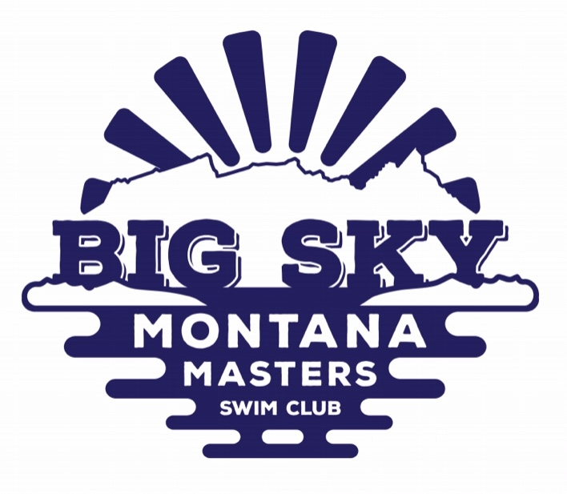

Northwest Zone & Montana State Championships
Friday, April 6, Saturday, April 7 & Sunday, April 8
University of Montana, Grizzly Pool
Swim Meet Registration

 | Open | Close
Individual Registration | Thurs, February 1,2018 12:00 MT | Sun. April 1, 2108 11:59 PM MT
Relay | Thurs, February 1,2018 12:00 MT | Day of Event
Sanctioned by Montana LMSC for USMS, Inc. Sanction #????
Meet Host: Big Sky Montana Masters Swim Club (BSMT)
Meet Referees: Merle Gunderson & Curt Jacobson
Meet Director: Donn Livoni (406) 381-5523 glenhollyfarm.livoni@gmail.com

Facility: The University of Montana Grizzly Pool is located on the UM campus between the Adams Center and Washington-Grizzly Stadium. Grizzly Pool is a 7-lane, 25-yard pool. One lane will be reserved for warm up during the meet. Parking after 5 PM Friday and all day Saturday and Sunday is open without restriction. The length of the competition course is in compliance and on file with USMS in accordance with articles 105.1.7 and 107.2.1. Food is allowed only in the balcony area. NO FOOD IN THE LOCKER ROOMS OR ON THE POOL DECK. Food may be purchased at the Student Union (UC) across the parking lot from the pool.

Rules: Swimmers must be registered with USMS for 2018. Age groups, based on the swimmer’s age as of April 8, 2018, are 18-24, 25-29 etc. in 5-yr increments as needed. Foreign registered swimmers must provide a copy of their current registration card. USMS One-Event Registration must occur at the time of entry and costs $20. One-Event Registrations are governed by USMS Rule 201.1.3.B. Specifically, One-Event swimmers will be considered unattached and their times will not be considered for to Top 10 tabulations, All-American status or any other USMS special awards. 2018 USMS rules govern the meet. Swimmers are limited to 6 individual entries per day, with a maximum of 8 total entries for the meet. During warm up, you must enter the pool feet first except in sprint lanes. No paddles or kickboards are allowed. All event entries must include an entry time. Event entries with NT (no time) will not be accepted.

Deadline: Online entries only by 11:59 PM MDT Sunday, April 1, 2018. No paper entries will be accepted and no deck entries will be accepted at the meet. Relay entries will be accepted at the meet by filling out relay cards and turning them into the computer operator during the warm up session.

Fee: $40 flat fee. There will be no refunds unless the meet is cancelled, in which case $15.00 of the fee paid will be retained and $25.00 will be refunded. If inclement weather occurs, the staff at the UM Grizzly Pool will determine by 2:00 PM Friday, April 6, if the pool will or will not open that evening or the following morning. If it opens the meet will be held.

Relay Registration: Each swimmer in a relay must be registered for the meet and must be a member of the same club. All swimmers must be USMS members. Because One-Event registrants are not affiliated with a club, they may not participate in relays. Relays may be organized by locale if all are members of the same club. There is no charge for relays.

Scoring & Awards: Individual events will be scored 7-5-4-3-2-1. Relays are not scored. Zone championship ribbons will be awarded to 6th place. Team awards for the Montana State meet will be given for places 1-3.

Seeding: All events will be seeded slow to fast, age and sexes mixed. Swimmers in the 1,650, and 1,000 free must confirm that they will swim at the check-in table (positive check-in). Positive check-in deadline for the 1,650 is 6:15 PM on Friday. Positive check-in deadline for the 1,000 is 11:00 AM on Sunday.

Lodging: A limited number of rooms have been reserved at the Comfort Inn, 1021 E. Broadway, Missoula, MT (406) 549-7600. These rooms are first come first served. Please contact the Comfort Inn directly for reservations. The Comfort Inn is within a 5-minute walk or drive to the Pool. The Comfort Inn offers free transport to and from the Missoula airport, free Wi-Fi, guest laundry and free breakfast. The discount code is “Masters Swim Meet”.

Social: There will be a social on Saturday, April 7 from 5:00 PM to 8:00 PM at the Loft, 119 W. Main St., Missoula A catered meal will be a pasta (salad, lasagne, desert) feed with a no-host cash bar (beer and wine) available. The Montana LMSC Annual Membership meeting will take place during the social. Cost for the social is $16.

EVENT SCHEDULE
FRIDAY, APRIL 6
Warm up 6-6:45 PM
Meet starts at 6:45 PM
Event 1 & 2 1650 Freestyle Positive check-in required.

SATURDAY, APRIL 7 SUNDAY, APRIL 8
Warm up 10 AM Warm up 9 AM
Meet starts at 10:45 AM Meet starts at 9:45 AM

Event 3 & 4 400 IM Event 25 & 26 200 Backstroke
Event 5 & 6 50 Freestyle Event 27 & 28 50 Breaststroke
Event 7 & 8 200 Butterfly Event 29 & 30 100 Butterfly
Event 9 & 10 100 Backstroke Break – 15 minutes
Break – 15 minutes Event 31 & 32 200 Freestyle Relay
Event 11 & 12 200 Medley Relay Break – 5 minutes
Break – 5 minutes Event 33 & 34 100 IM
Event 13 & 14 200 IM Break – 15 minutes
Break - 15 minutes Event 35 & 36 200 Freestyle
Event 15 & 16 100 Freestyle Event 37 & 38 100 Breaststroke
Event 17 & 18 50 Backstroke Event 39 & 40 50 Butterfly
Event 19 & 20 200 Breaststroke Break – 15 minutes
Break – 15 minutes Event 41 200 Mixed Medley Relay
Event 21 200 Mixed Freestyle Relay Break – 5 minutes
Break – 5 minutes Event 43 & 44 1000 Freestyle Positive check-in required
Event 23 & 24 500 Freestyle

