Deck Assignments

Day:___________________ Session:__________________

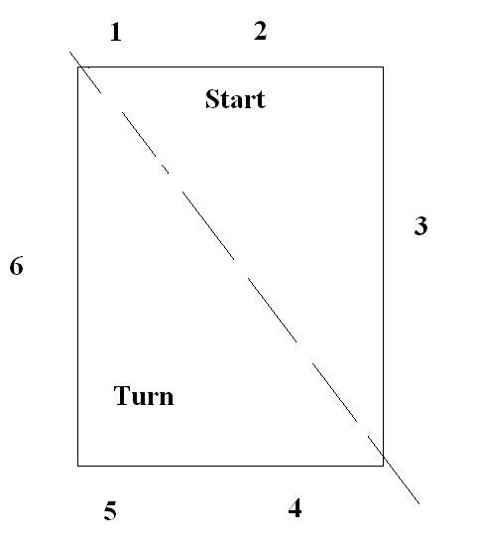
Deck Referees: 1._______________________
2._______________________
3._______________________

Starters: 1._______________________
2._______________________
3._______________________

Chief Judge: 1._______________________
2._______________________
3._______________________

Stroke and Turn Judges

Start End Turn End

1. 4.______________________________
2. 5.______________________________
3. 6.______________________________
a. a.______________________________
b. b.______________________________
c. c.______________________________
d. d.______________________________

