Deck Assignments

Day:___________________ Session:__________________
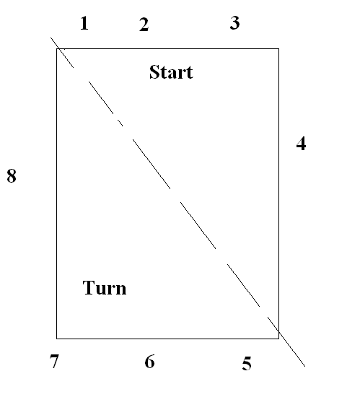
Deck Referees: 1.______________________
2. ________________________
3._________________________
Starters: 1._________________________ 2._________________________
3._________________________
Chief Judge: 1._________________________
2._________________________
3._________________________

Stroke and Turn Judges

Start End Turn End

1. 5.______________________________
2. 6.______________________________
3. 7.______________________________
4._________________________ 8.______________________________
a. a.______________________________
b. b.______________________________
c. c.______________________________
d. d.______________________________

