Deck Assignments
Day: Session:
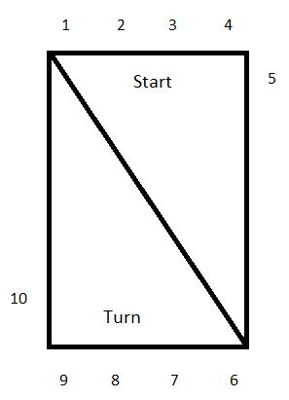
Deck Referees: 1.
2.
3.
Starters: 1.
2.
3.
Chief Judge: 1.
2.
3.

Stroke and Turn Judges
Start End Turn End
1. 6.
2. 7.
3. 8.
4. 9.
5. 10.
a. a.
b. b.
c. c.
d. d.

