Montana Swimming Semi-Annual
HOD Meeting Minutes
October 2, 2016 – 9:00 am
Butte YMCA, Butte, MT
Big Sky. Big Dreams. Big Success!
APPROVED - October 1, 2017

Present:
- Roll call:
  - See attached sign in sheets
- Welcome & Instructions:
  - General Chair, Tony Popp, called to order @ 9:03 am.
  - Review of Vision and Mission Statements. These are posted on the homepage of the MT Swimming website.
  - Many thanks to Butte Y team for hosting today’s meeting, and to Phillip Borup and the Butte YMCA for donating space for this meeting.
  - Phillip Borup’s report on the Butte YMCA:
    - Tarpons have donated $20K for new blocks; YMCA plans to add addition funding for additional upgrades.
    - New surface for the decking and additional bleacher seating are coming as well.
  - General Chair Tony Popp led the charge in Introductions of today’s attendees
    - Great athlete representation from around the state today!

Minutes:
- Spring 2016 HOD meeting minutes (05/20/2016):
  - Motion to approve, seconded, Motion carries.

Reports:
- Overview of officer positions and responsibilities within MT Swimming.
  - For a current list of positions and officers see the Montana Swimming website under the LSC contact information tab.
  - For duties and powers of the officers see Montana Swimming, Inc. Bylaws Section 606.7.
- Please see attached documents for submitted reports.
- 2016 USA Swimming National Convention in Atlanta, Georgia:
  - Montana Swimming pays for all four of our athlete reps to attend the annual USAS National Convention. All four of our athlete reps were able to attend this year’s convention hosted in Atlanta, Georgia.
  - Reports from this year’s attendees:
    - Jade Sobek: College recruiting workshop was great! Especially noticed the importance of MT swimmers being proactive during the recruiting process and lots of good ideas on how to help them get the attention of college coaches.
    - Tami Peters: Presented the workshop “Developing a Volunteer Recruitment and Retention Program for your Club or LSC”. Three other great workshops and committee meetings to highlight were: Sport Science, College Recruiting, and the Officials’ Committee Business meeting. Our athlete reps did a fantastic job representing Montana!
    - Larry Johnson: Not present.
    - Kyle Potter: Sorry Kyle, I completely missed the details of your report! From being there with you I know it was all good though!
    - Kirby Beierle: Diversity and Inclusion workshops were especially helpful and encouraging.
    - Brendan Campbell: Not present; family obligations.
    - Darya Peters: Not present; college recruiting trip.
    - Olivia Bauman: Great experience!
    - Hannah Stevens: Great experience!

Old Business:
- Zones 2016
  - Age Group CoachJade Sobek (BOZ): Several new records set, encouraged education of swimmers to remember they are part of “Team Montana” and must follow the guidelines set for the Montana Zones teams.
  - Senior Coaches Kirby Beierle (MYST) & Jay Friend (MAC): 34 senior swimmers attended, A B &C relay teams for all relays, great cohesiveness as “Team Montana” and spirit during finals, no phones on deck policy worked well. Finals included 7 individual athletes returning for finals.
  - Selection of Zones coaches: Ideal goal would be to have all four Zones coaches applications by this meeting.
    - Tony’s plea: Applications for all four of the 2017 Zones coaching positions are due to Tony by 12/1/2016!
- Futures updates:
  - Coach Mike (FAST): Athlete Colton Babcock
  - Coach Major (KATS):Athletes A.J. Popp, James Bouda, and Julia Peterson. Great competition, fast swims, half step up from Senior Zones, lots of college coaches in attendance.
- Junior Nats updates:
  - Coach Sean (BAC): Athletes attending: Ethan Harder, Adam Zimmer, Kathrine and Cale Berkoff.
  - Several MT coaches highlighted the advantages and importance of working together with all athletes attending these upper level meets, both Futures and JR Nats.
- Mixed Meet
  - Bids and dates for the next Mixed Meet will be coming out by December.
- AAA Camp/Montana All Stars - Coach Shelly Sobek (BOZ):
  - Investigating where our MT swimmers stand in comparison with the National standards; MT swimmers are below the National averages for qualifying for upper level meets and qualifying times. Athletes tend to rise to the highest standard encouraged. Currently in Montana we tend to focus on the BB cut for State. Need to create opportunities to encourage our athletes that “It doesn’t all stop at State Meet…”.
  - AAA Time standards are very close to the Age Group Zones qualifying times. All this information is available at you club portal.
  - AAA camp is for 13 & Over swimmers
  - AAA awards are for 12 & Under. Program Development Committee is responsible for these! ☺
- LEAP 3 - Tony Popp:
  - Currently, the biggest hurdle for MT Swimming in achieving LEAP 3 is the athlete performance requirement.

New Business:
- Annual Montana Swimming Officials meeting, October 1, 2016 - Merle Gunderson (Officials Chair)
  - Approximately 20-25 attended the meeting yesterday.
  - Requirements to become involved in officiating were updated, hopefully making the process simpler. These changes will be updated on the website.
  - Officials would like to make MT Swimming official shirts available to all officials. Discussion centered on best way to fund this and make the shirts available.
- Build a Pool
  - About 40 attendees from Montana and several surround states.
  - Very well received by Montana representatives.
  - Matt Yovich was invited to a “backstage tour” at Olympic Trials. Visited with folks from ND who received the Myrtha Pool after completion of Trials.
  - Finances covered included not only building costs, but also operational and programming expenses as well.
  - Topics involving retrofitting old pools were also discussed.
  - Lots of information is available through USA Swimming Facilities. See Matt Yovich also.
- Safe Sport presentation & Swimposium (Coach Shelly Sobek)
  - See attached Power Point slides and Coach Membership Requirement check list
- Budget (Craig Smith)
  - Craig Smith detailed the current budget and proposed budget for 2017.
  - License plate revenue is now in the positive (initial setup costs have been made). Tami will look back when the program was initially proposed to see what this income was hoped to be purposed towards.
  - Shelly pointed out the last AAA camp cost $4500 to fund; budget is set at $2500. Jade and Shelly funded that camp by combining it with a Developmental Camp, Fitter and Faster.
  - Awards – Big question is “Who is responsible for getting these done each year?” This is a policy question to be addressed later.
  - Funding is in the budget for support for Zones and Nationals. Major raised the question about support for Futures. This should be a proposal in the future. Is not currently in the budget due to Futures being a new meet over the past few years.
  - Few minor adjustments to budget were made at this time; final approval of budget will take place after proposals are discussed and voted on.
- 2016 Proposals
  - Proposal 1 – Motion to approve, seconded, Motion carries.
  - Proposal 2 – Pulled
    - Discussion on: Timeline concerns for both swimmers and coaches, this format seems to be a necessity for hosting the meet in Polson with its facility limitations.
    - Clarification: This proposal if for the 2017 Short Course State ONLY.
    - Vote:
      - For: 26, Against: 6
      - Proposal 2 PASSES.
  - Proposal 3 - Motion to approve, seconded, Motion carries.
  - Proposal 4 - Motion to approve, seconded, Motion carries.
  - Proposal 5 - Motion to approve, seconded, Motion carries.
  - Proposal 6 – Pulled
    - Discussion included a desire by delegates to fully support diversity and inclusion with camps and events supporting these interests. Conclusion focused on making sure finances for such camps are made available in the budget under the general headings of developmental camps and other camps and clinics, rather than attempting to have budgetary categories for each individual camp or event. Goal is to have funds available for such activities, yet maintain flexibility according to what camps, clinics, or events are actually able to be organized each year. Diversity and inclusion camps and other related events shall be funded upon request by these budget categories.
    - Vote:
      - For: 6, Against: 19
      - Proposal 6 FAILS.
  - Proposal 7 – Pulled
    - Lanni Jacobson (MAC) accepted the amendments as noted in the attached proposal.
    - Vote:
      - For: 28, Against: 2
      - Proposal 7 PASSES
- Long Course Schedule
  - See attached schedule.
- Long Course State Bid & Date
  - Maximum bid of $4,000.00
  - Purposed date: July 28-30, 2017.
    - Motion to approve LC State date, seconded, Motion carries
  - BOZ bid $4,000. LC State Meet awarded to BOZ.
- Elections:
  - All the below positions carry 2 year terms.
  - Approval of Official's Chair (nominated Oct 1, 2016 during officials' annual meeting).
    - Nomination: Merle Gunderson
    - Awarded by acclimation
  - Records Chair
    - Nominations: Susan Huckeby & Pam Harder
    - Vote:
      - Susan Huckeby: 5
      - Pam Harder: 25
    - Awarded to Pam Harder
  - Senior Age Group Chair
    - Nominations: Kyle Potter / Major Robinson would like to co-chair this position.
    - Awarded by acclimation
  - Treasurer
    - Nominations: Craig Smith
    - Awarded by acclimation
  - Admin. Vice Chair
    - Nominations: Tami Peters
    - Awarded by acclimation
  - General Chair
    - Nominations: Tony Popp (This would be Tony’s 2nd and thus final term)
    - Awarded by acclimation
  - Motion to destroy ballots, seconded, Motion carries.
- Finalize Budget
  - Motion to approve budget, seconded, Motion carries.
  - See attached budget as approved.
- Adjournment
  - Motion to adjourn, seconded, Motion carries.
  - Adjourned @ 2:12pm.

Respectfully submitted by Tami Peters, Secretary

2016 Fall HOD Sign-In Sheets:
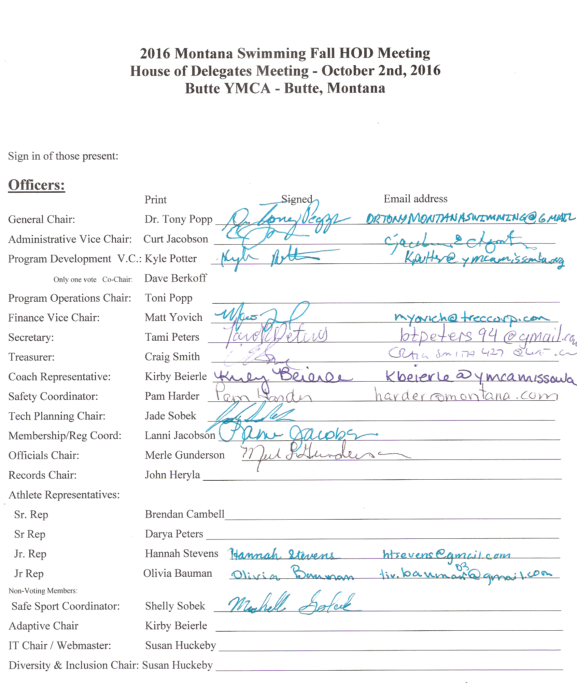

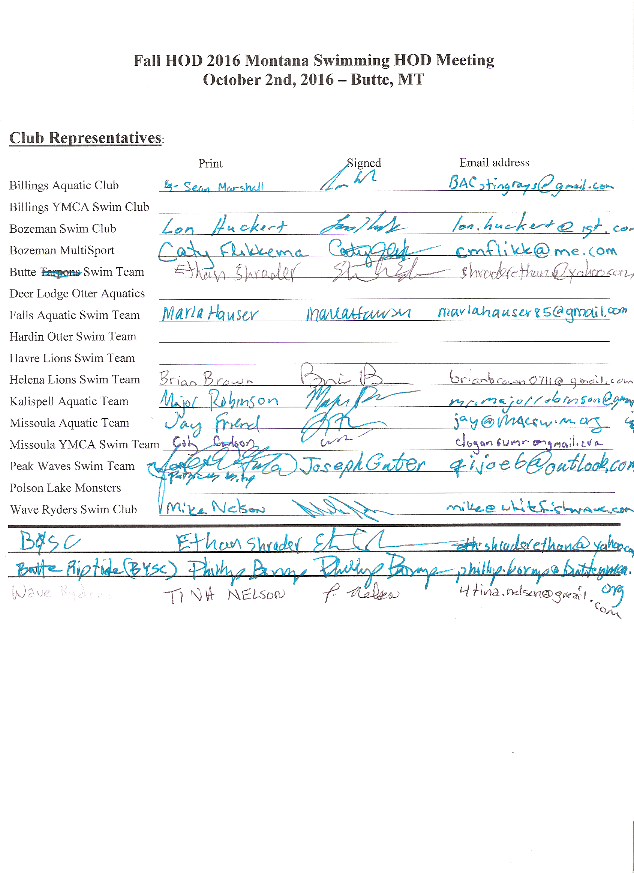
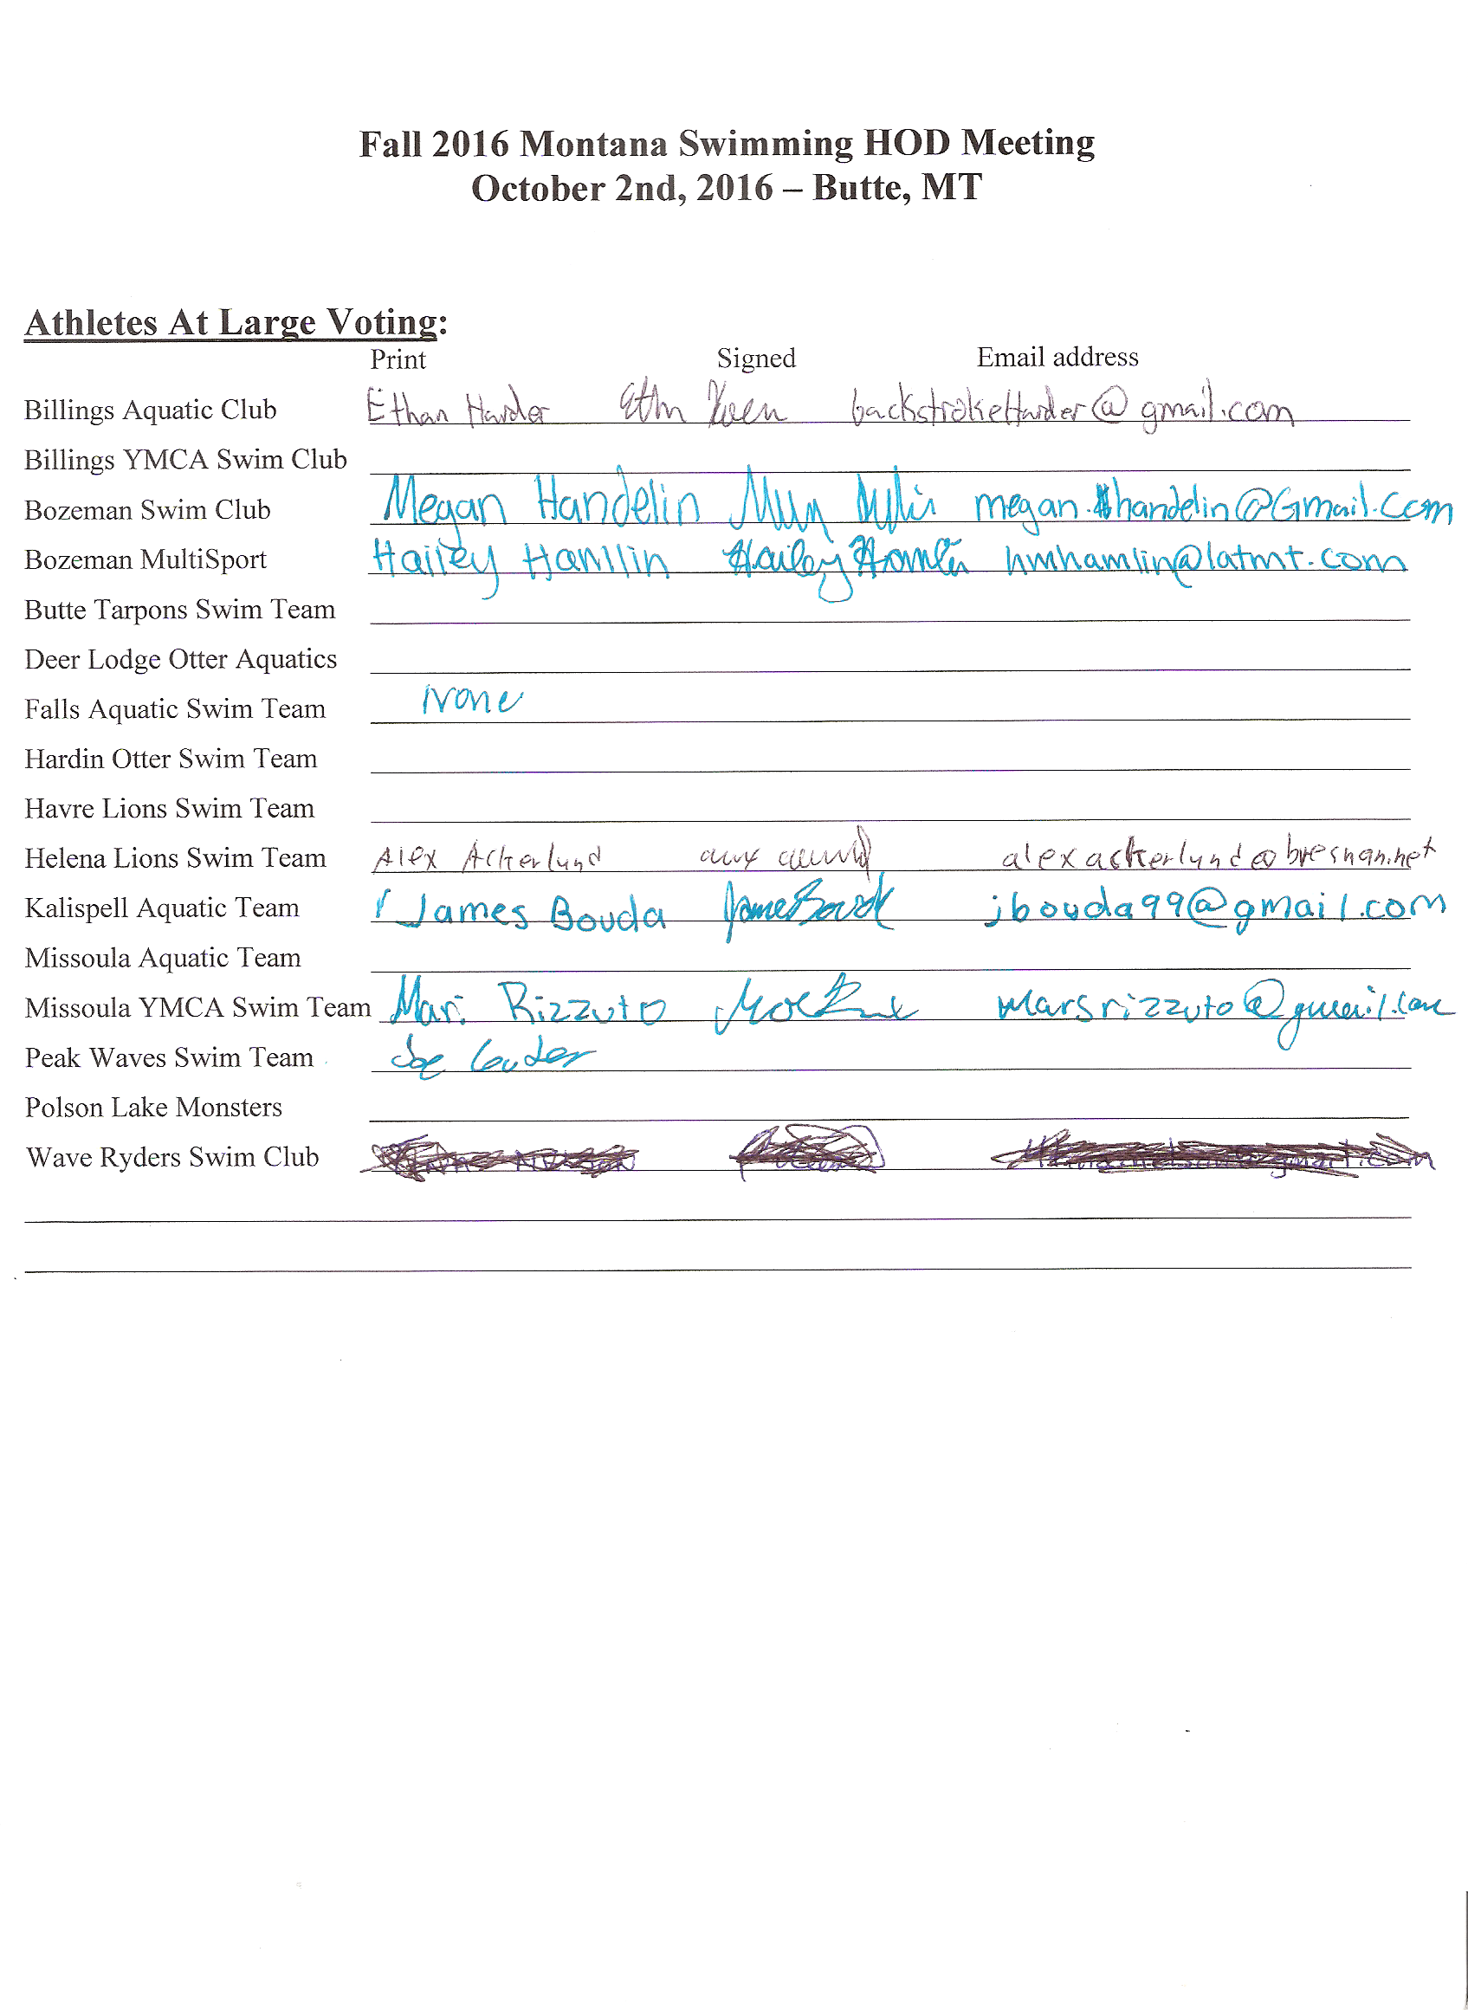
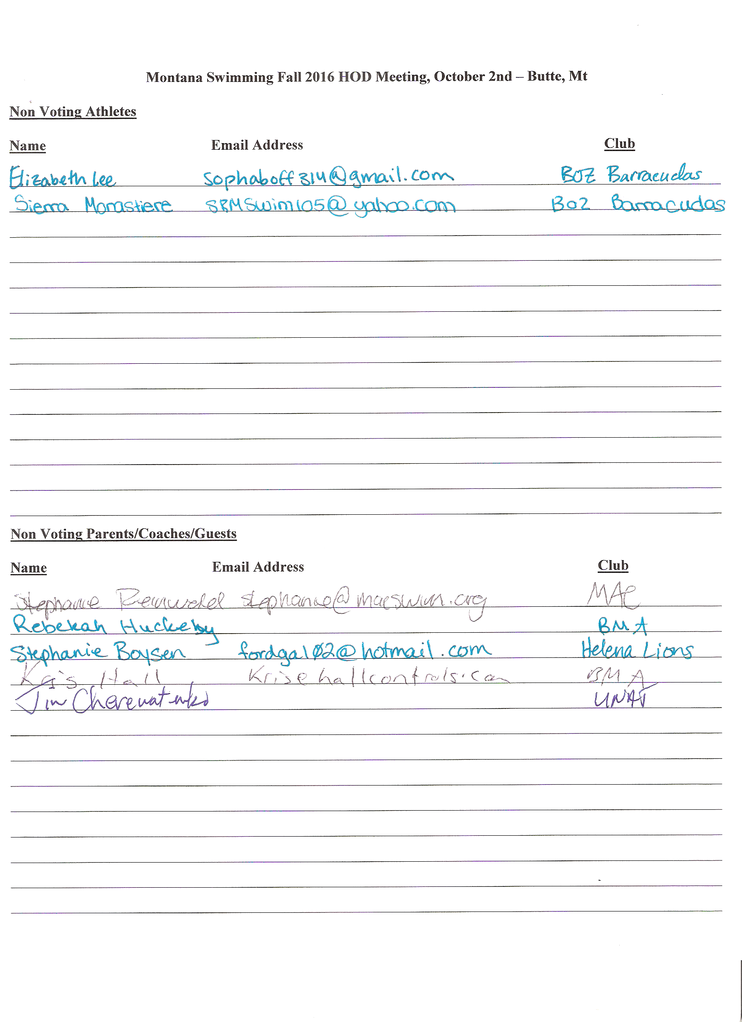
2017 Long Course Meet Schedule:

MONTANA SWIMMING OFFICIAL SCHEDULE LC 2017
Month | Weekend Dates | Event | City | Host Team
April | 1-2
 | 8-9
 | 15-16 | Easter
 | 22-23
 | 29-30
May | 6-7
 | 13-14
 | 19-21 | May Classic | Bozeman | BOZ
 | 27-28
June | 3-4
 | 10-11
 | 17-18
 | 22-25 | Firecracker | Missoula | MAC
July | 1-2
 | 8-9 | Last Chance | Helena | HLST
 | 14-16 | Big Sky State Games | Billings | BAC
 | 18-22 | Summer Sectionals | Gresham, OR
 | 28-30 | LC STATE? | Bozeman | BOZ
Aug | 1-5 | Senior Zones | Clovis, CA
 | 9-12 | Age Group Zones | Roseville, CA
 | 19-20
 | 26-27

Approved Budget for 2017: 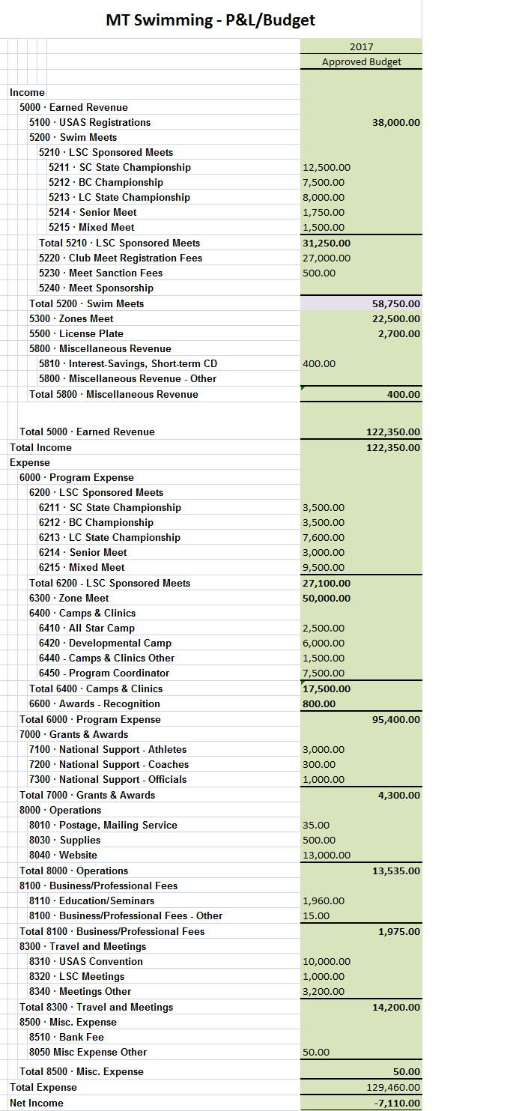

2016 Safe Sport Chair Report:

Safe Sport Chair Report
9-26-16

Reminder that with a new season beginning and new parents and athletes joining your programs to advertise the Parent and athlete online education tools that are offered at usaswimming.org on their Safe Sport page. (Click Here to be directed)

Additionally, clubs need to be sure to follow pre-employment guidelines before hiring. These are the “first line of defense” for clubs to secure quality coaches. These checks include but are not limited to:
- USA Swimming background checks (REQUIRED)
- Motor vehicle checks (REQUIRED)
- Reference checks (REQUIRED)
- Maintaining updates on Athlete Protection Trainings (APT) bi-annually (REQUIRED)
- Social media Search and Google Media Search (not required, but suggested)

Continuing to support coaches to maintain proper boundaries is essential. USA Swimming recommends that your team creates a culture that makes all athletes, parents, and coaches feel safe at all times. If the culture is created, any violations of Safe Sport will stick out and be noticed and able to be handled quickly. Consider posting the “No Camera’s” sign at your meet or in your team locker rooms as a reminder. The pdf of the poster can be found on the USA Swimming Safe Sport Page, at the bottom of the page, (Click Here) to be taken to the Safe Sport Resources Library Page.

Violations happen! Please don’t assume that because we are in Montana or a small LSC made up of relatively small teams, that safe sport is unnecessary. PLEASE support the policies of Safe Sport to make every swimmer safe at all events. (Click Here) for more tools from the USA Swimming Safe Sport page.

Safe Sport also addresses Bullying within our sport. Address reports of bullying within guidelines from USA Swimming or in your own club policies to ensure all swimmers feel safe at the pool physically and emotionally.
The USA Swimming model policies for bullying, travel, and electronic communication are available online from the safe sport page. (Click Here)

The Safe Sport Fellowship is now open for Athletes! Please go to the Safe Sport page on USA Swimming (click here) for the details!

Please contact coachsobek@gmail.com for any questions.

Submitted by Coach Shelly Sobek

2016 Officials Chair Report:

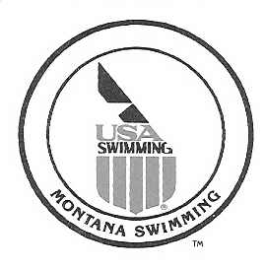

September 7, 2016

Montana Swimming House of Delegates,

I would like to report that as of September 7, 2016 we have 80 registered officials with 77 certified and 3 currently working on their stroke and turn certification.

We had a very successful long course season that concluded with the 2016 Montana Swimming LC State Championship Meet in Bozeman July 2016. We had a great turn out of officials that worked the meet over the three days. These officials made the meet was run extremely well and the comments which were made during and after the meet were all positive and the meet was completed ahead of the projected time line each day.

Montana Swimming had numerous officials who traveled and work both of the Western Zones Meet, Sectional Meet and the new USA Futures Meet this summer.

As we get ready to start the 2017 short course season, I would like to ask that we continue to recruit new officials from all the teams as we will continue to lose officials each year and the need for trained officials will grow each year. I would like to ask that we continue to add two officials from each team every year.

In conclusion, I would like to thank all the officials that have worked meets throughout the last year and provided training and mentoring for our new officials. I would encourage all our officials to continue with the training and mentoring of all the officials. We have a great group of officials in our LSC and I know we all learn something at the meets we work.

If anyone has questions or need anything please feel free to contact me.

Respectfully Submitted,

Merle L Gunderson
Montana Swimming Officials Chairman
mtgunders@outlook.com

2016 Diversity and Inclusion Report:
2016 Fall Diversity and Inclusion Chair report for Montana Swimming
Montana Swimming was well represented at the 2016 Western Zone Diversity and Inclusion Camp and Regional Diversity Summit held June 16-19 at the University of Utah in Salt Lake City. KATS swimmer AJ Popp was the lone Montana athlete at the camp and she enjoyed two a day practices designed by the five camp coaches along with other fun activities. She's a champion s'mores fixer too! (AJ's report on the camp is also posted on the website.) Mrs. Toni Popp (KATS) attended as a Regional Summit participant and she found the camp to be a great learning experience and met several new friends. She is excited to help with plans for a Western Zone diversity and inclusion camp planned for 2018. I attended as the Montana Swimming diversity and inclusion chair. I am also a member of the WZ diversity and inclusion committee that hosts the camp and is planning a multicultural heritage meet in 2019. I enjoyed meeting all the committee members that I’ve spoken with over the years via the phone and am thrilled that the camp had 40 athletes in attendance from across the Western Zone and over twenty participants in the regional diversity summit. As part of the leadership team, I presented a workshop on outreach membership.
Sabir Muhammad joined the campers as the national athlete. Sabir is one of the most well known African American swimmers. He swam for Stanford and was the first African American to compete for a men's varsity swim team. In 2000, Muhammad competed in the Short Course World Championships, winning silver and bronze medals and becoming the first African American to win a medal at a major international swimming competition. He competed as a championship finalist at the 2000 Olympic Trials in the 100 meter freestyle and as a semi-finalist in the 50-meter free, unfortunately missing the cut to make the Olympic team. In his career, Sabir broke 10 American records, became a two time Short Course World Championship medalist, a four-time U. S. Open champion, a five-time World Cup Swimming champion and two-time runner-up at U. S. Nationals. In 2009, Muhammad made a comeback after years off and earned another National Team spot in the 50 freestyle during ConocoPhillips USA Swimming National Championships. Sabir is 6'7" tall.
Montana Swimming paid the $240 registration fee for each participant and up to a maximum of $300 for travel for each participant based on submitted receipts as budgeted.
The next Western Zone Diversity and Inclusion Select Camp will be June will be June 14-17 at San Diego State University in beautiful San Diego, California. Camp applications will be available from the WZ diversity and inclusion committee by fall 2017. (Think outdoor pools, an ocean swim, and more!)
I also chair the WZ outreach membership eligibility sub-committee. This spring I compiled a document listing all the outreach eligibility criteria and outreach/diversity activities by LSC in the United States. That information was provided to USA Swimming and the national diversity and inclusion committee. At convention in September, the national committee provided that information to everyone in attendance at the national meeting. The next topic the sub-committee will address will be meet fee waivers for outreach athletes and how LSCs can incorporate these waivers into their meets and budgets. Many LSCs already offer meet fee waivers for low income athletes and this document will aid other LSCs in adding these waivers to their program.
For the fall Montana Swimming HOD meeting I am proposing that Montana Swimming set aside a $3000 annual budget appropriation to fund two one-day LSC diversity and inclusion camps each year. Eligible swimmers include those who are ethnic minorities, outreach members, LGBTQ, and disability members. We hope to hold camps at Polson and Hardin in the upcoming year. Many other LSCs in the western zone have held such camps and it is my hope Montana Swimming will join those moving forward with these camps. The Montana Swimming camps can be used as a stepping stone to the WZ diversity and inclusion select camp and the USA Swimming National Diversity Select Camp. I used the mixer meet model to help develop the budget for the camp. The camp budget request is very modest. Montana Swimming has allocated $12,000 to hold two mixer meets per year ($6000 per camp). Camp coaches received a stipend to coach at the mixer meet (the 2016 mixer meet had 6 coaches paid a total of $990 or $165 each). In the future, the diversity camp could be held as a two day camp and western zone recognized diversity and inclusion coach may be asked to lead the camp. While I do not have exact numbers on how many athletes may be eligible for the camp, I believe it could be 250-300 athletes. Along with the camp, a diversity summit will be held for interested parents, coaches, officials, and volunteers.
Finally the diversity tab on the website has several useful documents dealing with diversity, inclusion, outreach, and disability swimming. It has been my pleasure to serve as the diversity and inclusion chair for Montana Swimming.

Respectfully submitted,

Susan Huckeby
Montana Swimming Diversity and Inclusion Chair

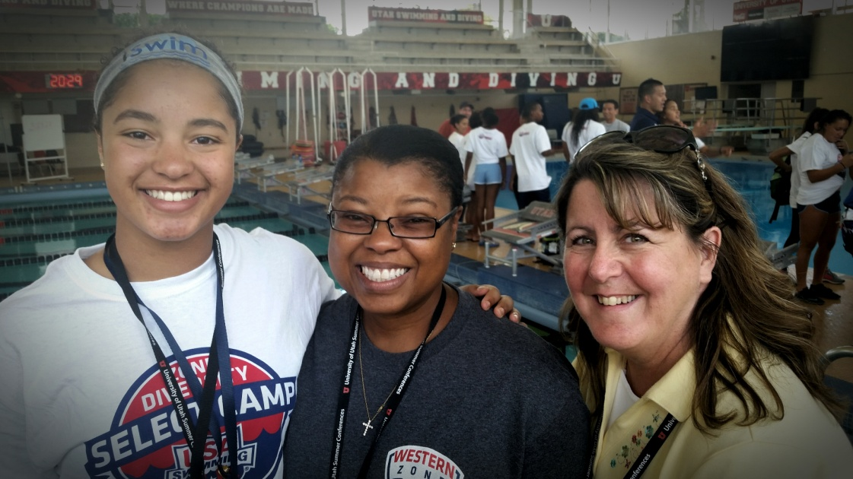

AJ Popp, Toni Popp, and Susan Huckeby at the 2016 Western Zone Diversity and Inclusion Select Camp at Salt Lake City, Utah.
2016 Diversity and Inclusion Select Camp Athlete Report:

2016 WZ Diversity and Inclusion Select Camp Athlete Report
2016 Fall Montana Swimming HOD Meeting

Dear MTS and MTS Athletes,

This past weekend (June 16-19) I had the opportunity to attend the USAS Diversity and Inclusion Camp in Salt Lake City. This year the camp was open to 9th and 10th graders from the Western Zone who applied to and were selected by their LSC. Not only did I learn new things ranging from nutrition to goals, but I also made new friends who I am excited to see again at higher level meets.

We had five pool practices over the three days. I was not expecting the sets to be as hard as they were, but I did like the challenge and maybe the best part was the the huge amounts of food Audrey (the camp coordinator) would always have for us afterwards. Besides the pool time we had other fun "dry" activities and things to do. The last night they took us to a woodsy area, built a fire and supplied us with 'smores fixin's. The girls from Alaska and I had to teach everyone else the "proper" technique for making the essential athlete treat.

All five of the coaches were very fun to be around and all gave good advice about something like a stroke or where to go during "The Purge'. To sum everything up I am very glad I had the opportunity to attend this camp and feel like it has benefited me in more ways than just swimming. Thanks to Montana Swimming for sending me and I encourage MTS athletes to apply for this camp in the future.

A.J. Popp
KATS
2016 IT Chair Webmaster Report:
IT Chair Webmaster Report 2016 Fall HOD Meeting

The Montana Swimming website continues to be updated since the new look occurred in mid-February. I have been updating the site with new information since the changeover. Several pages are still being updated, so please be patient as the updates are added. If the officers, teams, or others have information they would like posted, please e-mail it to me. I did post several photos from events over the summer on the news page. The registration tab has been updated for 2017. If teams have changed their club contact, please let me know and I will update the club contact page. If you have ideas or suggestions, feel free to send them to me.

Respectfully submitted,

Susan Huckeby
2016 Swim Scholastic All America Team Report:
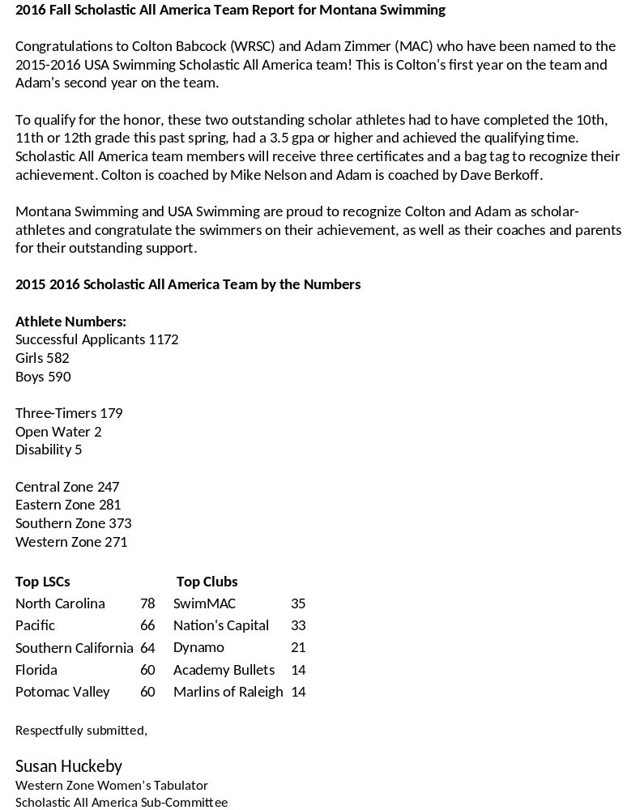

2016 Amended Proposals:
2016 MT Swim HOD Proposals

Proposal 1: Update Current MT-Athlete of the Year Policy/Procedure
Submitted by Coach Shelly Sobek
(Edits in Red from Current Policy—all dates at the end of each line will need to be updated as well if passed)
.1 MT-S Athlete of the Year
A. Selection of the Female and Male MT-S Athlete of the Year will be on a score basis, not a vote of the HOD. (Adopted: 10/2/11)
- Athletes will be nominated, sores submitted, and aAthletes of the year will be determined at the MT-S spring HOD. Scores must accompany any nominations. (Adopted: 10/2/11)
- In April of each year the MT-S General Chair will announce to the LSC that nominations for the MT-S Athletes of the Year are being accepted. The announcement and the application worksheet shall be sent to each team, each member of the MT-S HOD, placed on the MT-S web site and announced in any other manner deemed appropriate a the time. (Adopted: 10/2/11)
- Athlete nominations may be submitted to the General Chair prior to the spring MT-S HOD meeting or may be submitted during the spring HOD . (Adopted: 10/2/11)
- To qualify, athletes must be age 21 or younger when the power points were achieved. (Adopted: 10/2/11)
- To qualify, the athlete must be an active member of MT-S when the power point scores were achieved and must have competed in at least two MT-S swim meets during this time period. Power points scores achieved while the athlete is a member of another LSC do not qualify for this award. (Adopted: 10/2/11)
- Swimmers from college varsity swim teams and professional swimmers are ineligible for this award. (Adopted: 10/2/11)
- The qualifying time period is from April 1 of the previous year through March 31 of the current award year. (Adopted: 10/2/11)
- MT-S will award a plaque to the Male and Female Athletes of the Year at the MT-S LC State Championship meet. (Adopted: 10/2/11)
- In case of a tie, a joint award will be presented. (Adopted: 10/2/11)
- If no nominations are submitted, no award will be given that year. (Adopted, 10/2/11)
- The award shall be based on the top five Hy-tek power point scores for the athlete in the qualifying time period (50 FL, 50BK and 50 BR scores may be used). Multiple power point scores for the same event or for the same in event in a different course will not be accepted. (For example, the athlete may submit a score from the 100 yard freestyle, but may not also submit a score from the 100 LCM freestyle or 100 SCM freestyle.) (Adopted: 10/2/11)
- The power point scores may only be used will be calculated by the MT-Times Chair from times in the USA-S SWIMS data base. (Adopted: 10/2/11Scores will be based on the swimmers Age Group Power Point system. Scores will be based on the swimmers’ Age Group Power Point listing report (ex. 11-12 age group or 13-14 age group).
- MT Times Chair will submit the Names of the Male and Female recipients and their points to the current Long Course State Meet Manager, and it will be the responsibility of the Meet Manager to order the award for presentation at the State Meet and submit receipts to the MT-S Treasurer for reimbursement.
- Nominations must be accompanied by the application worksheet and a print out of the scores. (Adopted: 10/2/11)
- To print the power point scores use the current version of Hy-tek TM, go to reports, then Top Times report, use the since and use times until date function (April 1 of previous year to March 31 of current year), then click on courses, then chick points, then click Hy-tek power points, the click report. Print a copy of the results and circle the top five (5) power points scores. Submit this paperwork wit the application worksheet. (adopted 10/2/11)
- The application worksheet will be used to tally the scores. (Adopted: 10/2/11)

Full Clean Copy of the new proposal:
.1 MT-S Athlete of the Year
- Selection of the Female and Male MT-S Athlete of the Year will be on a score basis, not a vote of the HOD. (Adopted: 10/2/16)
- Athletes of the year will be determined at the MT-S spring HOD. (Adopted: 10/2/16)
- To qualify, athletes must be age 21 or younger when the power points were achieved. (Adopted: 10/2/11)
- To qualify, the athlete must be an active member of MT-S when the power point scores were achieved and must have competed in at least two MT-S swim meets during this time period. Power points scores achieved while the athlete is a member of another LSC do not qualify for this award. (Adopted: 10/2/11)
- Swimmers from college varsity swim teams and professional swimmers are ineligible for this award. (Adopted: 10/2/11)
- The qualifying time period is from April 1 of the previous year through March 31 of the current award year. (Adopted: 10/2/11)
- MT-S will award a plaque to the Male and Female Athletes of the Year at the MT-S LC State Championship meet. (Adopted: 10/2/11)
- In case of a tie, a joint award will be presented. (Adopted: 10/2/11)
- The award shall be based on the top five Hy-tek power point scores for the athlete in the qualifying time period (50 FL, 50BK and 50 BR scores may be used). Multiple power point scores for the same event or for the same in event in a different course will not be accepted. (For example, the athlete may score from the 100 yard freestyle, but may not also score from the 100 LCM freestyle or 100 SCM freestyle.) (Adopted: 10/2/16)
- The power point scores will be calculated by the MT-Times Chair from times in the USA-S SWIMS data base. (Adopted: 10/2/16)
- Scores will be based on the swimmers Age Group Power Point system. Scores will be based on the swimmers’ Age Group Power Point listing report (ex. 11-12 age group or 13-14 age group).
- MT Times Chair will submit the Names of the Male and Female recipients and their points to the current Long Course State Meet Manager, and it will be the responsibility of the Meet Manager to order the award for presentation at the State Meet and submit receipts to the MT-S Treasurer for reimbursement.

Proposal 2: Montana Swimming-Short Course State Meet Format Change
Submitted by Coach Jade Sobek, Technical Planning Chair
Proposal:
For the 2017 Short Course State Meet: Separate the 10 and under events into their own session in between the 11 and over prelims/finals sessions at the Short Course Montana Championship State Meet.
Meet line up would be:
- 11 and over Prelims (almost same current meet line up, with removal of 10 and under races, and switching of 200 FR and 100 FR on Friday and Sunday—see below), followed by distance races for that day.
- One, 30 minute, or two 20 minute warm-up session(s) for 10 and under swimmers based on number of 10 and under swimmers entered, at the discretion of the Meet Referee.
- Timed Finals session for 10 and under swimmers. Only change would be to Friday, in order to split up the 200FR and 200 IM races into separate days.
- 30 min break, then 45 minute open worm-up session, followed by Finals session for 11 and over swimmers, including relays at the conclusion of the meet.

Rational: Allowing Short Course State meet an alternate format for State Meet, based on possible space restraints at a venue.
For State meet to be held in Polson, MT in the upcoming year, (or future other bid winning venues) I believe some alterations to the meet format will need to be made in order to allow participants and spectators the opportunity to enjoy the meet and fit in the limited deck spaces that Montana Facilities provide.
This new format would allow for more space in areas around the pool for spectators by reducing the number of families at the facility at the same time. It also simplifies the format by separating the timed finals races of the 10 and unders from the Prelims/finals races of the 11 and overs. It would provide longer breaks between prelims and finals for 11 and over swimmers, and allow for adherence to the 4 hour session guidelines set by USA Swimming.
Possible concerns include having enough officials during the 10 and under session, but officials would already be at the meet for older swimmers, so hopefully this would not be a huge deterrent. There will be families that have swimmers in all the sessions, but it would ease the space issues for most families. The distance events being at the end of prelims, would allow for a nice transition of prelims swimmers/families exiting the facility, and 10 and under swimmers/families entering the building.
Draft Meet line up would be as follows (on next page):

Montana Swimming State Short Course Championship Meet Events
Preliminaries
 | Friday |  |  |  |  |  |  |  |  | Saturday |  |  |  |  |  | Sunday
Girls | Event |  |  |  |  |  | Boys |  | Girls | Event |  |  | Boys |  | Girls | Event |  |  | Boys
 | Session 1 |  |  |  |  |  |  |  |  | Session 4 |  |  |  |  |  | Session 7
1 | 11 - 21 | 200 |  | Fly |  |  | 2 |  | TF 33 | 11- 21 | 400 | IM | TF 34 |  | 67 | 11 - 21 | 200 | Breast | 68
3 | 11-21 | 50 |  | Back |  |  | 4 |  | 35 | 11-21 | 50 | Free | 36 |  | 69 | 11-21 | 50 | Fly | 70
5 | 11-21 | 100 |  | Free |  |  | 6 |  | 37 | 11-21 | 200 | Back | 38 |  | 71 | 11-21 | 200 | Free | 72
7 | 11-21 | 100 |  | Breast |  |  | 8 |  | 39 | 11-21 | 50 | Breast | 40 |  | 73 | 11-21 | 100 | Back | 74
9 | 11-21 | 200 |  | IM |  |  | 10 |  | 41 | 11-21 | 100 | Fly | 42 |  | 75 | 11-12 | 100 | IM | 76
TF 11 | 11 - 21 | 1000 |  | Free |  |  | TF 12 |  | 43 | 21&U | 500 | Free | 44 |  | 77 | 11 - 21 | 1650 | Free | 78
 | 30-40 Min. Warm-up |  |  |  |  |  |  |  |  | 30-40 Min. Warm-up |  |  |  |  |  | 30-40 Min. Warm-up
 | Session 2—all TF |  |  |  |  |  |  |  |  | Session 5-all TF |  |  |  |  |  | Session 8-All TF
13 | 8&U | 25 |  |  |  | Back | 14 |  | 45 | 8&U | 100 | IM | 46 |  | 79 | 10&U | 200 | IM | 80
15 | 10&U | 50 |  |  |  | Back | 16 |  | 47 | 10&U | 100 | IM | 48 |  | 81 | 8&U | 25 | Free | 82
17 | 8&U | 50 |  |  |  | Free | 18 |  | 49 | 10&U | 50 | Free | 50 |  | 83 | 10&U | 100 | Free | 84
19 | 10&U | 200 |  |  |  | Free | 20 |  | 51 | 8&U | 25 | Breast | 52 |  | 85 | 8&U | 50 | Back | 86
21 | 8&U | 50 |  |  |  | Breast | 22 |  | 53 | 10&U | 50 | Breast | 54 |  | 87 | 10&U | 100 | Back | 88
23 | 10&U | 100 |  |  |  | Breast | 24 |  | 55 | 8&U | 50 | Fly | 56 |  | 89 | 10&U | 200 | Free Relay | 90
25 | 10&U | 400 |  |  |  | Free Relay | 26 |  | 57 | 10&U | 100 | Fly | 58
 | 30 Min. Break |  |  |  |  |  |  |  | 59 | 10&U | 200 | Medley Relay | 60 |  |  | 30 Min. Break
 | 45 Min. Open W.U. |  |  |  |  |  |  |  |  | 30 min. Break then 45 Min. Open W.U. |  |  |  |  |  | 45 Min. Open W.U.
 | Session 3-Finals |  |  |  |  |  |  |  |  | Session 6-Finals |  |  |  |  |  | Session 9-Finals
 | Same order as Prelims |  |  |  |  |  |  |  |  | Same order as Prelims |  |  |  |  |  | Same order as Prelims
TF 27 | 11-12 |  | 400 |  | FR-R |  | TF 28 |  | 61 | 11-12 | 200 | Med-R | 62 |  | 91 | 11-12 | 200 | FR-R | 92
TF 29 | 13-14 | 400 |  |  |  | FR-R | TF 30 |  | 63 | 13-14 | 200 | Med-R | 64 |  | 93 | 13-14 | 200 | FR-R | 94
TF 31 | 15&U | 400 |  |  |  | FR-R | TF 32 |  | 65 | 15&U | 200 | Med-R | 66 |  | 95 | 15&U | 200 | FR-R | 96
TF - denotes Timed Finals events to be swum during Preliminaries
FO - Denotes Finals Only events to be swum at end of Finals

Proposal 3: Montana Swimming for Club Safe Sport Contact Network
Submitted by Coach Shelly Sobek, Safe Sport LSC Chair
Rational: Create a network of contacts for clubs in Montana for the Safe Sport Coordinator
Proposal: Teams will be required to designate the name of a “Safe Sport Club representative” with email address on their team registration form annually. Contact can be any person affiliated with the club (ie, club president, coach, or volunteer parent). If club contact changes during the year, it will be the responsibility of the club to name a new designee and provide contact information to the Montana Swimming Chair within 3 weeks of a written request by the Safe Sport Chair.
Responsibilities of the Club Safe Sport Representative:
- Receive communication from the Safe Sport Chair (~1-3 times per month).
- Distribute the information provided by the Safe Sport Chair to their club’s members.
- Provide any information from their club to the Safe Sport Chair if given.
- Provide new contact information to the Safe Sport Chair if they will no longer represent the club.

Proposal 4: Montana Swimming State Qualification Time Clarification
Submitted by Coach Shelly Sobek
Rational: To clarify standard used for “State Qualifying time” in order to add the 50 BK, BR or FL from a 100 qualifying time.
Current Wording in MT Rules and Regulations Under Section 4.C.4: Changes documented in red print.
- ELIGIBILITY: all swimmers must be registered with USA Swimming and Montana Swimming. Swimmer, official, and coach registration will be confirmed with Montana Swimming Registration Chairperson prior to the start of the meet. Swimmers must have achieved at least one qualifying time standard in any course between January 1st of the prior year, and the entry deadline, except relay only swimmers. Swimmers ages 8 and under must qualify in each individual 8 & under event entered. The 10 & U and older swimmers must enter at least one event with a “BB” qualifying time or faster and then may enter any subsequent event in which they have achieved a “B” time or faster. A swimmer qualified in either the 1000 or 1650 freestyle automatically qualifies for the opposite event. If a swimmer does not have an established qualifying time for the opposite event, the swimmer shall be entered with the established “B” time in the same course as the qualifying time in the opposite event. Any swimmer who enters the 1000 or 1650 yard freestyle may enter at his/her fastest time or at the B time standard. A “BB” qualifying time in 100 (yard/meter) of the backstroke, breaststroke, or butterfly automatically qualifies the swimmer for the 50 of the same stroke in the same course. Designate the swim as bonus in the Hy-Tek Team Manager entry file and note on the proof of time sheet that the 50 event is the bonus swim for the 100 qualifying swim if the swimmer does not have a qualifying time in the 50 event. (Adopted: 10/02/10) Altitude adjusted times will be accepted. Enter the swimmer with the altitude adjusted time (as a custom time) in the Hy-Tek entry file. Provide the correct documentation including the actual time, altitude adjusted time, meet, date achieved, city, and elevation in the accompanying proof of time documents.

Only times earned in a USA Swimming sanctioned or approved meet or at a USA Swimming sanctioned time trial or swims requested to be observed under authorization of USA Swimming rules at other meets (MHSA High School State Swimming Championships) can be used to qualify for this state meet. Times earned at a non-sanctioned meet or time trial cannot be used to enter this meet. All individual entry times must be proven through the USA Swimming SWIMS database or for 25 yard/meter events through the MT Swimming times data base.

Proposal 5: Change the entry qualifying times to allow no time (NT) entries for the MT Swimming Junior BC Championships. Wording in the meet information shall be as follows:
Swimmers may enter any event in which they have a 'B' time or slower in any course (SCY, LCM, SCM) within the qualifying time period. No time (NT) entries will be accepted.
Rationale: I believe since Montana Swimming began hosting this meet, we have allowed swimmers with no time (NT) entries to enter the meet with a "fake" entry time as NT entries weren't allowed. I don't see the point of continuing to allow swimmers to enter with fake times. Let's allow swimmers to enter the meet with a no time entry if the swimmer does not have a time in the event.
Submitted by Susan Huckeby
Proposal 6: Montana Swimming diversity and inclusion camp budget line item
Add to the budget $3000 annually for Montana Swimming LSC sponsored diversity and inclusion camps held within the state each year. (Create a diversity and inclusion camp budget line in the amount of $3000 annually.)
Rationale:
Plan for camps:
The current plan is to host two - one day camps (one in Eastern Montana and one in Western Montana) annually. The camps will be open to athletes 10 years and older who are ethnic minorities, LGBTQ, outreach members (low income) or disability athletes.
In the future, plans are to host a two day long camp or camps. In the future as interest in the camp grows, Montana Swimming could invite a coach from outside the state to the camp.
Camps will include pool sessions and classroom sessions for the athletes. There will also be a diversity summit classroom sessions for adults. Speakers for the adult diversity summit will be from Montana and possibly from, USA Swimming. Camp will provide lunch, snacks, stipend for the coaches, and hopefully some 'bling' for the participants. Montana Swimming will cover the costs including facility rent, all stipends, meals and snacks, and other expenses.
Camp reports will be submitted to Montana Swimming.
Budget: Approximately $1500 will be spent on each camp to cover costs.
While there aren't any absolutely fixed numbers of athletes who may be qualified for the camp, I believe there may be 250-300 athletes who could be eligible. Many athletes do not 'check the box' when asked about ethnicity on their registration form so there could be more ethnic minority athletes than what is currently reported. I don't know if any data has been collected on the number of LGBTQ athletes in the LSC.
USA Swimming and the Western Zone are encouraging LSCs to offer camps for diversity and inclusion athletes. This camp also includes disability swimmers. Several LSCs in the WZ already offer diversity and inclusion camps and now Montana Swimming can offer these camps to our members. These camps can be stepping stones to the Western Zone Diversity and Inclusion Select Camp and the National Diversity and Inclusion Select Camp. We would like to encourage senior swimmers in Montana Swimming who are also ethnic minorities, LGBTQ, outreach, or disability athletes to be speakers and mentors at the camp. These camps will be a great way to provide additional opportunities to our swimmers, coaches, and family members.
Purpose: Instill a vision of success and inspire athletes from under-represented populations to become leaders in the sport of swimming.
Goals: To empower athletes from ethnically under represented populations, those economically disadvantaged, and LGBT and their coaches to:
1. Demonstrate the viability of inclusiveness in swimming within Montana Swimming
2. Achieve performance excellence at every level of the sport
3. Expound the benefits and value of participating in the sport of swimming
4. Be positive leaders and role models that others from socioeconomic backgrounds can emulate
5. To connect, network and promote the virtues of the sport of swimming through a comprehensive strategy involving the athletes, coaches, parents and the diversity chair within Montana Swimming and throughout the Western Zone.
Submitted by: Susan Huckeby

Proposal 7: Paid coordinator position for athlete programs and events for Montana Swimming
Submitted by Curt Jacobson
This would benefit all swimmers from new swimmers to advanced swimmers. This also assures that we have the events each year.

Paid Coordinator position for Athlete Programs and events
This proposal authorizes the MT Swimming Executive Board to advertise and contract and oversee a paid event coordinator. This position will be a 1 year only position from September 1 to August 31st. The position will be voted on for it’s inception during the fall HOD meeting in 2016. After that, the position will be voted on at the spring HOD meeting in order for the coordinator to begin planning prior to September 1st.
Coordinator role:
- Provide events and programs for Montana Swimmers or potential swimmers.
- Stay within the designated budget defined by the HOD.
- Provide programs for all age levels and abilities throughout the year.
- Work with local representative to coordinate location and activities.
- Provide events in different cities across the state.

Coordinator compensation:
- $300 for 3 hour or less event (ie an after meet gathering)
- $600 for a full day event (ie Fitter and Faster clinic, clinic)
- $1200 for a weekend event (ie mixer meet, AAA camp, etc)
- Hotel costs covered, plus travel at current government mileage rate
- Compensation will be provided after completion of the event.
- This position will be considered an Independent Contractor per IRS definition.

Some recommendations for events:
- Mixer events after meets at a local hotel conference room
- Mixer Meet (1 per year)
- AAA camp
- Fitter and Faster or other clinic
- Swimming “carnivals”

Budget:
Recommended use of the $12,000 currently budgeted for 2 Mixer Meets. Entry fees for full day or weekend events are acceptable, but must be approved by the executive board during monthly meetings. No entry fees for events under 3 hours. All receipts must be submitted with correct forms to the MT Swimming Treasurer. Coordinator fees would be part of the $12,000 budget/event fees collected.
Example Event: Carnival with USA Swimming themes
After a meet, host a carnival at a local hotel conference area or gym space. Have “booths” around the arena. Bring in an inflatable obstacle course. Have an IMX Challenge booth with different activities required to complete the challenge. Have a relay race area for kids to gather and interact together/challenge other swimmers. Have a safe sport Hula Hoop contest to promote safe space around you. Have “water bottle ring toss” or other carnival type games. Provide prizes throughout the carnival promoting MT Swimming/USA Swimming (stickers, wrist bands, water bottles, caps, etc.). Have larger SWAG items (like coolers/bags) for the first 100-150 people that attend. Families will be welcomed, and swimmers can also invite a non-swimmer friend to increase awareness of the “funniest sport ever.” As part of the budget, volunteers for the event can earn money for their team or gift cards.

Safe Sport Presentation:

MEMBERSHIP REQUIREMENT CHECKLIST FOR COACH MEMBERS
□ Membership Application - Complete and mail a non-athlete membership application to the address
printed on the application form. Memberships are processed by each LSC (Local Swimming
Committee). Annual fees vary by LSC. Application forms can be found on each LSC website. A map of
LSCs and links to their websites can be found at http://www.usaswimming.org/LSCmap.
□ CPR/AED Certification - Obtain USA Swimming-approved adult & pediatric CPR/AED certification
(must maintain a current certification at all times) – see list of approved courses at
www.usaswimming.org/coachmember.
□ Safety Training for Swim Coaches –go to www.usaswimming.org/coachmember for list of acceptable
options. (Must maintain a current certification at all times).
□ Criminal Background Check - (www.usaswimming.org/backgroundcheck) ($36.50)
Anyone who has lived in New York State may have to pay more and the process may be delayed due
to NY requirements.
□ Athlete Protection Training (APT) Course (www.usaswimming.org/protect) - Current and previous
members can access the course at any time. This course is offered at no charge. New members cannot
begin the course until their membership applications have been processed by their LSCs. Once the
membership application has been processed, the coach will receive an email confirmation and at that
time the APT log-in procedure can begin. (An error message will appear during the log in if the new
member’s application hasn’t been processed yet. New members need to wait for the email confirmation
from their LSCs.)
□ Foundations of Coaching 101 – First year coaches must complete 101 Level Course ($15). Prior to
2nd year of registration, coaches must complete Foundations of Coaching 201 ($25) and Rules &
Regulations for Coaches (no fee). (www.usaswimming.org/coachmember.)
Coaches should enclose a copy of the CPR/AED and Safety Training for Swim Coaches certifications with their
application and payment to their LSC. The LSC will be notified automatically when a coach has passed the
background check, online athlete protection training, and the Foundations of Coaching exams. Once all
membership requirements have been met, the LSC will mail the coach membership card.
Questions regarding the membership process: memberservices@usaswimming.org.
Questions regarding the Foundations of Coaching courses: clubdevelopment@usaswimming.org.
Questions regarding the background check: backgroundcheck@usaswimming.org.
A coach can sign up for a Deck Pass account at www.usaswimming.org to be able to verify membership status
and check the expiration dates of all of coach membership requirements. Deck Pass also serves as an
electronic membership card at meets. Questions: deckpass@usaswimming.org.

