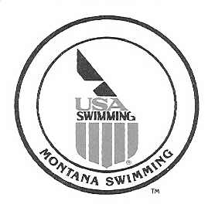

Referee Request for Montana State Championship Meets
To: Montana Swimming
Meet: Meet Dates:
Meet Location: , LSC: MT

Mail to: Lon Huckert, 150 Sheridan Ave, Bozeman, MT 59718 or email to lonhuckert@gmail.com or phone 406-581-0458.

Please consider me for assignments as Meet Referee at the above meet:

Name: LSC: USA S Reg #
Email: Phone:
Mailing Address:

Polo Shirt Size: ___________
Level LSC Years●months
(Choose each position) Level
Current Certifications: Stroke & Turn Judge:
Chief Judge:
Starter:
Deck Referee:
Administrative Referee:
Meet Referee:

Your Request: sorry, were not selected.

Selected for the following position - Ref, Ad Ref

______________________________________, Montana Swimming. Date: ______________________

Send “Confirmation”/”Sorry” to applicant.

