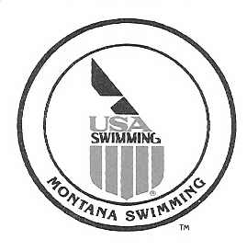

May 15, 2019

Montana Swimming House of Delegates,

I would like to report that as of May 15th Montana Swimming had 90 registered officials with only a few currently working on their stroke and turn certification.

We had a very successful short course season that concluded with the 2019 Montana Swimming SC State Championship Meet in Missoula March 1-3, 2019 and 2019 Montana Swimming B-C Championship Meet in Bozeman March 9-10, 2019. 36 officials that worked the Short Course State meet over the three days. With this many officials working, the meet was run extremely well and the majority of the comments, during and after the meet, all positive. Mary Jo Swalley came to the SC State Meet as an evaluator which allowed 14 of our officials to get valuable feedback and advance their national certifications. The officials that were given the responsibility to be the leads at the meet did a great job with the assignment of the deck officials and hopefully will volunteer for those positions in the future not only at Montana Swimming Meets but at upper level meets as well.
The 2019 Montana Swimming BC Championship Meet had 235 swimmers (100 more than last year). The meet was run with 10 officials. This made for long days on the deck for those officials. Several breaks were added to slow down the meet and get the officials off the deck for a short time. Since the gym was not available the pool deck was very crowded so that will need to be addressed before hosting another meet of this caliber in Bozeman.

Montana Swimming had several officials who traveled and worked upper level meets and should have numerous officials working the upper level meets this summer.

As the 2019 long course season starts, I would like to reinforce the need for all teams to step up and work to recruit new officials as we will continue to lose officials each year and the need for trained officials grows. I would like to ask that we continue to add two or more officials from each team every year.

In conclusion, I would like to thank everyone who has helped me transition into this roll over the last several months. I would also like to thank all the officials that have worked meets throughout the last year, and for all your efforts in training and mentoring our new officials. I would encourage all our officials to continue with the training and mentoring of each other. We have a great group of officials in our LSC and I know we all learn something at the meets we work.

If anyone has questions or needs anything please feel free to contact me.

Respectfully,

Lon H Huckert
Montana Swimming Officials Chairman
lonhuckert@gmail.com

